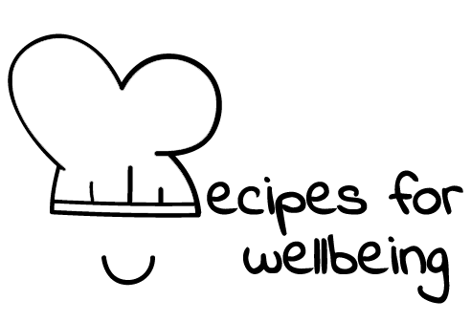
WHOLEBEING FOR EDUCATORS · LESSON PLAN
Meeting pressure with more support
The skill of breathing · awareness · one class period · ages 13 to 18
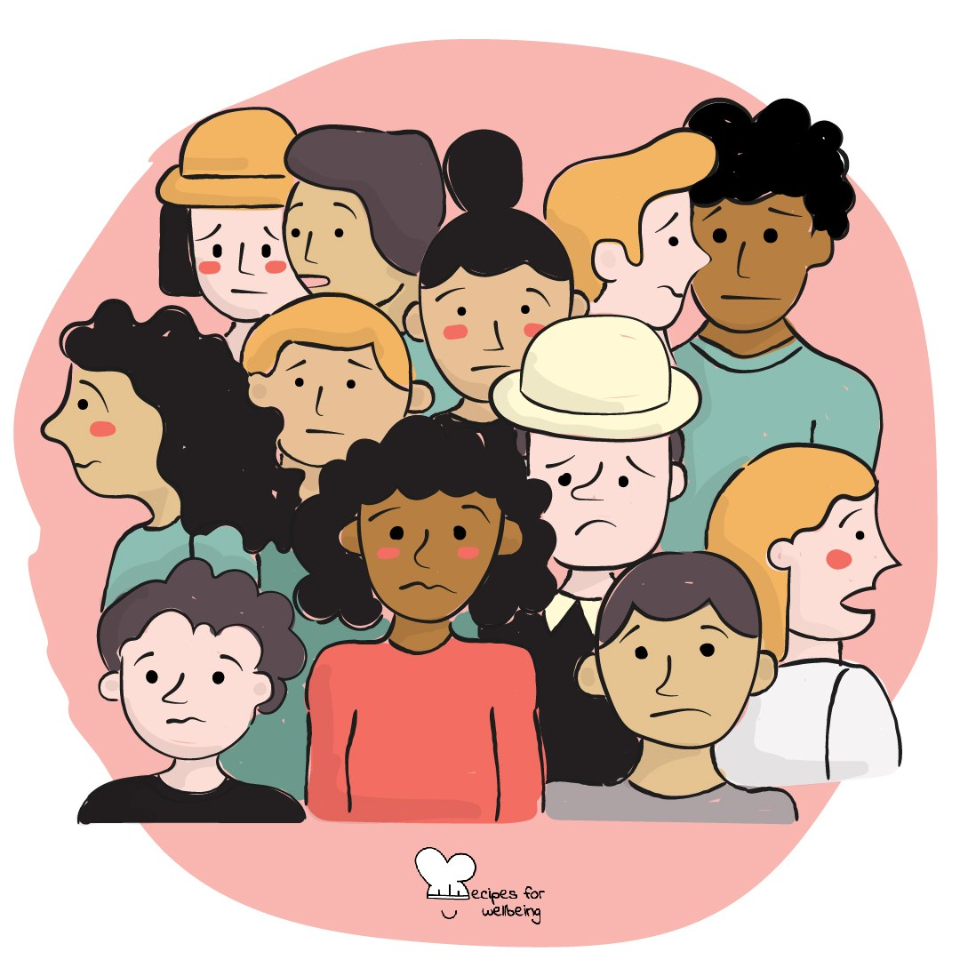
Learning intention
By the end of this lesson, students can notice one sign of stress and try several optional practices that may create a little space during pressure.

The big idea
Stress may appear before an exam, after a difficult message or in response to demands that have lasted too long. Noticing the response can help us choose support, but stress is not always something an individual can breathe away. This lesson offers several practices alongside the need for rest, practical help and changes to the conditions causing pressure.
Opener (5 min): Befriending the flutter
Use Befriending the flutter with external attention and non-participation available. Students should not be asked to locate or thank a bodily sensation if that feels uncomfortable.
Explore (10 min)
Stress involves the body and mind responding to demand. The response can sometimes support action, and it can also become exhausting, painful or difficult to manage, especially when pressure is intense or prolonged.
Breathing is one possible way to pause because its rhythm can be noticed and gently adjusted. It is not universally calming and should never replace medical, pastoral or practical support. A more useful question than "How do I make this feeling go away?" is "What might help me meet this moment safely?"
Discuss
- What signs may tell a person that pressure is building, and how might those signs vary?
- Why does "just relax" often fail to respond to what someone needs?
- Which sources of stress require a personal practice, another person's help or a change in conditions?
Activity (15 min): Build a pressure toolkit
Materials: optional private paper and pens · Grouping: whole class
- Explain that the class will sample several options, with ordinary breathing, watching or passing available at every stage.
- Try finger tracing: move one finger slowly up and down the other hand, breathing comfortably or ignoring the breath entirely.
- Try a counted breath with a gentle in-breath and a slightly longer out-breath. Remove holds and shorten every count as needed.
- Try an external anchor by identifying a colour, sound and point of contact with a surface.
- Add non-breath options, such as movement, water, clearer information, a quieter place, contacting a trusted person or reducing the next task.
- Students privately mark what felt usable, unsuitable or worth adapting. Nothing is collected and no one needs to state a preference aloud.
Reflect (7 min)
Picture an ordinary moment of pressure without naming it. Which practice, person or practical change may fit, and what could remind you that more than one kind of support is available?
How: private journal
Close (3 min)
These practices will not fix every source of stress, and they do not need to. They offer a few ways to make room and reach for the next kind of support.
In other settings
Form or tutor time (advisory / homeroom): Use the flutter check-in, then try one breath option and one non-breath option.
Assembly or large-group gathering: Lead an external anchor and an optional finger trace from the front, then name routes to support.
Youth club or small group: Sample several options and adapt the toolkit around sensory, access and contextual needs.
Adapting for age
13 to 15: Keep the practices brief, visible and choice-based. Model every option and include movement and external attention alongside breathing.
16 to 18: Connect the toolkit to exams, interviews, work and transitions, while discussing prolonged stress and when professional or structural support is needed.
Curriculum links
IB · Approaches to Learning: Self-management: affective skills (emotional management)
OECD Learning Compass 2030: Core foundations: health foundations (mental well-being); Core foundations: social and emotional foundations (emotional regulation)
UNESCO MGIEP · SEL (EMC framework): Mindfulness (body awareness and attention regulation)
WHO · Life skills education: Coping with stress — recognising sources of stress and how they affect us, and acting to control levels of stress
EU · LifeComp: P1 Self-regulation — understanding and regulating stress responses (P1.2); P3 Wellbeing — seeking social support (P3.3)
UNICEF MENA · Life Skills & Citizenship Education: Self-management — managing stress; Resilience — drawing on coping strategies and support
Australia · Personal & Social Capability: Self-awareness — emotional awareness; Self-management — emotional regulation
Brazil · BNCC general competences: Self-knowledge and self-care (GC 8) — caring for physical and emotional health; Responsibility and citizenship (GC 10) — resilience
Canada · British Columbia: Personal Awareness and Responsibility — well-being (managing stress); self-advocating (seeking help)
Canada · Ontario: Personal skills — recognizing sources of stress (1.1); coping skills such as relaxation, seeking help (1.2) · Gr 7–8: A1.2
Chile · Orientación: Wellbeing and self-care — managing stress appropriately (OA 4, 1°–2° medio); asking for help (OA 3)
England · DfE RSHE (statutory): Mental wellbeing: worrying and feeling down are normal, and managing those feelings (statement 4); physical activity, sleep and time outdoors (statement 2); coping strategies (statement 7)
England · PSHE Association: Health and Wellbeing: mental health and emotional wellbeing (KS3 H7, H10, KS4 H7, H8)
Finland · Transversal competences: L3 Taking care of oneself and managing daily life — ways of acting that promote health and wellbeing; emotional skills
Ghana · NaCCA core competencies (JHS): Personal Development and Leadership — health, resilience and self-regulation
Hong Kong · Values Education Curriculum Framework (2026): Health education (健康生活教育) — exercise and healthy ways to relieve exam and study pressure (S4–S6)
India · NEP 2020: Mental health (NEP 4.28); Life skills: resilience (NEP Principles)
Indonesia · 8 dimensi profil lulusan: Health (kesehatan) — physical and mental health: noticing stress and reaching for support
Ireland · Junior Cycle Wellbeing: Resilient — coping skills to deal with life's challenges; Aware — noticing my feelings and behaviours
Japan · Courses of Study (lower secondary): Health — stress affects mind and body; coping with it appropriately (ストレスへの対処)
Kenya · CBC core competencies & values: Self-efficacy — managing stressful situations; being aware of the resources at one's disposal
Mexico · Nueva Escuela Mexicana: Axis: Healthy living — keeping stress within manageable margins; Feelings and their influence on decision-making
New Zealand · Health and Physical Education: KAL mental health — supporting oneself and others in times of stress; Personal health and physical development — self-management
Scotland · Health and wellbeing (CfE): Mental and emotional wellbeing — coping skills, and support when mental health is hard (HWB 3-06a); people I can talk to (HWB 3-03a)
Singapore · Character & Citizenship Education: SEC: self-management; CCE Curriculum Content Area: Mental Health
South Africa · CAPS Life Orientation: Development of the self in society — stressors, signs of stress and stress management (Gr 12)
US · CASEL competencies: self-awareness, self-management
A guide, not a claim of full coverage. Check against your own scheme of work.
Holding the room
Breath and body attention may be uncomfortable for students with asthma, panic, trauma or other health needs. Follow individual health plans, stop if dizziness or distress appears and make external attention and non-participation easy. Refer persistent or serious concerns through pastoral, medical and safeguarding routes.
Recipes for Wellbeing · CC BY-NC 4.0 · free for classroom use · deep dive: https://recipesforwellbeing.substack.com/p/the-skill-of-breathing

