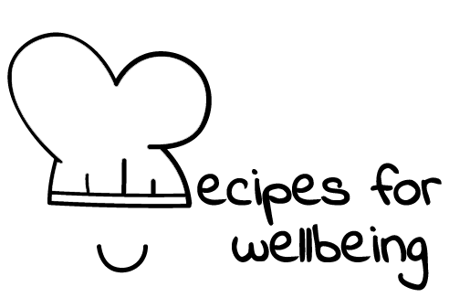
WHOLEBEING FOR EDUCATORS · LESSON PLAN
Finding shape in a complicated situation
The skill of sense-making · liberatory learning · one class period · ages 13 to 18
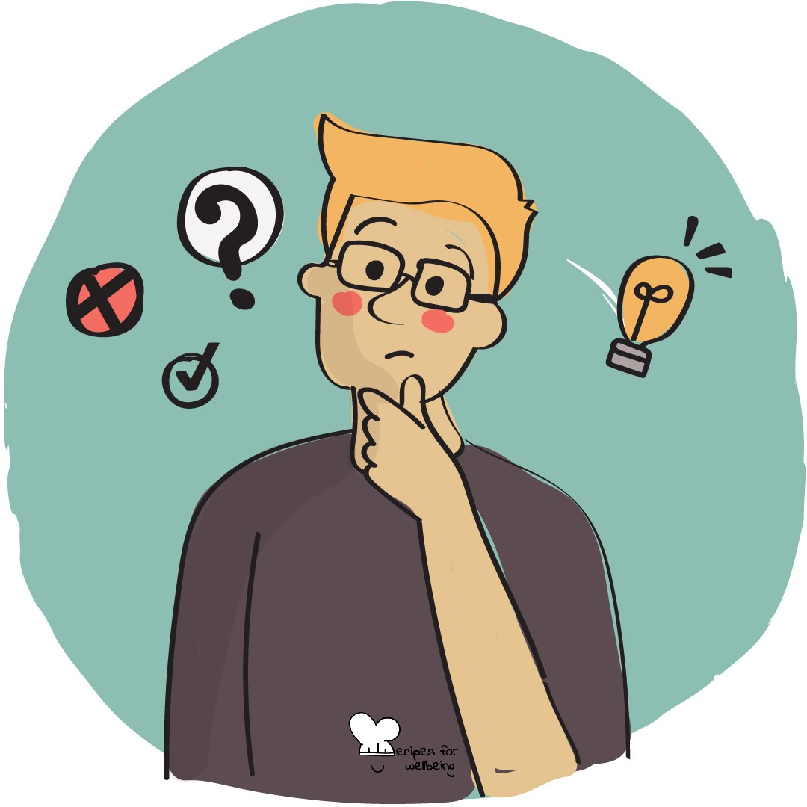
Learning intention
By the end of this lesson, students can map the parts, perspectives and open questions in a complex situation without forcing one quick explanation.

The big idea
Some experiences arrive without a clear story: an unexpected result, a disagreement or information that does not fit. Sense-making helps us hold several parts together, recognise what we do not know and build a provisional understanding. It does not require every mess to become meaningful or every question to be resolved.
Opener (5 min): First attempts
Use First attempts as a private look at information gained through trying. Students do not need to revisit a painful or high-stakes event.
Explore (10 min)
Sense-making is what we do when events, information and viewpoints need to be arranged into a picture we can work with. Our first explanation may be shaped by expectation, limited information or the need to escape uncertainty quickly.
A stronger account remains open to correction. It names what happened, who sees it differently, which relationships matter and what is still unknown. Sometimes the result is greater clarity; sometimes it is a more accurate understanding of why the situation remains complicated.
Discuss
- What is the difference between a quick take and a developed understanding?
- Why can uncertainty feel difficult to leave open?
- How do other perspectives improve sense-making, and when should an account not be treated as merely one side among many?
Activity (18 min): The mess map
Materials: large paper, pens and optional sticky notes · Grouping: groups of three or four
- Offer broad questions such as why misinformation spreads, why scrolling is hard to stop or why a rule can affect groups differently. Students may pass on a topic.
- Place one question in the centre of a large page and agree not to race towards a verdict.
- Build four branches: the parts involved, the positions people hold, the open questions and the connections between them.
- Mark evidence separately from assumptions and write "not sure" wherever the group does not know.
- Visit two other maps and add one missing position, piece of evidence or question, without trying to correct the whole map.
- Share one connection that became clearer and one part that became more complex.
Reflect (5 min)
When something stops making sense, which move may help you next: asking another question, drawing the parts, checking evidence or listening to a position you missed?
How: private journal
Close (2 min)
Not everything needs to be solved before it can be understood more carefully. Sense-making lets us build the clearest picture available and leave space for what has not yet found a place.
In other settings
Form or tutor time (advisory / homeroom): Use First attempts, then build a short map together with parts, positions and open questions.
Assembly or large-group gathering: Model one general mess map on screen and show how "not sure" can remain part of an honest account.
Youth club or small group: Explore one complicated general question conversationally, keeping evidence, assumptions and unknowns distinct.
Adapting for age
13 to 15: Use concrete topics such as rumours, group chats and games, and model each branch before groups begin. Keep "not sure" visible as a useful response.
16 to 18: Use systemic questions and add a branch for power and assumptions. Ask what evidence would change the map.
Curriculum links
IB · Approaches to Learning: Thinking: critical thinking skills (analysing complex concepts, using models to explore complex systems)
OECD Learning Compass 2030: Skills: cognitive and meta-cognitive skills (critical thinking)
UNESCO MGIEP · SEL (EMC framework): Critical Inquiry (mapping viewpoints instead of one explanation)
WHO · Life skills education: Critical thinking — analysing information and experiences; Problem solving — laying out the parts of a complex problem
EU · LifeComp: L2 Critical thinking — comparing and synthesising information and ideas (L2.2); S3 Collaboration — a systemic approach (S3.3)
UNICEF MENA · Life Skills & Citizenship Education: Critical thinking — separating evidence from assumption, weighing perspectives; Problem-solving
Australia · Personal & Social Capability: Social awareness: empathy
Brazil · BNCC general competences: Scientific, critical and creative thinking (GC 2) — critical analysis, formulating problems; Argumentation (GC 7) — reliable information
Canada · British Columbia: Critical and Reflective Thinking — analyzing and critiquing; Social Awareness and Responsibility — appreciating different perspectives
Canada · Ontario: Critical and creative thinking — organizing information, making connections, synthesizing (1.5) · Gr 7–8: A1.6
England · PSHE Association: Living in the wider world: media literacy and digital resilience, a partial fit (KS3 L23, L26)
Finland · Transversal competences: L1 Thinking and learning to learn — noticing interconnections (systemic thinking); dealing with unclear information
Ghana · NaCCA core competencies (JHS): Critical Thinking and Problem-Solving — analysing issues; Communication and Collaboration — valuing multiple perspectives
Hong Kong · Values Education Curriculum Framework (2026): Civic education (公民教育) — understanding issues rationally and from multiple angles (S4–S6); Media and information literacy education
India · NEP 2020: Problem solving and logical reasoning (NEP 4.23); Real understanding (NEP 4.4)
Indonesia · 8 dimensi profil lulusan: Critical reasoning (penalaran kritis) — analysing complex problems; logical arguments backed by evidence (SMA)
Ireland · Junior Cycle Wellbeing: Aware — making sense of my thoughts and reactions when a situation is complicated
Japan · Courses of Study (lower secondary): Moral education — thinking broadly, from many sides and angles (多面的・多角的); issues open to diverse views
Kenya · CBC core competencies & values: Critical Thinking and Problem Solving — logic, evidence and multiple perspectives; Learning to Learn — processing new information
Mexico · Nueva Escuela Mexicana: Axis: Critical thinking — analysing a complex situation from several positions
Singapore · Character & Citizenship Education: SEC: responsible decision-making
South Africa · CAPS Life Orientation: Democracy and human rights — critically analysing dilemmas, respecting differing opinions (Gr 11)
US · CASEL competencies: responsible decision-making, social awareness
A guide, not a claim of full coverage. Check against your own scheme of work.
Holding the room
Keep topics general and avoid asking groups to map a real conflict, disclosure or traumatic event. Do not treat abuse, discrimination or verified harm as a matter of equally valid perspectives. Pause and follow safeguarding procedures if personal material emerges.
Recipes for Wellbeing · CC BY-NC 4.0 · free for classroom use · deep dive: https://recipesforwellbeing.substack.com/p/the-skill-of-sense-making

