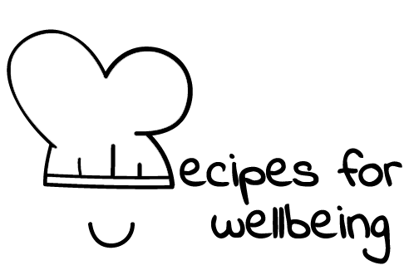
WHOLEBEING FOR EDUCATORS · LESSON PLAN
Finding a steadier next step
The skill of relaxation · rest · one class period · ages 13 to 18
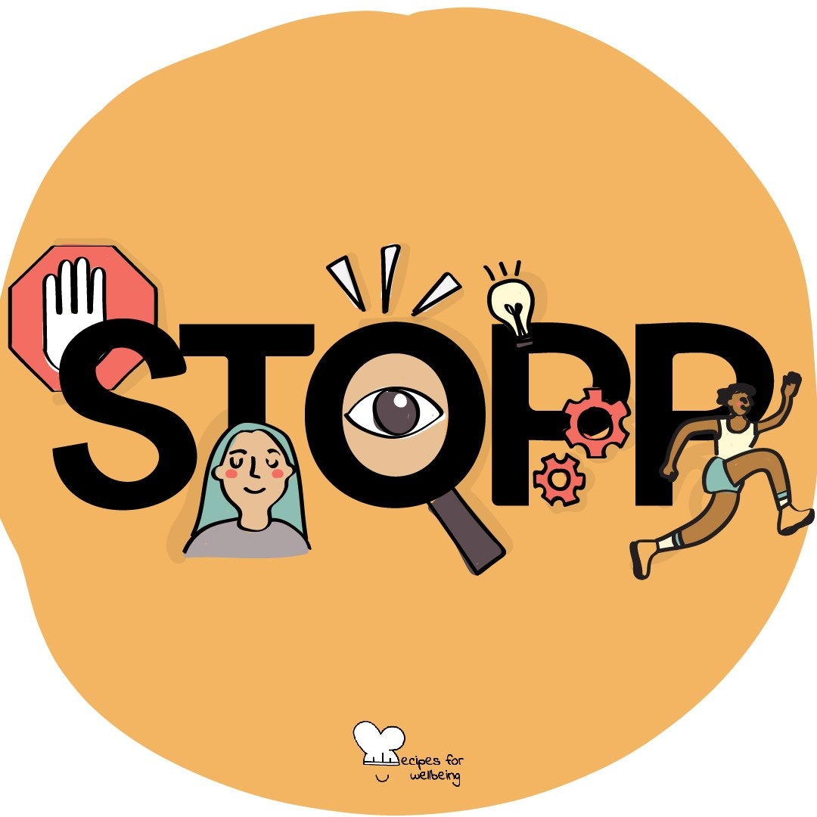
Learning intention
By the end of this lesson, students can use the STOPP sequence and identify different forms of rest or support that may help them respond to pressure.

The big idea
Pressure can narrow attention and make the next reaction feel immediate. Self-regulation is the practice of noticing what is happening, making a little space and choosing from the support that is available. Nobody is calm all the time, and some situations need safety, help or a change in conditions.
Opener (5 min): The full stop
Use The full stop to introduce STOPP. Students may breathe normally and interpret "pull back" as widening the view rather than leaving their body.
Explore (10 min)
Self-regulation includes the ways we influence attention, energy and action. It is shaped by sleep, sensory load, relationships, health, identity and environment, so it cannot be reduced to individual willpower.
STOPP is one brief option. Rest, movement, predictable routines, practical support, reduced demands and another person's presence may matter more. Regulation should help someone meet their needs and make a choice; it should not be used to make distress look tidy for other people.
Discuss
- What is the difference between looking regulated and having what you need?
- Which pressures are personal, and which are created by the environment?
- When might proceeding mean pausing longer or asking another person to step in?
Activity (17 min): Build a rest and support menu
Materials: paper, pens and optional sticky notes · Grouping: small groups
- Offer broad categories such as physical, mental, sensory, creative, social and emotional rest, explaining that they are prompts rather than a complete scientific model.
- Give each group one or two categories and ask for realistic options that cost little, fit different bodies and do not assume a supportive home environment.
- Add a column for changes other people or the setting can make, such as quieter space, clearer instructions, a break, fewer notifications or adjusted workload.
- Build one class menu that includes self-directed practices, relational support and environmental change.
- Invite students to notice privately what they may reach for and what would require an adult's help or permission.
- Keep the menu available without asking anyone to promise that they will use it.
Reflect (5 min)
When life speeds up, what form of rest, support or change is easiest to forget, and which part of today's menu may be worth remembering?
How: private journal
Close (3 min)
The full stop at the beginning did not solve the pressures around us. It offered enough room to notice them and consider what next step or support may be needed.
In other settings
Form or tutor time (advisory / homeroom): Practise STOPP, then collect one option for each rest or support category.
Assembly or large-group gathering: Lead STOPP with alternatives and present a menu that includes environmental changes as well as personal practices.
Youth club or small group: Practise the sequence and build a menu around the group's real access needs without requiring personal disclosure.
Adapting for age
13 to 15: Keep STOPP visible, practise it twice and provide concrete menu examples. Let students draw their ideas or contribute through a scribe.
16 to 18: Name exam, work and online pressure directly, and explore how busyness is rewarded. Ask what institutions should change to support regulation and rest.
Curriculum links
IB · Approaches to Learning: Self-management: affective skills (emotional management)
OECD Learning Compass 2030: Skills: cognitive and meta-cognitive skills (self-regulation)
UNESCO MGIEP · SEL (EMC framework): Mindfulness (steadying attention and body across different forms of rest)
WHO · Life skills education: Coping with stress — reducing sources of stress or changing the environment; Coping with emotions
EU · LifeComp: P1 Self-regulation — regulating emotions, thoughts and behaviour (P1.2); P3 Wellbeing — reliable support and services (P3.2)
UNICEF MENA · Life Skills & Citizenship Education: Self-management — regulating emotions and behaviour under pressure; Decision-making — choosing support
Australia · Personal & Social Capability: Self-management — emotional regulation; Self-awareness — emotional awareness
Brazil · BNCC general competences: Self-knowledge and self-care (GC 8) — caring for physical and emotional health and dealing with emotions
Canada · British Columbia: Personal Awareness and Responsibility — self-regulating; self-advocating (expressing needs, seeking help)
Canada · Ontario: Personal skills — adaptive, management and coping skills, incl. seeking help (1.2) · Gr 7–8: A1.1 (self-regulation), A1.2
Chile · Orientación: Wellbeing and self-care — healthy routines incl. rest (OA 4, 7°–8°); turning to support networks (OA 3, 1°–2° medio)
England · DfE RSHE (statutory): Mental wellbeing: worrying and feeling down are normal, and managing those feelings (statement 4); coping strategies (statement 7)
England · PSHE Association: Health and Wellbeing: mental health and emotional wellbeing (KS3 H6, H7, H10, KS4 H7)
Finland · Transversal competences: L3 Taking care of oneself and managing daily life — rest, a balanced daily rhythm and handling conflicting feelings
Ghana · NaCCA core competencies (JHS): Personal Development and Leadership — self-regulation and resilience
Hong Kong · Values Education Curriculum Framework (2026): Health education (健康生活教育) — psychological well-being; seeking family support in difficulties (S1–S3)
India · NEP 2020: Life skills: resilience (NEP Principles); Mental health (NEP 4.28)
Indonesia · 8 dimensi profil lulusan: Health (kesehatan) — physical and mental health; Independence (kemandirian) — adapting to varied situations
Ireland · Junior Cycle Wellbeing: Resilient — knowing where I can go for help; Responsible — acting to protect and promote my wellbeing
Japan · Courses of Study (lower secondary): Health — coping with stress; Special activities — resolving adolescent anxieties and worries (思春期の不安や悩みの解決)
Kenya · CBC core competencies & values: Self-efficacy — managing stressful situations; Learning to Learn — seeking and making use of guidance
Mexico · Nueva Escuela Mexicana: Feelings and their influence on decision-making — managing affect, self-regulation; Axis: Healthy living
New Zealand · Health and Physical Education: Personal health and physical development — self-management skills; Healthy communities and environments — community resources
Scotland · Health and wellbeing (CfE): Mental and emotional wellbeing — managing thoughts and emotions (HWB 3-02a); practical and emotional support (HWB 3-03a)
Singapore · Character & Citizenship Education: SEC: self-management; CCE Curriculum Content Area: Mental Health
South Africa · CAPS Life Orientation: Development of the self in society — stress management: own strategy (Gr 12); seeking support and assistance (Gr 11)
US · CASEL competencies: self-management, self-awareness
A guide, not a claim of full coverage. Check against your own scheme of work.
Holding the room
Breath focus, stillness and internal observation are optional. Offer external attention, movement and non-participation. If a student reports persistent sleeplessness, overwhelm or unsafe conditions, follow the setting's pastoral, health and safeguarding procedures.
Recipes for Wellbeing · CC BY-NC 4.0 · free for classroom use · deep dive: https://recipesforwellbeing.substack.com/p/the-skill-of-relaxation

