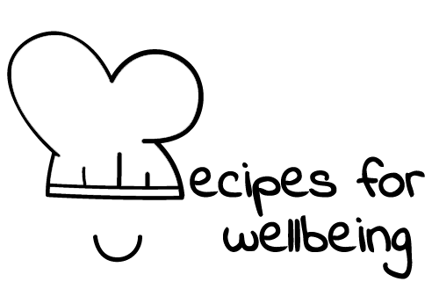
WHOLEBEING FOR EDUCATORS · LESSON PLAN
What else is also true?
The skill of reframing · positive emotion · one class period · ages 13 to 18
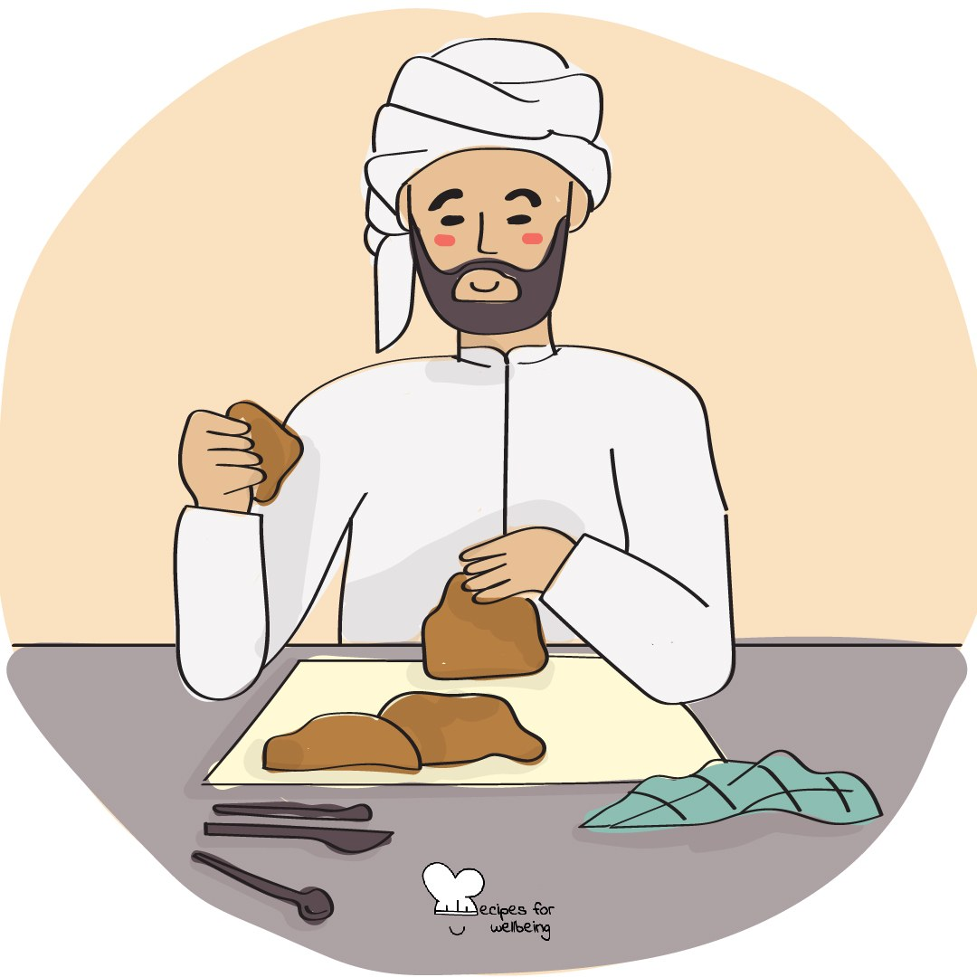
Learning intention
By the end of this lesson, students can find a second honest frame for a difficult situation and explain how it changes the possible next steps.

The big idea
When something goes wrong, the first story about it can feel like the only truth. Reframing keeps the facts and the difficult feeling. It asks whether another part of the situation is also true, and whether that wider view makes another response possible.
Opener (5 min): Stress, reintroduced
Use Stress, reintroduced as an optional experiment in interpretation. The bodily feeling may remain uncomfortable, and students do not need to believe a new story.
Explore (10 min)
A frame directs attention towards some parts of a situation and away from others. Reframing begins by separating the event from the story we have attached to it, then asking what else is supported by the facts.
An honest reframe leaves the difficulty in place. "This result shows me where I need support" may sit beside disappointment; it should not become "The result does not matter." Some situations are harmful or unjust and need action, not a more cheerful interpretation.
Discuss
- How can the same event support more than one honest story?
- Why might the first frame be especially narrow during pressure?
- How can we recognise when a reframe has become denial or forced positivity?
Activity (15 min): The frame swap
Materials: paper, pens and fictional scenario cards · Grouping: groups of three or four
- Model a low mark by separating the fact from a first frame such as "I am incapable" and another truth such as "This gives me information about where I need help."
- Give each group one fictional, low-disclosure situation, such as a missed bus, changed plan, disappointing result or place on the bench.
- Write the first narrow frame, then find two or three other frames that remain supported by the situation.
- Reject any wording that minimises the loss, blames the person or requires gratitude.
- Choose the frame that opens a realistic next step, including asking for help, resting, appealing a decision or doing nothing yet.
- Share the scenario, the wider frame and the possible next step, while leaving room for other interpretations.
Reflect (7 min)
Bring to mind a small, low-stakes hassle without writing what it was. What else is also true, and does that additional truth change anything you may choose next?
How: private journal
Close (3 min)
You do not need to argue with the first story or replace it with a brighter one. You can ask what else is true and let a fuller picture shape the next choice.
In other settings
Form or tutor time (advisory / homeroom): Use the optional stress reframe, then find one additional truth in a fictional low-stakes situation.
Assembly or large-group gathering: Model one scenario from the front and gather honest alternative frames without requiring personal examples.
Youth club or small group: Explore one fictional situation slowly and test each reframe for truth, care and the options it opens.
Adapting for age
13 to 15: Use light, concrete situations and the sentence starter "Another true part of this is..."
16 to 18: Use more complex fictional situations and examine the line between reappraisal, denial and the need for structural action.
Curriculum links
IB · Approaches to Learning: Self-management: affective skills (self-motivation, resilience)
OECD Learning Compass 2030: Skills: cognitive and meta-cognitive skills (creative thinking)
UNESCO MGIEP · SEL (EMC framework): Critical Inquiry (finding a second, honest frame); Mindfulness (attention regulation)
WHO · Life skills education: Creative thinking — exploring alternative ways to see a situation; Coping with emotions
EU · LifeComp: P2 Flexibility — reviewing opinions and courses of action (P2.1); P1 Self-regulation — hope and resilience (P1.3)
UNICEF MENA · Life Skills & Citizenship Education: Resilience — navigating setbacks constructively; Critical thinking — finding another honest frame
Australia · Personal & Social Capability: Self-management: emotional regulation; perseverance and adaptability
Brazil · BNCC general competences: Responsibility and citizenship (GC 10) — flexibility and resilience; Self-knowledge and self-care (GC 8) — dealing with emotions
Canada · British Columbia: Personal Awareness and Responsibility — self-regulating; Critical and Reflective Thinking — analyzing and critiquing
Canada · Ontario: Personal skills — adaptive skills: being flexible, trying out solutions (1.2) · Gr 7–8: A1.3 (reframing negative thoughts)
Chile · Orientación: Wellbeing and self-care — managing stress (OA 4, 1°–2° medio); Managing learning — redefining actions after results (OA 10, 7°–8°)
England · DfE RSHE (statutory): Mental wellbeing: worrying and feeling down are normal, and managing those feelings (statement 4)
England · PSHE Association: Health and Wellbeing: mental health and emotional wellbeing (KS3 H9, KS4 H7)
Finland · Transversal competences: L3 Taking care of oneself and managing daily life — handling conflicting feelings and thoughts; L1 — finding alternatives
Ghana · NaCCA core competencies (JHS): Critical Thinking and Problem-Solving — choosing the most appropriate of several solutions; Personal Development and Leadership — resilience
Hong Kong · Values Education Curriculum Framework (2026): Perseverance (堅毅) — getting through setbacks (S1–S3); Life education — facing adversity with a positive attitude (S4–S6)
India · NEP 2020: Life skills: resilience (NEP Principles); Mental health (NEP 4.28)
Indonesia · 8 dimensi profil lulusan: Critical reasoning (penalaran kritis) — considering various viewpoints; Independence (kemandirian) — adapting (beradaptasi)
Ireland · Junior Cycle Wellbeing: Resilient — believing that with effort I can achieve; Aware — making sense of my thoughts and feelings
Japan · Courses of Study (lower secondary): Moral education B — understanding many ways of seeing (相互理解，寛容); A — overcoming difficulty and failure (克己と強い意志)
Kenya · CBC core competencies & values: Self-efficacy — sustaining effort after failure; seeing difficulties as challenges rather than threats
Mexico · Nueva Escuela Mexicana: Feelings and their influence on decision-making — how feelings are built from ideas and experiences
New Zealand · Health and Physical Education: Hauora: taha hinengaro (thinking processes, responding constructively); KAL mental health — stress and disappointment
Scotland · Health and wellbeing (CfE): Mental and emotional wellbeing — learning ways of managing thoughts and emotions (HWB 3-02a); challenging times (HWB 3-07a)
Singapore · Character & Citizenship Education: SEC: self-management; CCE Curriculum Content Area: Mental Health
South Africa · CAPS Life Orientation: Development of the self in society — strategies to respond to emotions in challenging situations (Gr 9); adapting to change (Gr 12)
US · CASEL competencies: self-awareness, self-management
A guide, not a claim of full coverage. Check against your own scheme of work.
Holding the room
Never ask students to reframe trauma, discrimination, abuse or a live personal difficulty. Keep scenarios fictional and personal reflection low-stakes. Follow safeguarding procedures if a disclosure emerges.
Recipes for Wellbeing · CC BY-NC 4.0 · free for classroom use · deep dive: https://recipesforwellbeing.substack.com/p/the-skill-of-reframing

