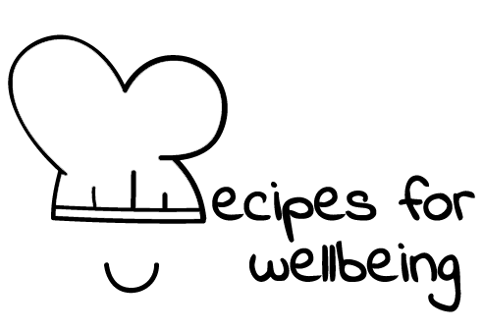
WHOLEBEING FOR EDUCATORS · LESSON PLAN
Looking back with care
The skill of reflection · awareness · one class period · ages 13 to 18
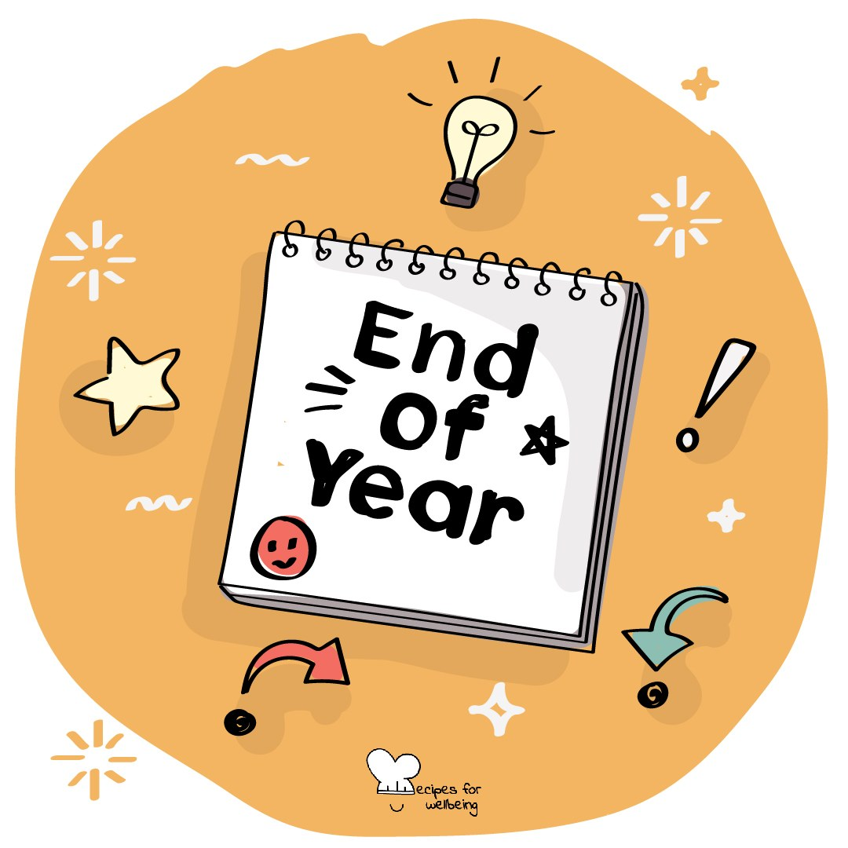
Learning intention
By the end of this lesson, students can look back on one ordinary experience, ask a useful question and identify something they may carry forward.

The big idea
Days can pass quickly, leaving little time to notice what changed, helped or needs attention. Reflection creates a deliberate look back. It is different from rumination, because we do not replay every detail. We look for understanding, a choice or a question that can travel with us.
Opener (5 min): The term, looking back
Use The term, looking back as a private reflection. Students may choose one word to share, while all details remain their own.
Explore (10 min)
Reflection can be held in three movements: pause on a moment, ask a curious question and decide what, if anything, to take from it. A helpful question opens understanding rather than attacking the person who had the experience.
"Why am I like this?" can close a reflection around blame. "What was happening, what helped and what might I need next time?" leaves more room. Sometimes the honest takeaway is that more information or support is needed, or that the moment is not ready to be examined.
Discuss
- How does reflection differ from replaying a moment on a loop?
- When can distance make looking back easier or harder?
- What makes a reflective question curious rather than blaming?
Activity (17 min): Moment, question, takeaway
Materials: paper, pens and fictional scenarios · Grouping: pairs, then individual
- Fold a page into three boxes labelled Moment, Question and Takeaway.
- Model the process with a neutral shared event, using a question that seeks understanding rather than fault.
- Give each pair a fictional low-stakes situation, such as missing a bus, sending an unclear message or revising the wrong topic.
- Pairs complete the three boxes and check whether the takeaway is information, a possible action or a request for support rather than a telling-off.
- Invite several pairs to share the takeaway only, showing that one moment can lead to different understandings.
- Offer an optional private round with a small personal moment. The paper is not collected and students may leave the boxes blank.
Reflect (5 min)
What kind of moment from a week may be worth looking back on, and what gentle question could help you learn from it without getting stuck inside it?
How: private journal
Close (3 min)
Looking back does not have to mean living the moment again. We can ask with care, and carry forward only what is useful or ready.
In other settings
Form or tutor time (advisory / homeroom): Use the term reflection, then model the three boxes with one neutral shared moment.
Assembly or large-group gathering: Demonstrate the three movements from the front and invite a silent private example without collection.
Youth club or small group: Talk through a fictional mix-up and compare several useful questions and takeaways.
Adapting for age
13 to 15: Use concrete fictional examples and keep question starters visible, such as "What was happening?", "What helped?" and "What next?"
16 to 18: Connect the process to revision, decisions and reflective writing, while discussing when reflection becomes rumination and a pause is needed.
Curriculum links
IB · Approaches to Learning: Self-management: reflection skills
OECD Learning Compass 2030: Anticipation-Action-Reflection cycle (reflection); Student agency
UNESCO MGIEP · SEL (EMC framework): Critical Inquiry (asking questions of ordinary experience); Mindfulness (attention regulation)
WHO · Life skills education: Self-awareness — understanding one's own experiences; Critical thinking — analysing experiences objectively
EU · LifeComp: L1 Growth mindset — reflecting on successful and unsuccessful experiences (L1.3); L3 Managing learning — reflecting (L3.3)
UNICEF MENA · Life Skills & Citizenship Education: Self-management — self-monitoring and self-evaluation; Critical thinking — thinking about one's own thinking
Australia · Personal & Social Capability: Self-awareness — reflective practice
Brazil · BNCC general competences: Self-knowledge and self-care (GC 8) — knowing oneself with self-criticism; Scientific, critical and creative thinking (GC 2) — reflection
Canada · British Columbia: Critical and Reflective Thinking — reflecting and assessing; Personal Awareness and Responsibility — self-regulating
Canada · Ontario: Critical and creative thinking — reflecting/evaluating, planning next steps (1.5); Personal skills — self-monitoring (1.1) · Gr 7–8: A1.5
Chile · Orientación: Managing learning — monitoring achievements and redefining actions (OA 10, 7°–8°)
England · PSHE Association: Health and Wellbeing: assessing strengths and acting on feedback (KS4 H1); Living in the wider world: learning skills (KS3 L2)
Finland · Transversal competences: L1 Thinking and learning to learn — reflecting on one's own experience; evaluating one's working process
Ghana · NaCCA core competencies (JHS): Critical Thinking and Problem-Solving — drawing on one's own experiences to analyse situations
Hong Kong · Values Education Curriculum Framework (2026): Moral and ethical education (品德及倫理教育) — reflecting on one's behaviour (S1–S3); self-examination (自省, S4–S6)
India · NEP 2020: Learning how to learn (NEP 4.4)
Indonesia · 8 dimensi profil lulusan: Independence (kemandirian) — the habit of reflection (refleksi) to improve oneself
Ireland · Junior Cycle Wellbeing: Aware — making sense of my thoughts, feelings and behaviours; understanding how I can improve
Japan · Courses of Study (lower secondary): Moral education A — looking at oneself to grow (自己を見つめ); Special activities — looking back on learning (振り返ること)
Kenya · CBC core competencies & values: Learning to Learn — awareness of one's learning process; building on prior learning and life experiences
Mexico · Nueva Escuela Mexicana: Building a life project — rethinking goals after analysing achievements and situations faced
New Zealand · Health and Physical Education: KAL mental health — self-awareness, self-reflection and self-appraisal; Hauora: taha hinengaro
Scotland · Health and wellbeing (CfE): Mental and emotional wellbeing — understanding my own behaviour (HWB 3-04a); Social wellbeing — managing my learning (HWB 3-11a)
Singapore · Character & Citizenship Education: SEC: self-awareness
South Africa · CAPS Life Orientation: Study skills — reflecting on how learning takes place (Gr 11); World of work — keeping a journal (Gr 9)
US · CASEL competencies: self-awareness, responsible decision-making
A guide, not a claim of full coverage. Check against your own scheme of work.
Holding the room
Keep shared work fictional and personal reflection optional, private and uncollected. Do not ask students to revisit trauma or disclose a difficult event. If reflection surfaces distress, help the student return to the present and follow usual safeguarding routes.
Recipes for Wellbeing · CC BY-NC 4.0 · free for classroom use · deep dive: https://recipesforwellbeing.substack.com/p/the-skill-of-reflection

