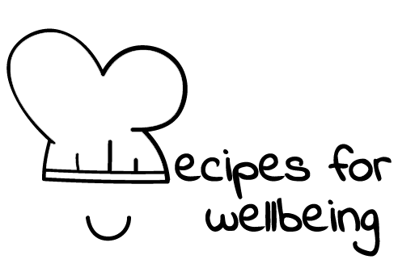
WHOLEBEING FOR EDUCATORS · LESSON PLAN
Keeping the flow going both ways
The skill of non-extracting · community · one class period · ages 13 to 18
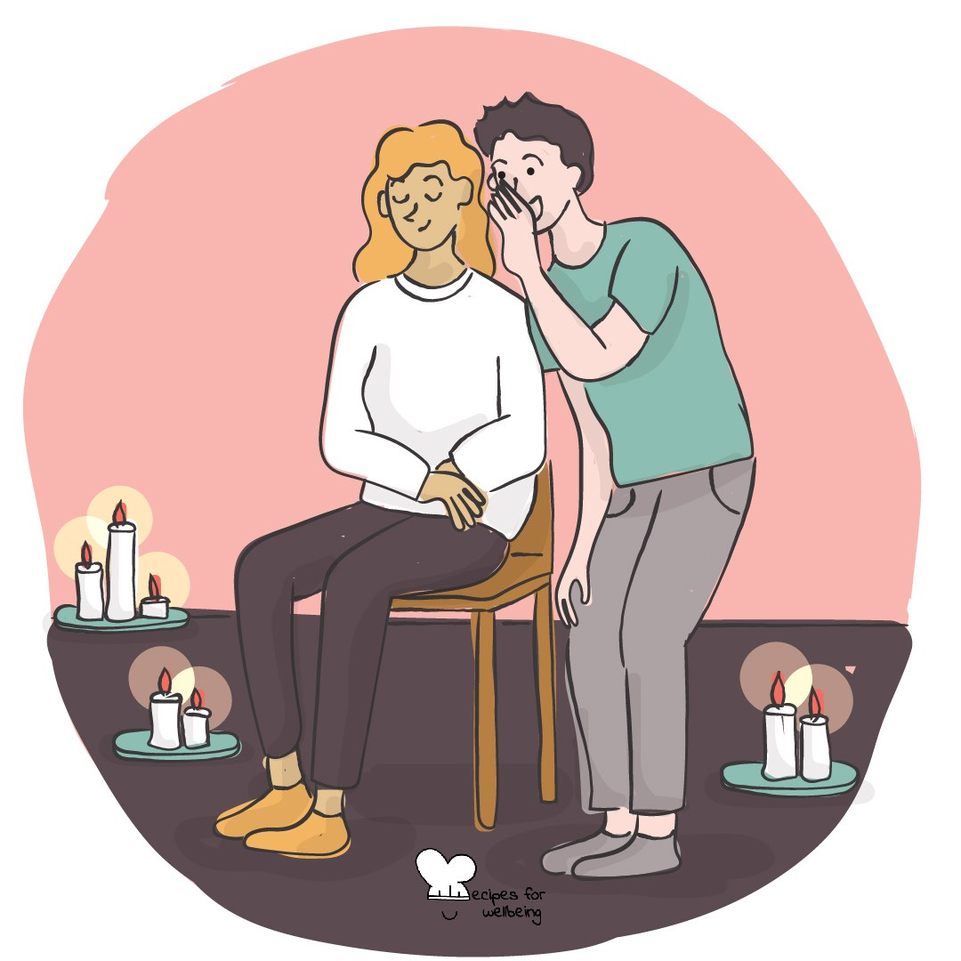
Learning intention
By the end of this lesson, students can identify one-way and reciprocal patterns, and suggest a change that meets a need without leaving another person or system depleted.

The big idea
Friendships, teams, shared spaces and living systems depend on movement in more than one direction. Reciprocity asks what we receive, what we return and whether the arrangement remains fair over time. Nobody is asked to give endlessly. Limits and rest are part of what keeps a relationship going.
Opener (5 min): Giving and receiving
Use Giving and receiving with appreciation limited to observable, appropriate behaviour. Students may appreciate the group, listen or pass.
Explore (10 min)
Reciprocity describes a flow in which receiving and contributing can continue over time. It does not require an exact exchange in every moment; people bring different needs and resources, and care is not a debt to be repaid immediately.
Problems arise when one person, community or ecosystem is expected to keep giving while others take without acknowledgement, repair or limit. A reciprocal response asks how a need can be met without quietly moving the cost onto someone with less power.
Discuss
- What makes an exchange reciprocal even when both sides do not give the same thing?
- How can a group notice when one person is carrying too much?
- What is the difference between reciprocity and keeping score?
Activity (16 min): Redesign the flow
Materials: paper and pens; fictional scenarios · Grouping: groups of four or five
- Offer fictional one-way flows, such as one person organising every group chat, a shared fridge never being restocked, a student contacted only for notes or an app taking attention without supporting a stopping point.
- Groups choose two scenarios and identify what is being received, who supplies it and where the hidden cost sits.
- Redesign one scenario so the need can still be met while responsibility, acknowledgement or resources move more fairly.
- Include a boundary for the person or system that has been giving too much.
- Summarise the redesign in one sentence: "Instead of..., the group could..., so that..."
- Share the recipes and test whether each redesign asks the least powerful person to do even more work.
Reflect (6 min)
Think of an everyday flow you are part of without naming anyone. What could put something back, and what boundary would keep the exchange from becoming draining?
How: private journal
Close (3 min)
Reciprocity means noticing the flow and sharing the load, so that care can keep going. No one has to give until nothing remains.
In other settings
Form or tutor time (advisory / homeroom): Use the appreciation practice, then redesign one fictional one-way flow together.
Assembly or large-group gathering: Introduce reciprocity through one system example and ask what a fairer flow would return and protect.
Youth club or small group: Explore two scenarios conversationally and pay particular attention to boundaries and unequal power.
Adapting for age
13 to 15: Use concrete scenarios involving chargers, games, group chats and shared spaces. Model the hidden cost and the boundary before groups begin.
16 to 18: Extend the activity to unpaid labour, fast fashion, the attention economy and ecological extraction, and ask how power shapes what counts as a fair return.
Curriculum links
IB · Approaches to Learning: Social: collaboration skills (making fair and equitable decisions)
OECD Learning Compass 2030: Skills: social and emotional skills (collaboration); Transformative competencies: taking responsibility
UNESCO MGIEP · SEL (EMC framework): Empathy; Critical Inquiry (examining one-way patterns)
WHO · Life skills education: Interpersonal relationship skills — keeping relationships fair; Problem solving — redesigning a one-way arrangement
EU · LifeComp: S3 Collaboration — fair sharing of tasks, resources and responsibility (S3.3); fair, respectful relationships (S3.2)
UNICEF MENA · Life Skills & Citizenship Education: Negotiation — exchanging things of value fairly; Cooperation — sharing responsibility for a common purpose
Australia · Personal & Social Capability: Social awareness: relational awareness; Social management: collaboration
Brazil · BNCC general competences: Empathy and cooperation (GC 9) — cooperation, resolving conflicts; Responsibility and citizenship (GC 10) — solidary, sustainable decisions
Canada · British Columbia: Social Awareness and Responsibility — contributing to community and caring for the environment; resolving problems
Canada · Ontario: Interpersonal skills — negotiating (1.3); working towards a common goal (1.4) · Gr 7–8: A1.4 (helping others, giving back)
Chile · Orientación: Interpersonal relationships — agreements that benefit all parties, with reciprocal commitment (OA 6, 1°–2° medio)
England · DfE RSHE (statutory): Respectful relationships: mutual respect and generosity in positive relationships (statement 1)
England · PSHE Association: Relationships: forming and maintaining respectful relationships, including trust (KS3 R14, R10)
Finland · Transversal competences: L7 Participation, involvement and building a sustainable future — negotiation; changing practices towards sustainable wellbeing
Ghana · NaCCA core competencies (JHS): Core value — equity: caring for one another; Personal Development and Leadership — responsibility
Hong Kong · Values Education Curriculum Framework (2026): Responsibility (責任感) — actively taking on shared responsibilities at home (S1–S3); Unity (團結)
India · NEP 2020: Collaboration and teamwork (NEP 4.23); Ethical decisions (NEP 4.28)
Indonesia · 8 dimensi profil lulusan: Collaboration (kolaborasi) — caring, sharing and building cooperation (peduli, berbagi, kerja sama)
Ireland · Junior Cycle Wellbeing: Connected — how my actions and interactions affect others' wellbeing, locally and globally
Japan · Courses of Study (lower secondary): Moral education B — gratitude and responding in return (感謝，進んでそれに応え); C — fairness and impartiality (公正，公平)
Kenya · CBC core competencies & values: Communication and Collaboration — working together to realise shared goals; Core value — social justice
Mexico · Nueva Escuela Mexicana: Field: The human and the community — reciprocity, mutual help and dialogue
New Zealand · Health and Physical Education: Relationships with other people — relationships; Healthy communities and environments — identifying inequities and making changes
Scotland · Health and wellbeing (CfE): Mental and emotional wellbeing — sharing and fairness in relationships (HWB 3-05a); Relationships, sexual health and parenthood: the importance of being cared for and caring for others in relationships (HWB 3-44a)
Singapore · Character & Citizenship Education: SEC: relationship management and responsible decision-making
South Africa · CAPS Life Orientation: Development of the self in society — relationships and well-being: rights and responsibilities (Gr 11); power relations (Gr 10)
US · CASEL competencies: social awareness, relationship skills, responsible decision-making
A guide, not a claim of full coverage. Check against your own scheme of work.
Holding the room
Keep scenarios fictional and do not invite disclosure about family finances, friendship exploitation or care responsibilities. Avoid suggesting that students owe access, affection or forgiveness. Follow safeguarding and pastoral routes if a real pattern of coercion or deprivation is disclosed.
Recipes for Wellbeing · CC BY-NC 4.0 · free for classroom use · deep dive: https://recipesforwellbeing.substack.com/p/the-skill-of-non-extracting

