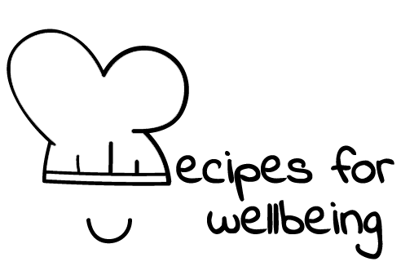
WHOLEBEING FOR EDUCATORS · LESSON PLAN
For the sake of what?
The skill of purpose · meaning · one class period · ages 13 to 18
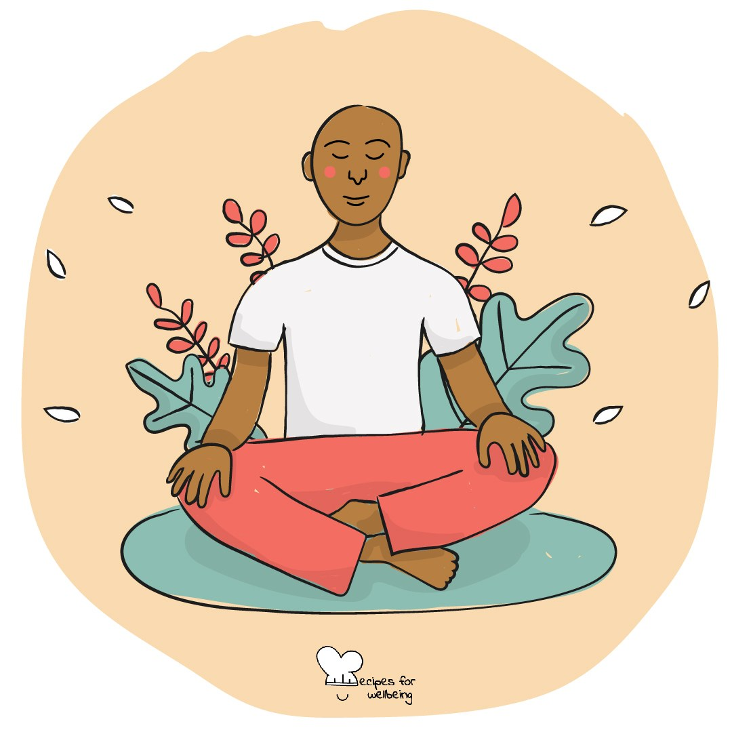
Learning intention
By the end of this lesson, students can connect an everyday action with something it may serve and describe purpose as a changing sense of direction rather than one fixed answer.

The big idea
When tasks and expectations pile up, it can be difficult to remember what any of them are for. Purpose asks what an action serves and whether that direction still matters to us. It can be small, uncertain and shared with others; no young person is expected to identify one grand reason for their life.
Opener (5 min): For the sake of what
Use For the sake of what as a private question. Students may find a large reason, a practical reason or no answer yet.
Explore (10 min)
Purpose can be understood as a compass rather than a complete map. It offers a direction, but it does not specify every turn or guarantee that the route will remain the same.
The same action may serve connection, independence, care, curiosity, security or someone else's expectation. Asking what it is for can help us see whether the action feels chosen, imposed or mixed. Purpose cannot make unreasonable work reasonable, and people may need material support and wider change before a sense of direction is possible.
Discuss
- Why might the same action feel meaningful to one person and empty to another?
- What makes people lose contact with what an activity is for?
- Where does pressure to have a life purpose figured out come from?
Activity (17 min): The why ladder
Materials: paper, pens and a board · Grouping: groups of four
- Model a neutral action on the bottom rung of a ladder, then ask "For the sake of what?" three times to explore possible values beneath it.
- Groups choose a low-disclosure action such as learning to cook, saving money, practising a sport, studying or supporting a friend.
- Build at least three rungs, allowing branches where different reasons are possible.
- Mark which parts depend on personal choice and which depend on resources, other people or wider conditions.
- Each group shares only one top rung, and the class notices where different ladders meet or remain different.
- Students privately take one ordinary action from their week and ask the question once, with "not sure yet" available.
Reflect (6 min)
Choose one ordinary thing you will do this week. For whose or what sake might you do it, and is that reason one you want to keep?
How: private journal
Close (3 min)
Purpose does not need to arrive as one large answer. For now, it may be enough to ask what the next action serves and allow the answer to keep changing with you.
In other settings
Form or tutor time (advisory / homeroom): Use the private question, then build one three-rung ladder together from a neutral action.
Assembly or large-group gathering: Model a branching ladder on screen and keep the audience's own answers private.
Youth club or small group: Build several ladders conversationally and notice how the same action can serve different or mixed purposes.
Adapting for age
13 to 15: Use concrete actions and limit ladders to three rungs. Repeat that uncertainty is not a problem to solve in the lesson.
16 to 18: Include study, work, money and transitions beyond school, while questioning the expectation that every decision must express one settled purpose.
Curriculum links
IB · Approaches to Learning: Self-management: reflection skills; Self-management: organisation skills (planning towards personal goals)
OECD Learning Compass 2030: Attitudes and values; Student agency & co-agency
UNESCO MGIEP · SEL (EMC framework): Critical Inquiry (tracing actions back to deeper reasons)
WHO · Life skills education: Self-awareness — recognising what one values; Decision making — whether an action still serves that value
EU · LifeComp: P1 Self-regulation — a sense of purpose that supports learning and action (P1.3); L3 Managing learning — purposes (L3.3)
UNICEF MENA · Life Skills & Citizenship Education: Self-management — motivation rooted in what matters; Decision-making — weighing personal choice and wider conditions
Australia · Personal & Social Capability: Self-awareness: personal awareness; Self-management: goal setting
Brazil · BNCC general competences: Work and life project (GC 6) — choices aligned with one's life project, with autonomy and critical awareness
Canada · British Columbia: Positive Personal and Cultural Identity — personal values and choices; Personal Awareness and Responsibility — ethical decisions
Canada · Ontario: Personal skills — using personal strengths and values to guide decisions (1.1) · Gr 7–8: A1.5 (sense of mattering and purpose)
Chile · Orientación: Personal growth — comparing life-project alternatives (OA 1, 1°–2° medio); Managing learning — interests, motivations (OA 9, 7°–8°)
England · PSHE Association: Living in the wider world: learning skills, values (KS3 L2)
Finland · Transversal competences: L1 Thinking and learning to learn — ethical thinking about the good life; L6 — choices grounded in one's own interests
Ghana · NaCCA core competencies (JHS): Personal Development and Leadership — self-knowledge, dreams and aspirations
Hong Kong · Values Education Curriculum Framework (2026): Life education (生命教育) — seeking the meaning of life (S1–S3); clear goals and aspirations (S4–S6)
India · NEP 2020: Ethical decisions (NEP 4.28); Socio-emotional learning (NEP 5.14)
Indonesia · 8 dimensi profil lulusan: Independence (kemandirian) — taking responsibility for one's own development
Ireland · Junior Cycle Wellbeing: Aware — knowing my personal values and thinking through my decisions
Japan · Courses of Study (lower secondary): Moral education — deepening thought about one's way of life (人間としての生き方); Special activities — career formation and self-realisation
Kenya · CBC core competencies & values: Self-efficacy — setting and pursuing personal, family and community goals
Mexico · Nueva Escuela Mexicana: Building a life project — interests, strengths and goals for personal and collective well-being
New Zealand · Health and Physical Education: Hauora: taha wairua (values and beliefs; the search for meaning and purpose in life)
Scotland · Health and wellbeing (CfE): Planning for choices and changes — relevance of learning to future opportunities; informed choices about life (HWB 3-19a)
Singapore · Character & Citizenship Education: SEC: self-awareness and responsible decision-making; Becoming my Best Self
South Africa · CAPS Life Orientation: Social and environmental responsibility — personal mission statement and vision (Gr 12); World of work — work and personal potential (Gr 7)
US · CASEL competencies: self-awareness, responsible decision-making
A guide, not a claim of full coverage. Check against your own scheme of work.
Holding the room
Keep group examples hypothetical and personal writing private. Questions about purpose may connect with hopelessness or family pressure. Do not explore this publicly; offer a quiet check-in and follow usual safeguarding and pastoral procedures.
Recipes for Wellbeing · CC BY-NC 4.0 · free for classroom use · deep dive: https://recipesforwellbeing.substack.com/p/the-skill-of-purpose

