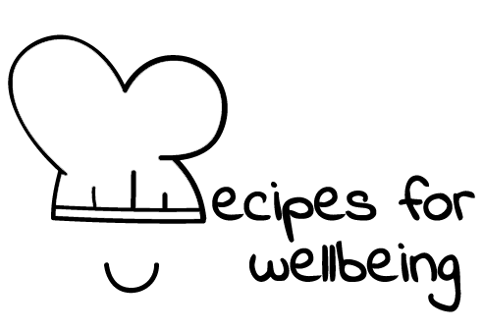
WHOLEBEING FOR EDUCATORS · LESSON PLAN
Returning to where you are
The skill of presence · awareness · one class period · ages 13 to 18
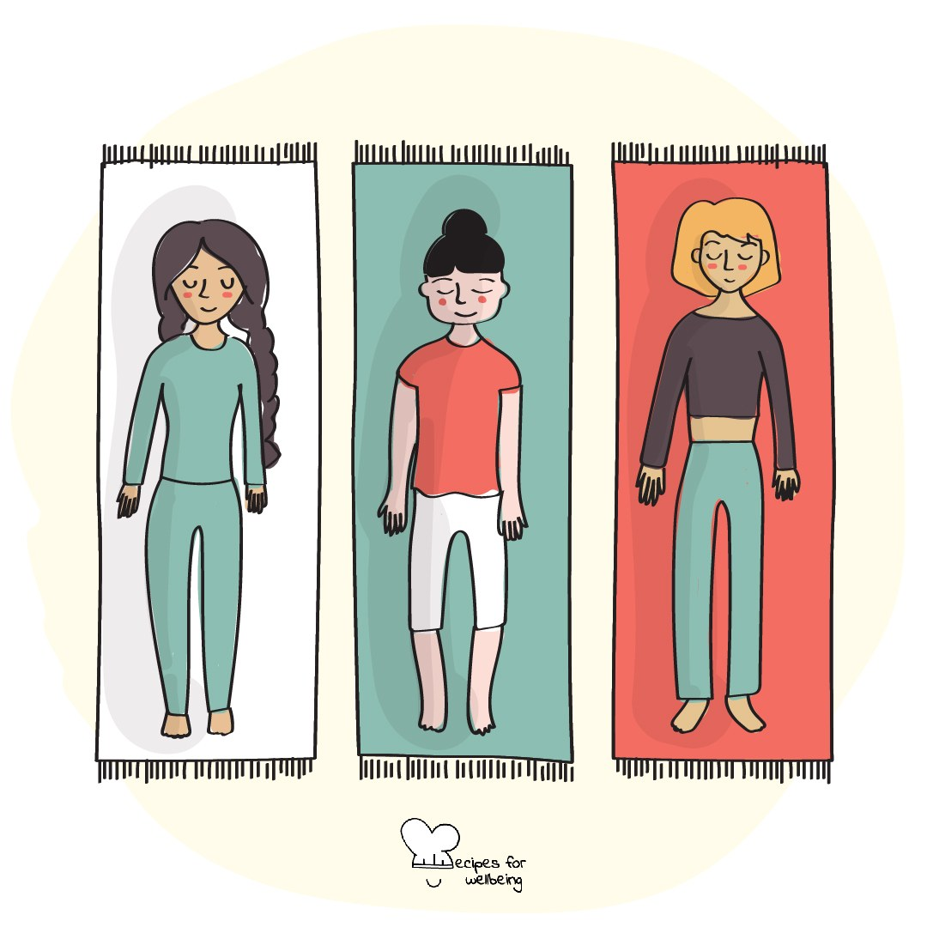
Learning intention
By the end of this lesson, students can notice when attention has moved away and use one sensory anchor to return to the present.

The big idea
Attention moves between memories, plans, screens and whatever is happening in front of us. Presence is the repeated practice of noticing where attention has gone and deciding whether to return. Nobody holds attention perfectly or empties the mind.
Opener (5 min): Arriving here
Use Arriving here to notice one sound, one bodily sensation and one thought. Eyes remain open by default, and students do not need to change what they find.
Explore (10 min)
Our minds move through time and possibility because that is part of thinking. Presence does not make this movement wrong. It helps us recognise when the mind is somewhere different from the task, conversation or experience we want to meet.
An anchor is one present detail we can return to, such as contact with the floor, a sound, an object or an ordinary breath. Coming back may happen many times, and each return is part of the practice. Sometimes turning attention away is protective, so choice and safety matter more than staying with an uncomfortable sensation.
Discuss
- What most often competes for people's attention?
- How does an absorbed experience differ from one met with divided attention?
- When might external rather than internal attention feel safer or more useful?
Activity (16 min): Three ways back to now
Materials: ordinary classroom objects · Grouping: individual and pairs
- Introduce anchors as present details that attention can rest on, with sitting, standing and movement available.
- Try a contact anchor by noticing the floor, chair or another surface supporting the body for five seconds.
- Try a sound anchor by identifying several separate sounds, or use visual details if listening closely is uncomfortable.
- Try one ordinary breath without changing its depth or pace.
- In pairs, each person describes a neutral object for one minute while their partner listens. The task is detailed attention, not an impressive description.
- Discuss how often attention wandered and how it returned, without ranking anyone's concentration.
Reflect (6 min)
Where does your attention become absorbed naturally, and which anchor might help when you want to return to what is in front of you?
How: private journal
Close (3 min)
Attention will wander again, because that is what minds do. Presence is the moment you notice and choose where to place it next.
In other settings
Form or tutor time (advisory / homeroom): Use Arriving here, then try the contact and sound anchors.
Assembly or large-group gathering: Guide two external anchors from the front and keep all responses private.
Youth club or small group: Try the anchors and talk about what makes returning to the present easier or harder in different environments.
Adapting for age
13 to 15: Keep the anchors brief and concrete, allow students to remain seated with an open gaze and frame the object description as noticing detail.
16 to 18: Connect divided attention to study and conversation without making unsupported claims about performance. Invite students to test an anchor and observe their own experience.
Curriculum links
IB · Approaches to Learning: Self-management: affective skills (mindfulness awareness)
OECD Learning Compass 2030: Core foundations: health foundations (mental well-being); Core foundations: social and emotional foundations (emotional regulation)
UNESCO MGIEP · SEL (EMC framework): Mindfulness (noticing attention drift and returning to an anchor)
WHO · Life skills education: Self-awareness — noticing where one's attention is; Coping with stress — grounding attention in the present
EU · LifeComp: P1 Self-regulation — awareness of one's thoughts and behaviour (P1.1); L3 Managing learning — knowing one's learning processes (L3.1)
UNICEF MENA · Life Skills & Citizenship Education: Self-management — regulating attention; returning to the present
Australia · Personal & Social Capability: Self-awareness — emotional awareness; Self-management — emotional regulation
Brazil · BNCC general competences: Self-knowledge and self-care (GC 8) — knowing oneself and caring for emotional health
Canada · British Columbia: Personal Awareness and Responsibility — self-regulating
Canada · Ontario: Personal skills — self-awareness and self-monitoring (1.1); practising mindfulness · Gr 7–8: A1.1
Chile · Orientación: Wellbeing and self-care — building actions that favour wellbeing into daily life (OA 4)
England · DfE RSHE (statutory): Mental wellbeing: worrying and feeling down are normal, and managing those feelings (statement 4); coping strategies (statement 7)
England · PSHE Association: Health and Wellbeing: mental health and emotional wellbeing (KS3 H7, H10, KS4 H7)
Finland · Transversal competences: L1 Thinking and learning to learn — ways of maintaining attention and concentration
Ghana · NaCCA core competencies (JHS): Personal Development and Leadership — self-awareness and self-regulation
Hong Kong · Values Education Curriculum Framework (2026): Life education (生命教育) — living well in the present (活好當下, S4–S6)
India · NEP 2020: Mental health (NEP 4.28)
Indonesia · 8 dimensi profil lulusan: Health (kesehatan) — mental health (kesehatan mental): returning attention to the present
Ireland · Junior Cycle Wellbeing: Aware — noticing my thoughts and behaviours; understanding what helps me to learn
Japan · Courses of Study (lower secondary): Health — maintaining mental health (心の健康)
Kenya · CBC core competencies & values: Self-efficacy — self-awareness
Mexico · Nueva Escuela Mexicana: Feelings and their influence on decision-making — distinguishing emotions, moods and feelings
New Zealand · Health and Physical Education: Hauora: taha hinengaro (coherent thinking processes) and taha tinana (the body)
Scotland · Health and wellbeing (CfE): Mental and emotional wellbeing — being aware of my feelings (HWB 3-01a); learning ways of managing thoughts (HWB 3-02a)
Singapore · Character & Citizenship Education: SEC: self-awareness and self-management
South Africa · CAPS Life Orientation: Study skills — concentration (Gr 10); Development of the self in society — stress management (Gr 12)
US · CASEL competencies: self-awareness, self-management
A guide, not a claim of full coverage. Check against your own scheme of work.
Holding the room
Internal attention can surface discomfort or difficult memories. Offer external visual and sound anchors, movement, quiet observation and leaving the room according to school procedures. Do not press for an explanation of non-participation.
Recipes for Wellbeing · CC BY-NC 4.0 · free for classroom use · deep dive: https://recipesforwellbeing.substack.com/p/the-skill-of-presence

