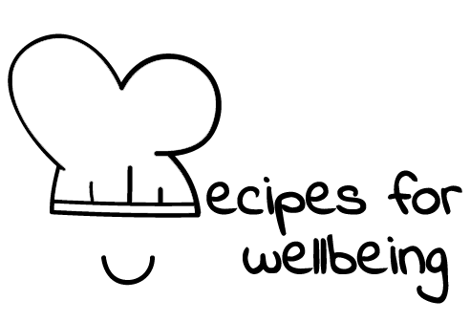
WHOLEBEING FOR EDUCATORS · LESSON PLAN
Making a little room
The skill of pausing · rest · one class period · ages 13 to 18
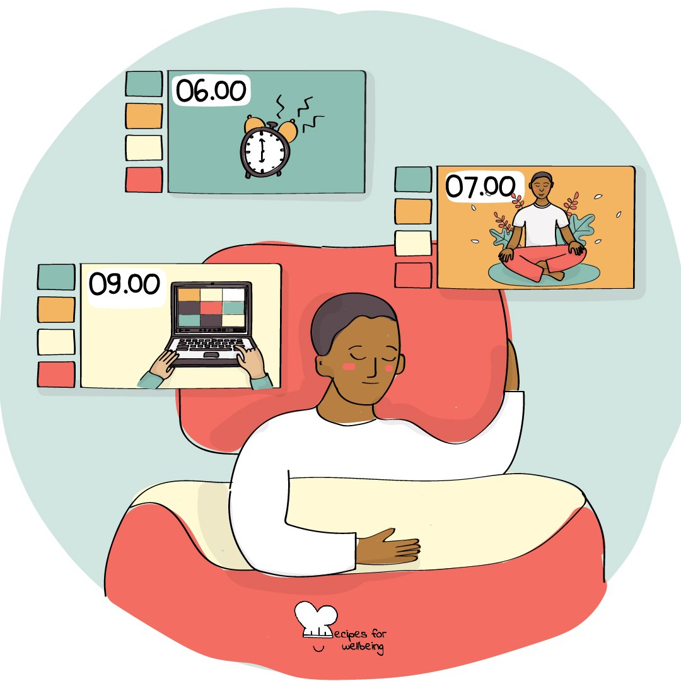
Learning intention
By the end of this lesson, students can try several short pauses and describe what a pause may make possible before they respond or continue.

The big idea
Many parts of the day arrive without a gap: one lesson follows another, messages ask for replies and a reaction can be expected immediately. A pause offers a small space in which nothing needs to be produced and the next response does not have to be automatic. The pressure around us stays. A pause may still give us time to notice what is needed.
Opener (5 min): Ninety seconds of nothing
Use Ninety seconds of nothing while keeping eyes open and movement available. Nothing will be requested or collected at the end.
Explore (10 min)
A pause can be brief: looking away from a screen, feeling contact with the floor, taking an ordinary breath or waiting before replying. Its value does not depend on helping us work faster afterwards.
A pause may also create choice between an event and a response. It does not make every reaction controllable, and people need different amounts of time and support. When a situation is unsafe, pausing should lead towards protection and help rather than greater tolerance of harm.
Discuss
- Where does the day leave little room between one demand and the next?
- Why can stopping feel uncomfortable or undeserved?
- When might a pause help before replying, and when is immediate action needed?
Activity (18 min): A menu of pauses
Materials: paper, pens and a teacher-held timer · Grouping: whole class, with optional pairs
- Explain that the class will try three pauses, with watching, adapting or passing available throughout.
- First, trace a square while breathing at a comfortable pace. Students may remove every hold or trace while breathing normally.
- Second, let the eyes look towards a distant point or close briefly if that feels safe. Avoid pressing or covering the eyes.
- Third, place pens and devices down if possible and notice three sounds, or three visual details if sound is uncomfortable.
- Students privately record which pauses felt usable, unusable or worth adapting, and where a minute may be possible.
- Gather techniques rather than personal reactions, while noting that access to a pause also depends on timetables, spaces and adult expectations.
Reflect (6 min)
If you had one minute tomorrow in which nothing needed to be completed, where might it fit and what kind of pause would feel possible there?
How: private journal
Close (3 min)
A pause does not need to be long or productive to count. It can simply be a small piece of room before the day continues.
In other settings
Form or tutor time (advisory / homeroom): Use the 90-second pause, then try one further technique and name where it could fit.
Assembly or large-group gathering: Lead one or two pauses with eyes-open and movement options, without asking the audience to report how they feel.
Youth club or small group: Try several pauses and talk about what makes them accessible, including environmental and timetable changes.
Adapting for age
13 to 15: Keep each sample short, name it clearly and hold the timing for the class. Make adaptation and movement visible from the beginning.
16 to 18: Connect the lesson to revision and exam pressure while questioning advice that values breaks only because they improve performance.
Curriculum links
IB · Approaches to Learning: Self-management: affective skills (mindfulness awareness, emotional management)
OECD Learning Compass 2030: Core foundations: health foundations (mental well-being); Core foundations: social and emotional foundations (emotional regulation)
UNESCO MGIEP · SEL (EMC framework): Mindfulness (pausing to regulate attention and body)
WHO · Life skills education: Coping with emotions — making room to respond rather than react; Coping with stress — learning how to relax
EU · LifeComp: P1 Self-regulation — awareness and regulation of emotions, thoughts and behaviour (P1.1–P1.2)
UNICEF MENA · Life Skills & Citizenship Education: Self-management — controlling impulses, pausing before responding; Decision-making — choosing the next step
Australia · Personal & Social Capability: Self-management: emotional regulation; Self-awareness: emotional awareness
Brazil · BNCC general competences: Self-knowledge and self-care (GC 8) — recognising one's emotions and the capacity to deal with them
Canada · British Columbia: Personal Awareness and Responsibility — self-regulating; well-being (strategies for challenging moments)
Canada · Ontario: Personal skills — adaptive, management and coping skills (1.2) · Gr 7–8: A1.2 (pausing and reflecting)
Chile · Orientación: Wellbeing and self-care — appropriate rest and managing stress in daily life (OA 4)
England · DfE RSHE (statutory): Mental wellbeing: worrying and feeling down are normal, and managing those feelings (statement 4); coping strategies (statement 7)
England · PSHE Association: Health and Wellbeing: mental health and emotional wellbeing (KS3 H7, H10, KS4 H7)
Finland · Transversal competences: L3 Taking care of oneself and managing daily life — rest and handling feelings; L1 — maintaining attention and concentration
Ghana · NaCCA core competencies (JHS): Personal Development and Leadership — self-regulation
Hong Kong · Values Education Curriculum Framework (2026): Moral and ethical education (品德及倫理教育) — controlling impulsive emotions and behaviour with self-discipline (S1–S3)
India · NEP 2020: Mental health (NEP 4.28); Life skills: resilience (NEP Principles)
Indonesia · 8 dimensi profil lulusan: Health (kesehatan) — mental health (kesehatan mental): short pauses in a busy day
Ireland · Junior Cycle Wellbeing: Aware — noticing my thoughts, feelings and behaviours; Resilient — coping skills
Japan · Courses of Study (lower secondary): Health — coping with desires and stress (欲求やストレスへの対処)
Kenya · CBC core competencies & values: Self-efficacy — managing stressful situations before responding
Mexico · Nueva Escuela Mexicana: Feelings and their influence on decision-making — self-regulation before responding; Axis: Healthy living
New Zealand · Health and Physical Education: Hauora: taha hinengaro (responding constructively); Personal health and physical development — self-management skills
Scotland · Health and wellbeing (CfE): Mental and emotional wellbeing — how feelings and reactions change (HWB 3-04a); learning ways of managing them (HWB 3-02a)
Singapore · Character & Citizenship Education: SEC: self-management; CCE Curriculum Content Area: Mental Health
South Africa · CAPS Life Orientation: Development of the self in society — appropriate responses to pressure: coping skills (Gr 7); stress management (Gr 12)
US · CASEL competencies: self-awareness, self-management, responsible decision-making
A guide, not a claim of full coverage. Check against your own scheme of work.
Holding the room
Stillness, breath focus and closing the eyes can be uncomfortable. Offer movement, ordinary breathing, an open gaze and quiet non-participation. Keep all sharing about techniques, and follow usual pastoral procedures if a student becomes distressed.
Recipes for Wellbeing · CC BY-NC 4.0 · free for classroom use · deep dive: https://recipesforwellbeing.substack.com/p/the-skill-of-pausing

