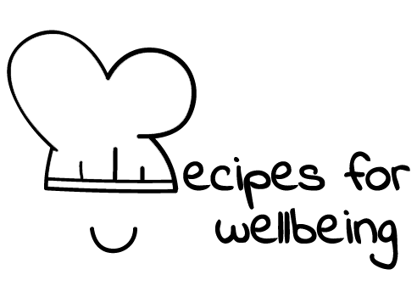
WHOLEBEING FOR EDUCATORS · LESSON PLAN
Letting an ordinary day count
The skill of ordinariness · accomplishments · one class period · ages 13 to 18
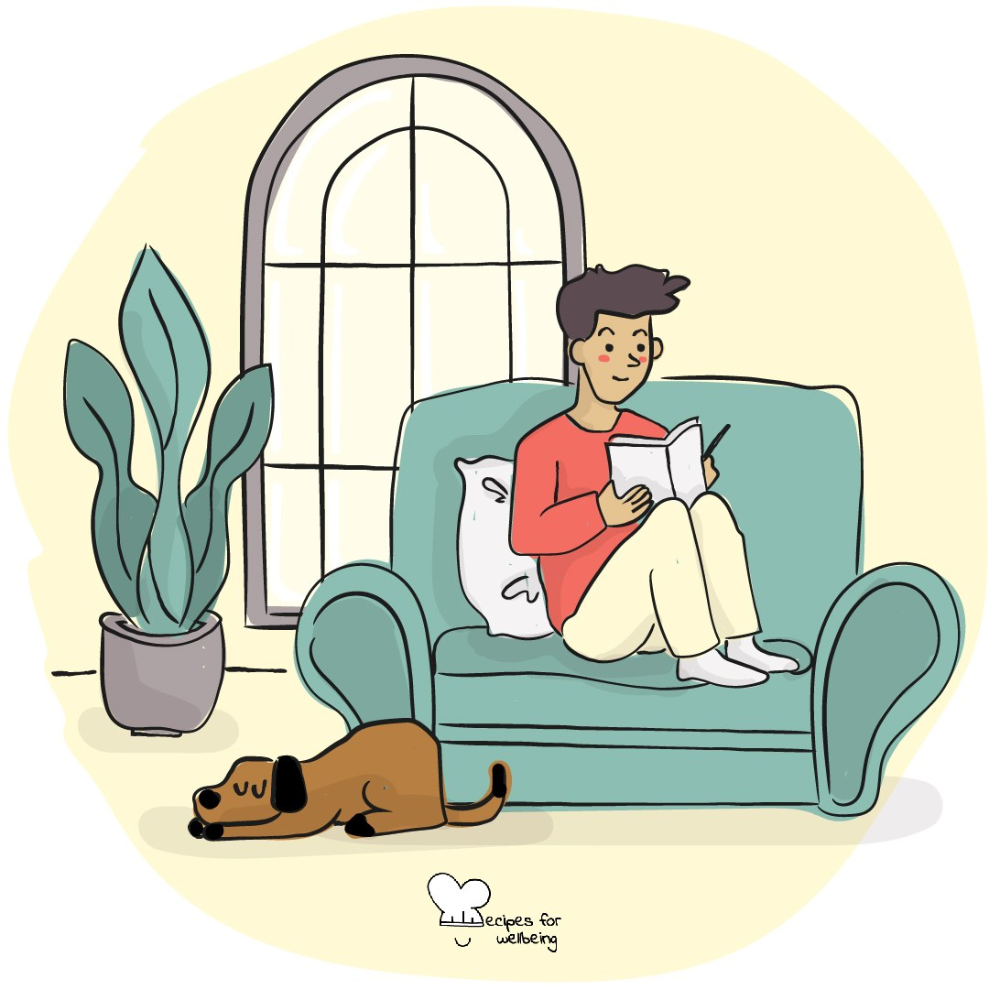
Learning intention
By the end of this lesson, students can notice ordinary moments that matter and question the idea that value depends on standing out or achieving more.

The big idea
Grades, applications, followers and public achievements can make ordinary life seem like the space between important events. Yet much of what holds a life is repeated and unremarkable: meals, journeys, familiar places, small kindnesses and time with other people. Ordinariness allows these parts to count without needing to turn them into highlights.
Opener (5 min): The done list
Use The done list to notice completed effort beside what remains. Students can count one, two or three items and keep them private.
Explore (10 min)
Ordinariness is permission to let a normal day matter. It pushes back against the idea that a person must be exceptional, visible or constantly improving to deserve care and belonging.
Ambition still has a place, and ordinary life is not always comfortable. Achievement is one part of a person, and the repeated, unnoticed parts of a day have value of their own. No one needs to perform being content with less when their needs are not being met.
Discuss
- Where does pressure to be exceptional come from?
- What might highlight culture do to the way a normal day is experienced?
- Which ordinary parts of life deserve more care from schools and communities?
Activity (18 min): The ordinary gallery
Materials: anonymous paper slips and pens · Grouping: groups of four or five, then whole class
- Give each student two or three slips and invite general examples of ordinary moments that make life feel comfortable, interesting or connected.
- Offer examples such as a familiar route, a warm drink, a song arriving at the right time or someone making space at a table.
- Keep slips unsigned and free of private or identifying detail.
- Groups read their slips without ranking them, then choose three that many kinds of people might recognise.
- Build a shared wall and read it quietly, noticing both common ground and different needs.
- Ask which ordinary experience people your age are encouraged to overlook, and what would help it receive more care.
Reflect (6 min)
What ordinary part of a normal day would you quietly miss if it disappeared? You do not need to explain or share it.
How: private journal
Close (3 min)
Some days will hold milestones, while many will not. An ordinary day is part of the life those achievements sit in, and it counts too.
In other settings
Form or tutor time (advisory / homeroom): Use The done list and collect one anonymous ordinary moment from anyone who wants to add it.
Assembly or large-group gathering: Lead the private done list and read several ordinary moments from the front without asking for personal examples.
Youth club or small group: Share ordinary moments or pass, then discuss why they can be easy to overlook.
Adapting for age
13 to 15: Use concrete, playful examples and keep the slips anonymous. Model one ordinary moment without asking students to reveal anything personal.
16 to 18: Explore pressure from exams, applications, productivity and public comparison, and ask what makes a person valuable beyond achievement.
Curriculum links
IB · Approaches to Learning: Self-management: affective skills (emotional management, self-motivation)
OECD Learning Compass 2030: Core foundations: health foundations (mental well-being)
UNESCO MGIEP · SEL (EMC framework): Mindfulness (noticing small, ordinary moments)
WHO · Life skills education: Critical thinking — assessing pressures to stand out, such as media and comparison; Self-awareness — recognising one's own character
EU · LifeComp: P3 Wellbeing — life satisfaction; how social factors influence health and wellbeing (P3.1)
UNICEF MENA · Life Skills & Citizenship Education: Critical thinking — questioning norms that tie value to standing out or achieving more
Australia · Personal & Social Capability: Self-awareness: personal awareness; emotional awareness
Brazil · BNCC general competences: Self-knowledge and self-care (GC 8) — appreciating oneself within human diversity
Canada · British Columbia: Positive Personal and Cultural Identity — personal strengths and abilities (a unique individual); Personal Awareness and Responsibility
Canada · Ontario: Personal skills — a realistic understanding of one's own strengths (1.1) · Gr 7–8: A1.5 (sense of mattering)
Chile · Orientación: Personal growth — positive self-representations (OA 1, 7°–8°)
England · DfE RSHE (statutory): Wellbeing online: unhealthy comparison and curated images of life online (statement 2); Mental wellbeing: which activities contribute to wellbeing (statement 6)
England · PSHE Association: Health and Wellbeing: what affects wellbeing, and how media shapes how we see ourselves (KS3 H2, H3, KS4 H2)
Finland · Transversal competences: L3 Taking care of oneself and managing daily life — what promotes one's wellbeing in everyday life
Ghana · NaCCA core competencies (JHS): Personal Development and Leadership — self-awareness and self-esteem
Hong Kong · Values Education Curriculum Framework (2026): Life education (生命教育) — accepting and appreciating oneself as one is (接受和欣賞自己, S4–S6)
India · NEP 2020: Mental health (NEP 4.28)
Ireland · Junior Cycle Wellbeing: Aware — making sense of thoughts and feelings about achievement; Connected — to friends and community
Kenya · CBC core competencies & values: Self-efficacy — self-awareness and self-esteem
Mexico · Nueva Escuela Mexicana: Ways of being, thinking, acting and relating — self-knowledge through everyday experiences
New Zealand · Health and Physical Education: Personal health and physical development — personal identity; KAL mental health — a sense of self-worth
Singapore · Character & Citizenship Education: SEC: self-awareness; CCE Curriculum Content Area: Mental Health
South Africa · CAPS Life Orientation: Development of the self in society — self-esteem and the influence of the media (Gr 10)
US · CASEL competencies: self-awareness, self-management
A guide, not a claim of full coverage. Check against your own scheme of work.
Holding the room
Keep examples general and reflections private. Do not use ordinariness to minimise poverty, discrimination, unmet needs or a student's desire for change. Follow up privately if an anonymous slip or conversation raises concern.
Recipes for Wellbeing · CC BY-NC 4.0 · free for classroom use · deep dive: https://recipesforwellbeing.substack.com/p/the-skill-of-ordinariness

