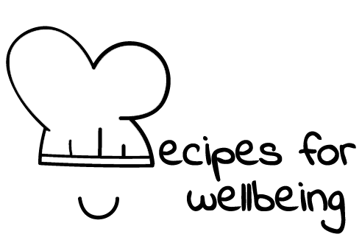
WHOLEBEING FOR EDUCATORS · LESSON PLAN
Rest without having to earn it
The skill of non-performing · rest · one class period · ages 13 to 18
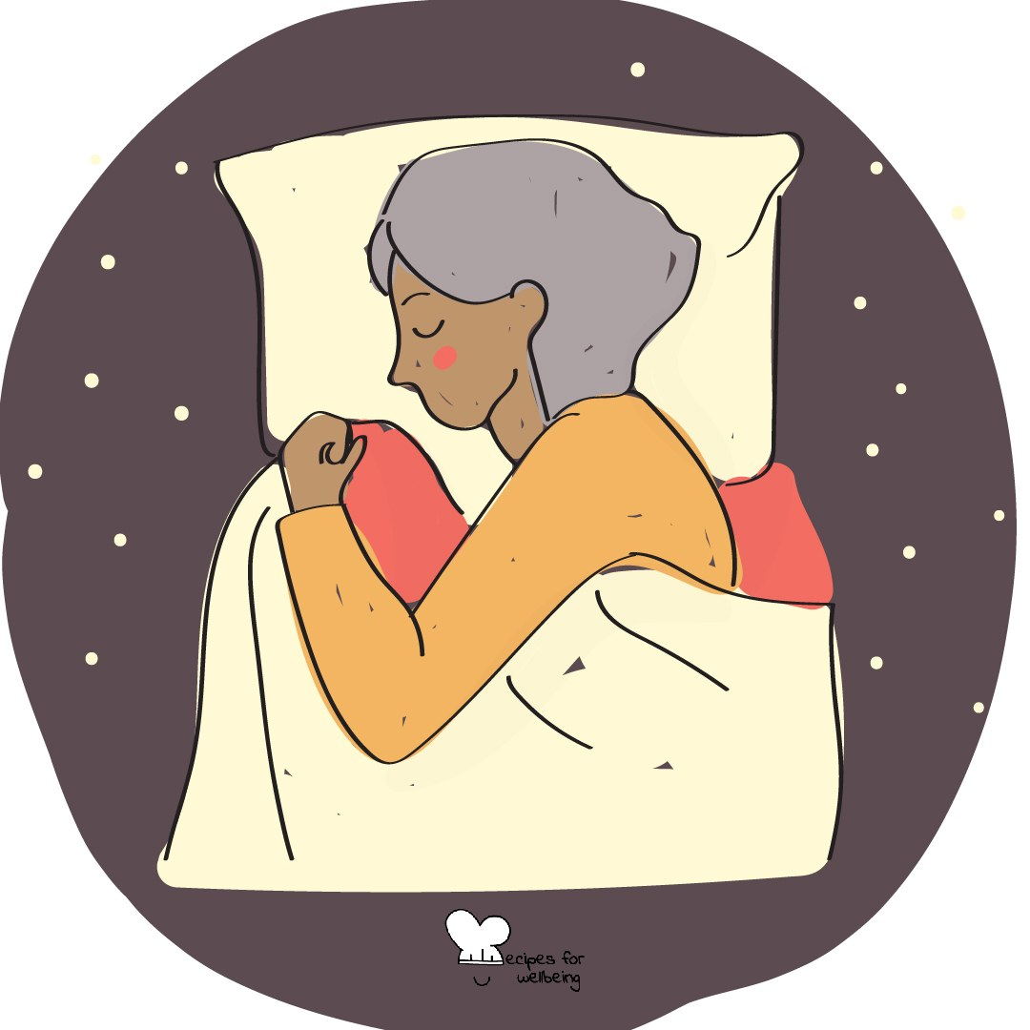
Learning intention
By the end of this lesson, students can describe non-performing and identify a small form of rest that does not need to justify itself through productivity.

The big idea
School, work and online life can make worth feel tied to output, responsiveness and achievement. Non-performing reminds us that a person remains worthy when nothing is being produced or improved. Rest is a foundation of life. It does not have to earn its place by sending us back to work with more energy.
Opener (5 min): The do-nothing minute
Use The do-nothing minute without directing students' bodies to relax. They may move, doodle, look outside or sit quietly, and nothing will be collected afterwards.
Explore (10 min)
Non-performing means stepping out of the demand to demonstrate value for a while. It is not the same as avoiding every responsibility, and it does not deny that work can carry meaning. It asks whether there is room to exist beyond what we complete, earn or show.
Rest can be sleep, quiet, movement, play, company, solitude or doing something with no measurable result. People have unequal access to time, space and safety for rest, so this cannot become another individual instruction offered in place of changing unreasonable demands.
Discuss
- Where does pressure to stay useful or responsive come from?
- Why can doing nothing feel uncomfortable or guilty?
- What would a school that treated rest as foundational do differently?
Activity (15 min): A menu with no useful outcome
Materials: paper and pens · Grouping: groups of four
- Ask each group to create a menu of small, safe and enjoyable activities that do not need to achieve or improve anything.
- Offer examples such as watching clouds, doodling without a plan, listening to one song or feeling sunlight on the face.
- Include options for different bodies, sensory needs, living situations, budgets and levels of available time.
- Ask which items may be difficult to allow without guilt and where that guilt may have been learned.
- Name the difference between a personal pause and the structural need for humane workloads, breaks and access to rest.
- Gather one idea from each group, then let students privately choose one, reject the menu or add their own.
Reflect (7 min)
Where do people your age meet pressure to be productive, and what is one form of rest that could be allowed to matter without becoming useful?
How: private journal
Close (3 min)
Nothing in the opening minute needed to be earned. Your value did not rise or fall with what you produced, and rest does not need to repay the time it takes.
In other settings
Form or tutor time (advisory / homeroom): Use the do-nothing minute and build a short menu of rest that does not need to improve performance.
Assembly or large-group gathering: Offer the minute from the front with several ways to take part, then name rest as a shared condition as well as a personal practice.
Youth club or small group: Take the minute, make a playful menu together and talk about what helps rest feel possible without asking anyone to disclose home circumstances.
Adapting for age
13 to 15: Keep the menu playful and concrete, and explain non-performing as time in which no one has to show how well they are doing.
16 to 18: Discuss exam pressure, paid work, hustle culture and the unequal distribution of rest. Keep personal circumstances private.
Curriculum links
IB · Approaches to Learning: Self-management: affective skills (emotional management, self-motivation)
OECD Learning Compass 2030: Core foundations — health foundations (mental well-being); Attitudes and values
UNESCO MGIEP · SEL (EMC framework): Mindfulness (attention regulation)
WHO · Life skills education: Coping with stress — recognising sources of pressure and making room to rest
EU · LifeComp: P3 Wellbeing — care of physical and mental health, a sustainable lifestyle (P3.3); P1 Self-regulation — stress responses (P1.2)
UNICEF MENA · Life Skills & Citizenship Education: Critical thinking — questioning norms that tie worth to productivity; Self-management — managing stress, including rest
Australia · Personal & Social Capability: Self-awareness: personal awareness; emotional awareness
Brazil · BNCC general competences: Self-knowledge and self-care (GC 8) — appreciating oneself and caring for physical and emotional health
Canada · British Columbia: Personal Awareness and Responsibility — well-being; Positive Personal and Cultural Identity — a healthy sense of oneself
Canada · Ontario: Personal skills — recognizing stress and its causes (1.1); coping skills (1.2) · Gr 7–8: A1.5 (caring for oneself, sense of mattering)
Chile · Orientación: Wellbeing and self-care — appropriate rest (OA 4, 7°–8°); Personal growth — each person as unique, original and valuable
England · DfE RSHE (statutory): Mental wellbeing: sleep (statement 2); which activities contribute to wellbeing (statement 6)
England · PSHE Association: Health and Wellbeing: balance between school, leisure and online time, and sleep (KS3 H2, H13, H15)
Finland · Transversal competences: L3 Taking care of oneself and managing daily life — sleep, rest and a balanced daily rhythm
Ghana · NaCCA core competencies (JHS): Personal Development and Leadership — health; building and renewing self-esteem
Hong Kong · Values Education Curriculum Framework (2026): Health education (健康生活教育) — leisure good for body, mind and spirit (身心靈, S1–S3); psychological well-being
India · NEP 2020: Mental health (NEP 4.28)
Indonesia · 8 dimensi profil lulusan: Health (kesehatan) — mental health and healthy living patterns
Ireland · Junior Cycle Wellbeing: Responsible — taking action to protect my wellbeing; Aware — making sense of feelings such as guilt about resting
Japan · Courses of Study (lower secondary): Special activities — healthy, safe attitudes and habits for mind and body (心身ともに健康で安全な生活態度や習慣)
Kenya · CBC core competencies & values: Self-efficacy — self-esteem and personal well-being
Mexico · Nueva Escuela Mexicana: Axis: Healthy living — living with manageable levels of stress; Ways of being, thinking, acting and relating — personal well-being
New Zealand · Health and Physical Education: Personal health and physical development — patterns of work, relaxation and recreation; Hauora: taha tinana and taha hinengaro
Scotland · Health and wellbeing (CfE): Mental and emotional wellbeing — understanding the importance of mental wellbeing (HWB 3-06a)
Singapore · Character & Citizenship Education: SEC: self-management; CCE Curriculum Content Area: Mental Health
South Africa · CAPS Life Orientation: Physical Education — recreational and relaxation activity (Gr 11); Development of the self in society — balanced lifestyle (Gr 11)
US · CASEL competencies: self-awareness, self-management
A guide, not a claim of full coverage. Check against your own scheme of work.
Holding the room
Do not interpret fidgeting or tiredness in public. Keep reflection general and private, and remember that home may not be a safe or restful place. Follow pastoral and safeguarding procedures if a student signals exhaustion, neglect or unsafe demands.
Recipes for Wellbeing · CC BY-NC 4.0 · free for classroom use · deep dive: https://recipesforwellbeing.substack.com/p/the-skill-of-non-performing

