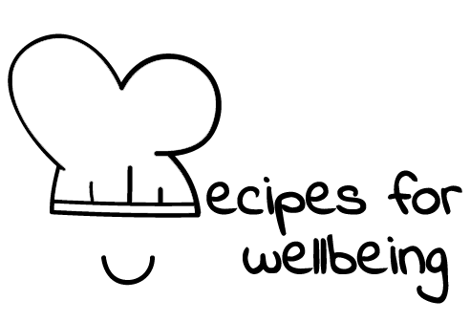
WHOLEBEING FOR EDUCATORS · LESSON PLAN
Belonging to the living world
The skill of nature kinship · bioempathy · one class period · ages 13 to 18
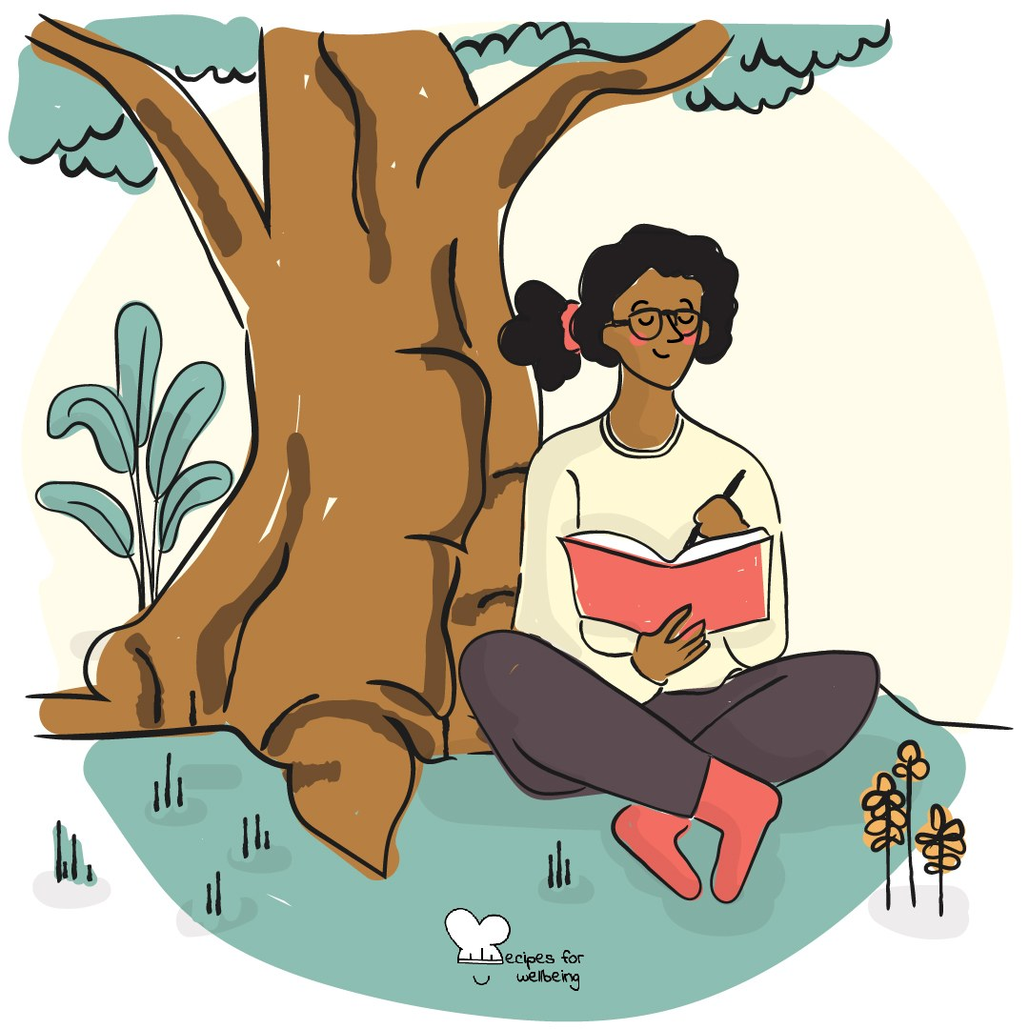
Learning intention
By the end of this lesson, students can observe one living thing closely and describe a way its life is connected with their own.

The big idea
The living world continues within and around busy school days, even when our attention is elsewhere. Noticing one living thing can remind us that human life depends on wider relationships with air, water, soil, plants and other species. Connection does not require access to a dramatic landscape; it can begin with what is already nearby.
Opener (5 min): One sign of spring
Use One sign of spring as seasonal noticing, adapting the season and local signs to where the class is. Students can use memory, the view outside or a picture.
Explore (10 min)
Nature sensitivity means recognising the living world as a relationship rather than scenery. We are not separate observers: our food, breath, water, shelter and climate are held within wider living systems.
This does not require romanticising nature. The living world includes competition, decay, danger and change as well as beauty and care. Closer attention can deepen connection while leaving room for grief, fear, responsibility and the unequal access people have to healthy environments.
Discuss
- Where does the living world appear in an ordinary day, including in cities and indoors?
- What changes when people speak of belonging to nature instead of visiting it?
- Who has access to clean, safe and biodiverse spaces, and who is responsible for that access?
Activity (18 min): Meet one living thing
Materials: a living thing to observe, a view, or photo cards; paper and pens · Grouping: groups of three or four
- Give each group one nearby or pictured living thing, such as a tree, bird, insect, moss or classroom plant.
- Spend two quiet minutes observing colour, shape, movement, surroundings and change. Separate what can be observed from what is imagined.
- Create a short profile of what the organism may need, what relationships sustain it and what it contributes to its surroundings.
- Trace one connection between its life and human life, avoiding claims the group cannot support.
- As a creative option, write one or two lines the living thing might say to the school or city, clearly naming this as imagination.
- Share one observation or connection from each group and collect questions that remain.
Reflect (5 min)
What is one small and possible way to remain in contact with the living world during a busy day, and what conditions would make that easier?
How: private journal
Close (2 min)
The living world does not begin at the edge of a city or a school. It is already part of the air, water, food and relationships that hold this day.
In other settings
Form or tutor time (advisory / homeroom): Notice one living thing from a window or image and name one observable connection to the school day.
Assembly or large-group gathering: Lead seasonal noticing from the front and show one local species through several relationships rather than as an isolated object.
Youth club or small group: Go outside or sit near a window if accessible, observe together and let the questions guide a gentle conversation.
Adapting for age
13 to 15: Use clear photographs or a direct view, welcome drawing and keep observation separate from imaginative Tree talk.
16 to 18: Explore reciprocity, environmental justice and eco-emotions through a local species or place, without requiring personal disclosure.
Curriculum links
IB · Approaches to Learning: Self-management: affective skills (mindfulness awareness)
UNESCO MGIEP · SEL (EMC framework): Mindfulness (attention regulation)
WHO · Life skills education: Critical thinking — separating what is observed from what is imagined; Creative thinking — imagining another perspective
EU · LifeComp: P3 Wellbeing — environmental factors in wellbeing (P3.1); a sustainable lifestyle that respects the environment (P3.3)
Australia · Personal & Social Capability: Social awareness: community awareness
Brazil · BNCC general competences: Responsibility and citizenship (GC 10) — sustainable decisions; Argumentation (GC 7) — socio-environmental awareness, care for the planet
Canada · British Columbia: Social Awareness and Responsibility — connections between people and the natural environment; caring for the environment
Canada · Ontario: Interpersonal skills — showing respect for others and the environment (1.4); Critical and creative thinking — making connections (1.5)
England · DfE RSHE (statutory): Mental wellbeing: time outdoors (statement 2)
Finland · Transversal competences: L7 Participation, involvement and building a sustainable future — how one's choices matter for nature; L1 — making observations
Hong Kong · Values Education Curriculum Framework (2026): Education for sustainable development (可持續發展教育) — caring about environmental issues (S4–S6); Life education (生命教育)
India · NEP 2020: Environmental awareness (NEP 4.23); Respect for the environment (NEP 4.28)
Indonesia · 8 dimensi profil lulusan: Citizenship (kewargaan) — sustaining life and the environment; Health (kesehatan) — environmental health
Ireland · Junior Cycle Wellbeing: Connected — to the wider world; how my actions affect wellbeing in local and global contexts
Japan · Courses of Study (lower secondary): Moral education D — love and care for nature (自然愛護); preciousness of life (生命の尊さ)
Kenya · CBC core competencies & values: Values — being stewards of the earth; Citizenship — a web of connections and interdependencies
Mexico · Nueva Escuela Mexicana: Axis: Healthy living — the web of relations between the environment and community life
New Zealand · Health and Physical Education: Healthy communities and environments — people and the environment (interdependence); Hauora: taha wairua
Singapore · Character & Citizenship Education: Building Connections: care for nature and animal welfare; environmental issues and sustainability
South Africa · CAPS Life Orientation: Health, social and environmental responsibility — being kinder to Earth (Gr 8); Social and environmental responsibility — environmental justice (Gr 11)
US · CASEL competencies: self-awareness, social awareness
A guide, not a claim of full coverage. Check against your own scheme of work.
Holding the room
Nature and climate discussion can bring grief, fear or experiences of unsafe environments. Do not require calm, hope or personal testimony. Receive concern without pressing for detail and follow usual pastoral or safeguarding routes when needed.
Recipes for Wellbeing · CC BY-NC 4.0 · free for classroom use · deep dive: https://recipesforwellbeing.substack.com/p/the-skill-of-nature-kinship

