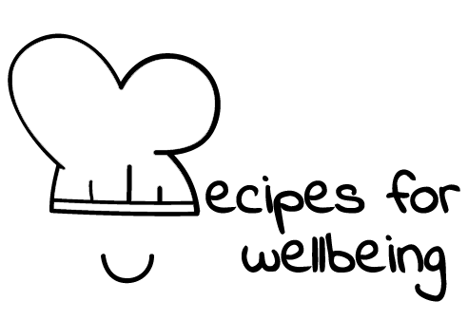
WHOLEBEING FOR EDUCATORS · LESSON PLAN
What it means to be heard
The skill of hosting conversations · community · one class period · ages 13 to 18
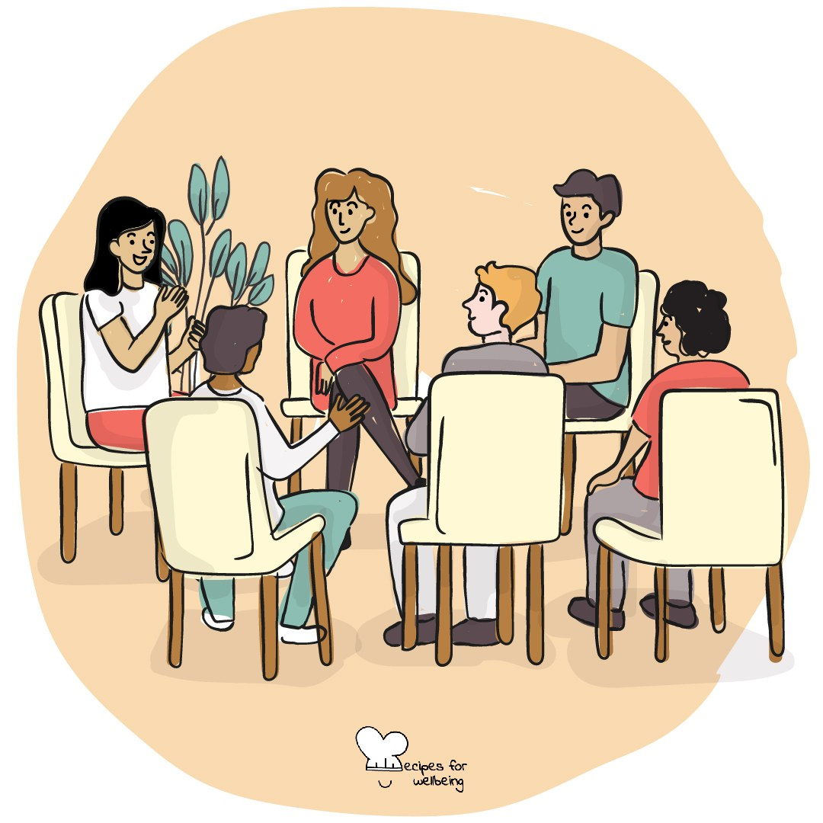
Learning intention
By the end of this lesson, students can listen for a sustained turn, reflect back what they heard and identify something that pulls attention away.

The big idea
Many conversations happen beside notifications, tiredness and the pressure to prepare a reply. Listening well means giving enough attention to understand what another person is trying to say. It will not settle every disagreement. It can make a conversation more accurate and more human.
Opener (5 min): One word for the road
Use One word for the road to practise receiving without replying. Offer your own word first, and let pass remain a full response.
Explore (10 min)
Listening means following what someone means, and coming back honestly when our attention wanders. We do not pretend we heard what we missed.
Reflecting back can help us check our understanding. It is a brief account of what the speaker chose to say. It does not guess at hidden feelings. A useful listener can also ask whether the person wants a question, a response or simply to be heard.
Discuss
- What do people do that shows they are listening, and which signs may vary between people or cultures?
- What commonly pulls attention away from a conversation?
- How can someone repair a moment when they realise they stopped listening?
Activity (18 min): An uninterrupted 90 seconds
Materials: an optional topic menu and a timer · Grouping: pairs
- Arrange pairs and offer light topics, such as a film to recommend, an ideal Saturday or something ordinary to look forward to. Students may choose another safe topic or pass.
- Partner A speaks for up to 90 seconds while Partner B listens without interrupting, advising or moving the conversation to their own experience.
- Partner B reflects one sentence beginning, "What I heard was..." or "What seemed important in what you said was..."
- The speaker can correct the reflection, and the listener may ask one open question if it is welcome.
- Swap roles and repeat.
- Discuss the process rather than the content: what supported attention, when did it wander and how did the listener return?
Reflect (5 min)
What tends to pull your attention away in a conversation, and what could help you return honestly when you notice it happening?
How: private journal
Close (2 min)
Full attention will not be possible in every moment. Listening is the practice of coming back, and letting the other person finish their own thought.
In other settings
Form or tutor time (advisory / homeroom): Use the one-word opener, then run one 60-second listening round with a reflect-back.
Assembly or large-group gathering: Describe attentive listening and invite students to think privately of the varied ways a trusted listener shows attention.
Youth club or small group: Use longer paired rounds and discuss how the group wants to handle interruption, silence and repair.
Adapting for age
13 to 15: Use 45- to 60-second turns, keep the topic menu and reflection stems visible, and model one complete round.
16 to 18: Use the full 90 seconds and explore listening during disagreement, including when reflection does not mean agreement.
Curriculum links
IB · Approaches to Learning: Social: collaboration skills (listening actively to other perspectives); Communication: communication skills
OECD Learning Compass 2030: Skills: social and emotional skills (empathy, collaboration)
UNESCO MGIEP · SEL (EMC framework): Empathy; Mindfulness (attention regulation)
WHO · Life skills education: Effective communication — listening and reflecting back what was said; Interpersonal relationship skills
EU · LifeComp: S2 Communication — listening and engaging in conversations with reciprocity (S2.3); S1 Empathy — another's perspective (S1.2)
UNICEF MENA · Life Skills & Citizenship Education: Communication — listening and reflecting back shared meaning; Empathy
Australia · Personal & Social Capability: Social awareness — empathy; Social management — communication
Brazil · BNCC general competences: Communication (GC 4) — producing meanings that lead to mutual understanding; Empathy and cooperation (GC 9) — dialogue
Canada · British Columbia: Communicating — connecting and engaging with others; focusing on intent and purpose
Canada · Ontario: Interpersonal skills — active listening: paraphrasing, clarifying, questioning, responding (1.3) · Gr 7–8: A1.4 (listening)
Chile · Orientación: Interpersonal relationships — dialogue and empathic listening (OA 6, 7°–8°)
England · DfE RSHE (statutory): Respectful relationships: communicating respectfully (statement 5)
England · PSHE Association: Relationships: forming and maintaining respectful relationships, active listening and clear communication (KS3 R16)
Finland · Transversal competences: L1 Thinking and learning to learn — listening to oneself and others; L2 Cultural competence, interaction and self-expression — dialogue
Ghana · NaCCA core competencies (JHS): Communication and Collaboration — listening to and learning from others
Hong Kong · Values Education Curriculum Framework (2026): Respect for Others (尊重他人) — respectful discussion, harmony in difference (和而不同, S4–S6); Empathy (同理心)
India · NEP 2020: Oral and written communication (NEP 4.23); Socio-emotional learning (NEP 5.14)
Indonesia · 8 dimensi profil lulusan: Communication (komunikasi) — listening (menyimak) well and ethically in different contexts
Ireland · Junior Cycle Wellbeing: Respected — being listened to and valued; positive relationships with friends, peers and teachers
Japan · Courses of Study (lower secondary): Moral education B — mutual understanding: conveying and respecting views (相互理解，寛容); courtesy (礼儀)
Kenya · CBC core competencies & values: Communication and Collaboration — interacting well: accuracy, clarity, comprehensibility
Mexico · Nueva Escuela Mexicana: Ways of being, thinking, acting and relating — promoting mutual understanding
New Zealand · Health and Physical Education: Relationships with other people — interpersonal skills; KAL mental health — listening to the ideas and feelings of others
Scotland · Health and wellbeing (CfE): Relationships — responding appropriately to verbal and non-verbal communication (HWB 3-45b); sustaining relationships (HWB 3-44b)
Singapore · Character & Citizenship Education: SEC: social awareness and relationship management
South Africa · CAPS Life Orientation: Development of the self in society — communication: understanding others (Gr 12); Study skills — listening and concentration (Gr 10)
US · CASEL competencies: relationship skills, social awareness
A guide, not a claim of full coverage. Check against your own scheme of work.
Holding the room
Use light, self-chosen topics and make passing available. Listeners must not probe, interpret trauma or promise confidentiality. If a disclosure raises concern, pause the activity and follow usual safeguarding procedures privately.
Recipes for Wellbeing · CC BY-NC 4.0 · free for classroom use · deep dive: https://recipesforwellbeing.substack.com/p/the-skill-of-hosting-conversations

