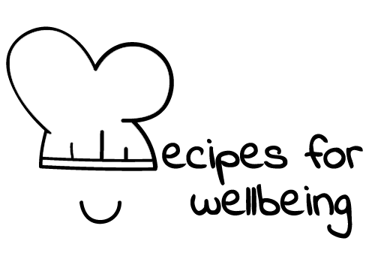
WHOLEBEING FOR EDUCATORS · LESSON PLAN
A small thing that helps
The skill of compassion · radical care · one class period · ages 13 to 18
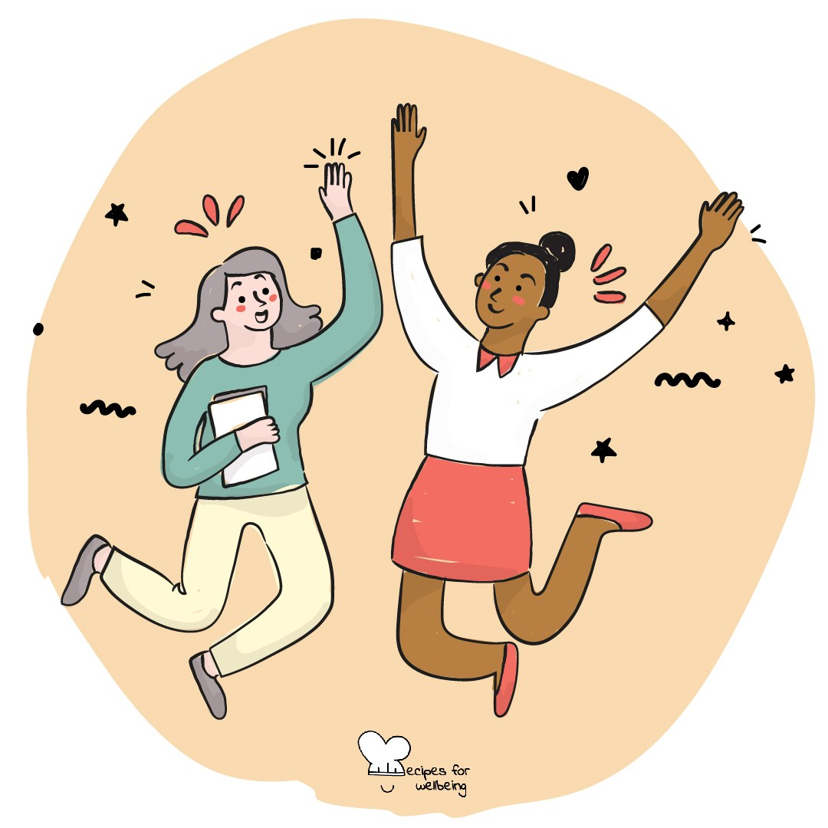
Learning intention
By the end of this lesson, students can describe everyday kindness and suggest a response that may bring some relief without trying to fix everything.

The big idea
We rarely know everything another person is carrying. Kindness is an ordinary response that says their experience matters, whether through attention, practical help or a respectful gesture. It can be offered to ourselves too, especially when the usual inner response is harsh.
Opener (5 min): One breath for you, one for them
Use One breath for you, one for them as a quiet practice. Students may breathe normally, keep both wishes for themselves or simply listen.
Explore (10 min)
Kindness can be simple: noticing someone, including them, checking what they need or making one part of the day easier. It does not place one person above another or assume we know what is best.
A kind intention still needs consent and judgement. Sometimes help is welcome; sometimes a person wants company, space or support from someone with more responsibility. We can ask rather than guess, and we can care without taking on a role that is not safe for us.
Discuss
- What small actions can make an ordinary day easier for another person?
- Why might someone hold back from offering or receiving kindness?
- How can we find out whether a person wants listening, practical help or space?
Activity (18 min): What might help?
Materials: fictional scenario slips, paper and pens · Grouping: groups of three or four
- Give each group several fictional situations, such as a student receiving a disappointing result, sitting alone, regretting an argument or arriving after a difficult morning.
- For each situation, list responses that may minimise, embarrass or take over, and explain why they may not help.
- Write one respectful question that could help the character say what they need.
- Offer two possible responses: one small practical action and one way of staying alongside without fixing.
- Add a scenario in which the character speaks harshly to themselves. Students privately draft what they would say to a friend in the same position.
- Gather one response from each group and notice how the most useful ideas leave room for the other person's choice.
Reflect (6 min)
Think of one small kindness you could offer to yourself or someone else in the next few days. What would make it caring, realistic and free of pressure?
How: private journal
Close (3 min)
We will not always know what another person is carrying, and we will not always be able to change it. We can still ask, and offer one small thing with care.
In other settings
Form or tutor time (advisory / homeroom): Use the breath practice, then work through one fictional situation by asking what may help and what may not.
Assembly or large-group gathering: Lead the private wishes and model a kind response that begins with a question rather than an assumption.
Youth club or small group: Explore two scenarios together and make room for different helpful responses, including listening, space and adult support.
Adapting for age
13 to 15: Use concrete school-based scenarios and model a question and response before groups begin. Keep the share-back brief.
16 to 18: Use layered scenarios involving withdrawal, exam pressure and support that is refused. Explore the line between care, responsibility and a boundary.
Curriculum links
IB · Approaches to Learning: Social: collaboration skills (practising empathy)
OECD Learning Compass 2030: Skills: social and emotional skills (empathy); Transformative competencies: taking responsibility
UNESCO MGIEP · SEL (EMC framework): Compassion (small, everyday prosocial acts); Empathy
WHO · Life skills education: Empathy — encouraging caring behaviour towards others; Interpersonal relationship skills — relating in positive ways
EU · LifeComp: S1 Empathy — understanding what another person is experiencing (S1.2); S3 Collaboration — respect for human dignity (S3.2)
UNICEF MENA · Life Skills & Citizenship Education: Empathy — responding to what another may need; Communication — asking what would help
Australia · Personal & Social Capability: Social awareness: empathy; relational awareness
Brazil · BNCC general competences: Empathy and cooperation (GC 9) — promoting respect for others; Self-knowledge and self-care (GC 8) — caring for oneself
Canada · British Columbia: Social Awareness and Responsibility — building relationships; contributing to community (acting for others' benefit)
Canada · Ontario: Interpersonal skills — relationship and social skills, showing respect for others (1.4) · Gr 7–8: A1.4 (kindness and empathy)
Chile · Orientación: Interpersonal relationships — relationships based on dignity (OA 5); Wellbeing and self-care — help from significant people (OA 3)
England · DfE RSHE (statutory): Respectful relationships: kindness in positive relationships, treating others with kindness and respect (statements 1, 2)
England · PSHE Association: Relationships: forming and maintaining respectful relationships (KS3 R14)
Finland · Transversal competences: L2 Cultural competence, interaction and self-expression — meeting others with appreciation; L3 — practising social skills
Ghana · NaCCA core competencies (JHS): Personal Development and Leadership — empathy, meeting other people's needs
Hong Kong · Values Education Curriculum Framework (2026): Benevolence (仁愛) — sincerity, care, respect and courtesy in relationships (S1–S3)
India · NEP 2020: Values including helpfulness, courtesy, empathy and compassion (NEP 4.28)
Indonesia · 8 dimensi profil lulusan: Collaboration (kolaborasi) — the habit of caring and sharing (peduli dan berbagi)
Ireland · Junior Cycle Wellbeing: Respected — showing care and respect for others; Connected — how my actions affect others' wellbeing
Japan · Courses of Study (lower secondary): Moral education B — consideration for others (思いやり); Special activities — building better relationships
Kenya · CBC core competencies & values: Core value — love; Self-efficacy — interpersonal skills: empathy, effective communication
Mexico · Nueva Escuela Mexicana: Feelings and their influence on decision-making — managing affect to build inclusive, equitable relationships
New Zealand · Health and Physical Education: Relationships with other people — relationships; Hauora: taha whānau (compassion and caring)
Scotland · Health and wellbeing (CfE): Mental and emotional wellbeing — caring and showing respect for myself and others (HWB 3-05a); appropriate support (HWB 3-08a)
Singapore · Character & Citizenship Education: SEC: social awareness; CCE Curriculum Content Area: Mental Health
South Africa · CAPS Life Orientation: Health, social and environmental responsibility — volunteerism: helping others (Gr 9); Development of the self in society — respect for others (Gr 7)
US · CASEL competencies: social awareness, relationship skills, self-awareness
A guide, not a claim of full coverage. Check against your own scheme of work.
Holding the room
Keep all scenarios fictional and the self-directed writing private. Redirect discussion that names classmates. Make clear that students should involve a trusted adult when someone may be unsafe, and follow the setting's safeguarding procedures if a concern arises.
Recipes for Wellbeing · CC BY-NC 4.0 · free for classroom use · deep dive: https://recipesforwellbeing.substack.com/p/the-skill-of-compassion

