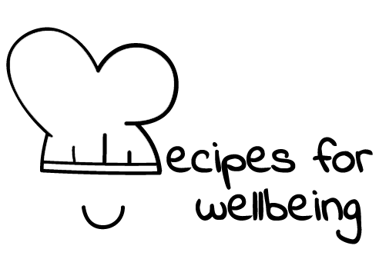
WHOLEBEING FOR EDUCATORS · LESSON PLAN
Making room for what brings you alive
The skill of zest · positive emotion · one class period · ages 13 to 18
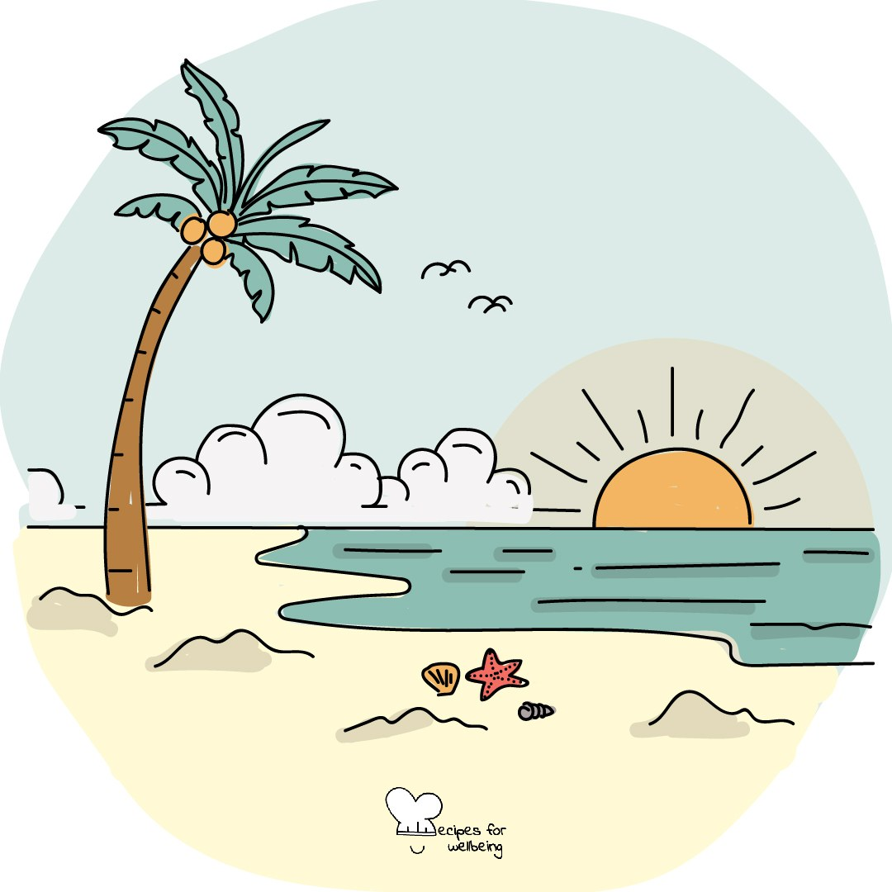
Learning intention
By the end of this lesson, students can identify ordinary sources of enjoyment or aliveness and describe a realistic way to make room for one of them.

The big idea
Joy can become something we postpone until the work is finished or life feels easier. This lesson treats it as part of a whole life rather than a reward for coping well. Joy does not cancel grief, stress or injustice, and no one is required to find it on demand.
Opener (5 min): Hardwiring the good
Use Hardwiring the good to give one pleasant or neutral moment a little more attention. Students may use a real memory, an imagined safe place or simple awareness of the room.
Explore (10 min)
Joy may arrive as excitement, absorption, warmth, play, beauty or a quiet sense of being alive. It is personal, and it may be faint or absent on a difficult day.
Making room for joy leaves room for what hurts too. We allow a whole range of experience, including moments that nourish us. Access is not equal, so the practice should not become another task or a claim that everyone can simply choose to feel better.
Discuss
- Why is enjoyment often treated as something to earn after the work is done?
- What kinds of ordinary experiences bring people your age a sense of aliveness?
- How can a group make room for joy without demanding a cheerful mood?
Activity (15 min): A menu of sparks
Materials: paper and pens · Grouping: individual, with optional pairs
- Explain that each student will make a private menu of small experiences that bring enjoyment, interest, comfort or energy. The page is not collected.
- Offer three headings: quick sparks that take two minutes or less, larger sparks that need more time, and sparks that cost no money.
- Add optional prompts involving beauty, trying something new, movement, rest, creativity, nature or time with people who feel safe.
- In pairs, students may offer one idea they are happy for someone else to borrow. Passing needs no explanation.
- Gather anonymous ideas on the board to create a shared menu without attaching names.
- Students privately mark one idea they would like to make room for, or note what currently makes joy difficult to reach.
Reflect (7 min)
Complete privately: "One spark I would like to make a little more room for is..." Then notice what may support or crowd out that possibility.
How: private journal
Close (3 min)
Joy does not have to wait until everything is resolved. When it is available, we can let an ordinary moment matter without asking it to carry the whole day.
In other settings
Form or tutor time (advisory / homeroom): Use Hardwiring the good, then invite a private list under the three headings and one optional choice to revisit.
Assembly or large-group gathering: Lead the short memory practice and offer a broad menu of possible sparks without asking for responses.
Youth club or small group: Talk gently about what helps people feel interested or alive, with the option to make a shared menu or simply listen.
Adapting for age
13 to 15: Model several concrete sparks and let students draw or use single words. Keep the pace light and the sharing optional.
16 to 18: Name the tendency to postpone enjoyment until after exams or results. Explore sources of aliveness that remain possible during busy periods without presenting them as tools for greater productivity.
Curriculum links
IB · Approaches to Learning: Self-management: affective skills (self-motivation)
OECD Learning Compass 2030: Core foundations: health foundations (mental well-being)
UNESCO MGIEP · SEL (EMC framework): Mindfulness (savouring positive moments)
WHO · Life skills education: Self-awareness — recognising one's desires and dislikes, including what brings enjoyment
EU · LifeComp: P3 Wellbeing — pursuit of life satisfaction, care of mental health; P1 Self-regulation — nurturing optimism (P1.3)
Australia · Personal & Social Capability: Self-awareness: emotional awareness
Brazil · BNCC general competences: Self-knowledge and self-care (GC 8) — caring for emotional health; Cultural repertoire (GC 3) — enjoying arts and culture
Canada · British Columbia: Personal Awareness and Responsibility — well-being (factors in holistic wellness); Positive Personal and Cultural Identity
Canada · Ontario: Personal skills — self-awareness: knowing one's likes and dislikes (1.1) · Gr 7–8: A1.5 (caring for oneself)
Chile · Orientación: Wellbeing and self-care — positive use of leisure time (OA 4, 1°–2° medio)
England · DfE RSHE (statutory): Mental wellbeing: which activities contribute to wellbeing (statement 6); happiness and connection (statement 3)
England · PSHE Association: Health and Wellbeing: mental health and emotional wellbeing (KS3 H10, KS4 H7)
Finland · Transversal competences: L3 Taking care of oneself and managing daily life — ways of acting that promote wellbeing; L2 — creative activity, enjoying aesthetics
Ghana · NaCCA core competencies (JHS): Personal Development and Leadership — health; identifying and developing talents
Hong Kong · Values Education Curriculum Framework (2026): Life education (生命教育) — loving life (熱愛生命, S1–S3)
India · NEP 2020: Mental health (NEP 4.28)
Indonesia · 8 dimensi profil lulusan: Health (kesehatan) — physical and mental health; fitness (kebugaran)
Ireland · Junior Cycle Wellbeing: Responsible — taking action to promote my own wellbeing; Aware — noticing my feelings
Japan · Courses of Study (lower secondary): Moral education D — being moved by beauty (感動); joy of living well (よりよく生きる喜び)
Kenya · CBC core competencies & values: Self-efficacy — personal well-being; intrinsic interest and deep engrossment in activities
Mexico · Nueva Escuela Mexicana: Ways of being, thinking, acting and relating — recognising tastes, interests and desires; Axis: Arts and aesthetic experiences
New Zealand · Health and Physical Education: Hauora: taha hinengaro and taha wairua; Personal health and physical development — making room for recreation
Scotland · Health and wellbeing (CfE): Mental and emotional wellbeing — fostering and strengthening mental wellbeing (HWB 3-06a)
Singapore · Character & Citizenship Education: SEC: self-awareness; CCE Curriculum Content Area: Mental Health
South Africa · CAPS Life Orientation: Development of the self in society — recreation and emotional health (Gr 10); healthy and balanced lifestyle (Gr 11)
US · CASEL competencies: self-awareness, self-management
A guide, not a claim of full coverage. Check against your own scheme of work.
Holding the room
Menus remain private and passing is always available. A student who cannot identify a spark should not be pressed or reassured publicly. Offer a quiet follow-up and use usual pastoral routes if loss of interest or low mood raises concern.
Recipes for Wellbeing · CC BY-NC 4.0 · free for classroom use · deep dive: https://recipesforwellbeing.substack.com/p/the-skill-of-zest

