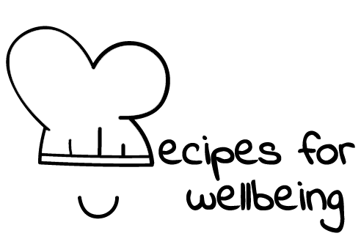
WHOLEBEING FOR EDUCATORS · LESSON PLAN
Looking beneath the first answer
The skill of sense-making · liberatory learning · one class period · ages 13 to 18
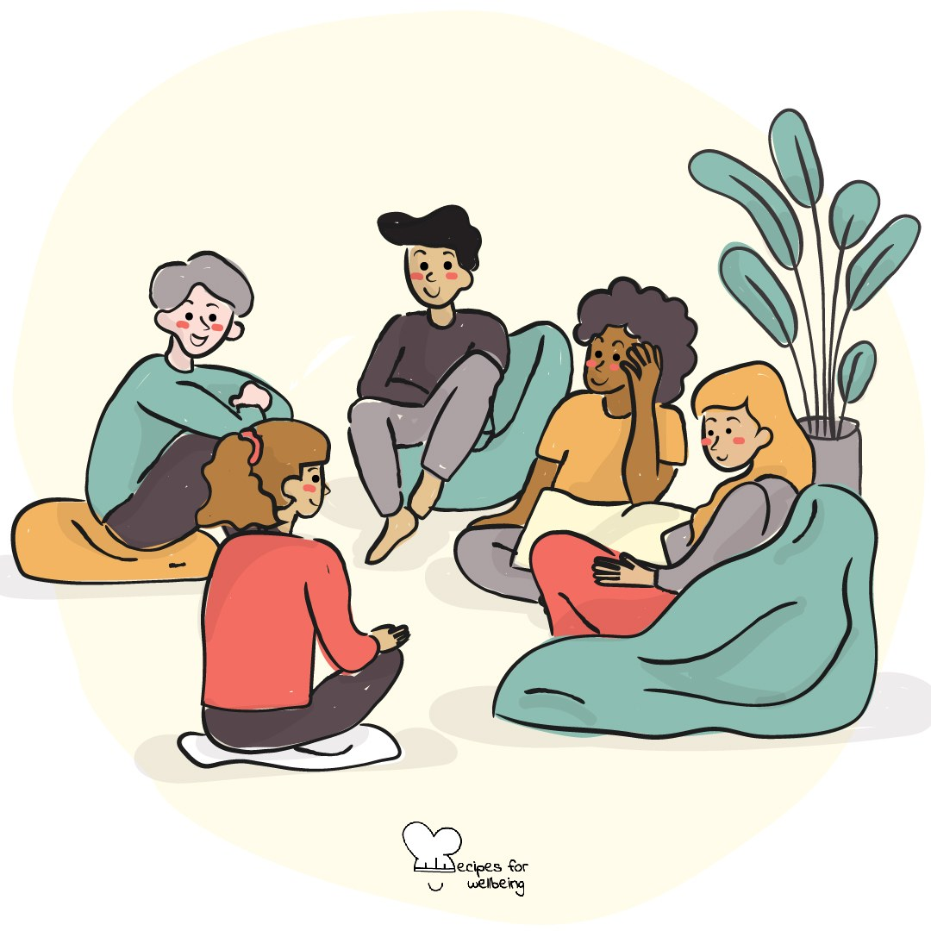
Learning intention
By the end of this lesson, students can generate deeper questions about a complex situation and distinguish a first explanation from a fuller understanding.

The big idea
The first explanation for a confusing event can feel convincing because it arrives quickly. Inquiry asks us to slow down, notice our assumptions and look from more than one position. This can help us understand people and situations more fairly, while accepting that some uncertainty may remain.
Opener (5 min): A question with no answer
Use A question with no answer as a low-stakes encounter with uncertainty. Students can keep their thoughts private or offer one unfinished sentence to a neighbour.
Explore (10 min)
Inquiry begins when we recognise that our first story may be incomplete. We ask what we know, how we know it, whose view is missing and what evidence could change our understanding.
Inquiry is careful attention to complexity. It never means endless doubt, or questioning another person's account of their own experience. A good question can reveal assumptions and root causes without promising that every situation has one hidden answer.
Discuss
- How can we tell a quick opinion from a developed understanding?
- Why are simple explanations attractive when a situation is complicated?
- When is more inquiry useful, and when is timely action needed?
Activity (17 min): The root-question tree
Materials: paper and pens; hypothetical scenarios on the board · Grouping: groups of four or five
- Give each group an external scenario, such as an unexpected school rule, a sudden online trend, a shop closing or two reports describing the same event differently.
- Write the first conclusion someone might reach, then set it aside as one possible interpretation.
- Generate as many genuine questions as possible for three minutes without answering them.
- Draw a tree and place factual surface questions on the leaves and questions about causes, power, assumptions or perspectives on the roots.
- Choose one root question and examine it from two positions within the scenario. Note what evidence each person might see or miss.
- Each group shares one question and one way its understanding changed or remained uncertain.
Reflect (6 min)
What question could help you look beneath the surface the next time something feels confusing? Keep the situation itself private.
How: private journal
Close (2 min)
Inquiry does not ask us to have every answer. It asks us to stay with the question long enough to see what our first explanation left out.
In other settings
Form or tutor time (advisory / homeroom): Use the opening question, then name a first conclusion and create a short root-question tree for one scenario.
Assembly or large-group gathering: Put one scenario on screen and sort audience questions into surface and root questions from the front.
Youth club or small group: Choose one everyday puzzle and collect questions together, noticing when a question changes the first story.
Adapting for age
13 to 15: Use familiar, concrete scenarios and model several surface and root questions. Welcome a wide range of questions, however plain they sound.
16 to 18: Use systemic or contested examples and ask what evidence would change each interpretation. Explore how power shapes which questions are treated as legitimate.
Curriculum links
IB · Approaches to Learning: Thinking: critical thinking skills (recognising assumptions and bias, considering multiple perspectives)
OECD Learning Compass 2030: Skills: cognitive and meta-cognitive skills (critical thinking, learning-to-learn); Student agency
UNESCO MGIEP · SEL (EMC framework): Critical Inquiry (moving from surface ideas to root causes)
WHO · Life skills education: Critical thinking — analysing information and experiences, recognising assumptions; Problem solving — looking for root causes
EU · LifeComp: L2 Critical thinking — awareness of bias, analysing to draw conclusions (L2.1–L2.2); P2 Flexibility — revising opinions (P2.1)
UNICEF MENA · Life Skills & Citizenship Education: Critical thinking — examining assumptions, norms and power structures; Problem-solving — looking beneath the first explanation
Australia · Personal & Social Capability: Social awareness: empathy (respecting perspectives); Social management: decision-making
Brazil · BNCC general competences: Scientific, critical and creative thinking (GC 2) — investigating causes, critical analysis; Argumentation (GC 7) — reliable facts
Canada · British Columbia: Critical and Reflective Thinking — questioning and investigating; analyzing and critiquing
Canada · Ontario: Critical and creative thinking — processing: interpreting, analysing and evaluating (1.5) · Gr 7–8: A1.6
England · PSHE Association: Living in the wider world: media literacy and digital resilience, a partial fit (KS3 L23, L26)
Finland · Transversal competences: L1 Thinking and learning to learn — examining issues critically from different perspectives; handling contradictory information
Ghana · NaCCA core competencies (JHS): Critical Thinking and Problem-Solving — analysing issues and situations; Cultural Identity and Global Citizenship — analysing trends
Hong Kong · Values Education Curriculum Framework (2026): Civic education (公民教育) — careful, discerning analysis of issues and the values in them (慎思明辨, S4–S6)
India · NEP 2020: Scientific temper and evidence-based thinking; Problem solving and logical reasoning (NEP 4.23); Learning how to learn (NEP 4.4)
Indonesia · 8 dimensi profil lulusan: Critical reasoning (penalaran kritis) — analysing complex problems from several viewpoints (berbagai sudut pandang)
Ireland · Junior Cycle Wellbeing: Aware — noticing my assumptions and thinking through my decisions
Japan · Courses of Study (lower secondary): Moral education A — pursuit of truth (真理の探究); B — many ways of seeing and thinking (相互理解，寛容)
Kenya · CBC core competencies & values: Critical Thinking and Problem Solving — exploring multiple perspectives; Citizenship — thinking critically about what is just
Mexico · Nueva Escuela Mexicana: Axis: Critical thinking — questioning first explanations and whose view is missing
Singapore · Character & Citizenship Education: SEC: responsible decision-making and self-awareness
South Africa · CAPS Life Orientation: Social and environmental responsibility — critical thinking for civic life (Gr 10); Democracy and human rights — sources of bias (Gr 10)
US · CASEL competencies: self-awareness, social awareness, responsible decision-making
A guide, not a claim of full coverage. Check against your own scheme of work.
Holding the room
Keep scenarios hypothetical and do not use sensitive current events without preparation and support. Never use inquiry to cast doubt on a student's disclosure. If personal material arises, pause the public discussion and follow safeguarding procedures.
Recipes for Wellbeing · CC BY-NC 4.0 · free for classroom use · deep dive: https://recipesforwellbeing.substack.com/p/the-skill-of-sense-making

