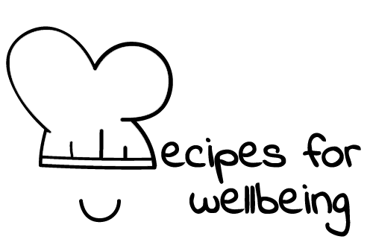
WHOLEBEING FOR EDUCATORS · LESSON PLAN
Noticing what is already here
The skill of celebration · positive emotion · one class period · ages 13 to 18
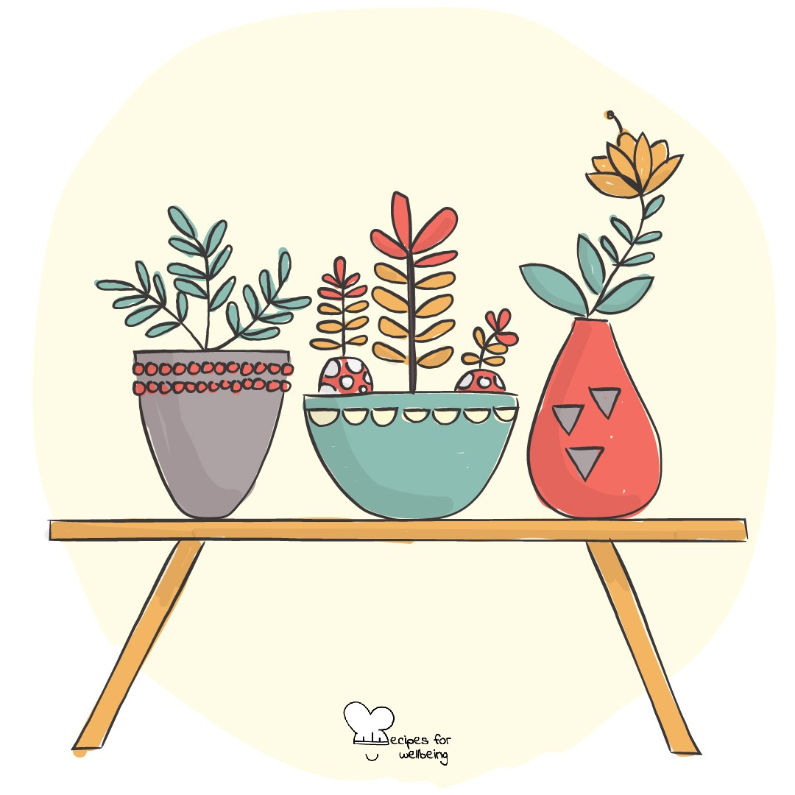
Learning intention
By the end of this lesson, students can notice small things they appreciate and explain how gratitude can sit beside difficult or unfinished experiences.

The big idea
Deadlines, comparison and worry can take up much of our attention, while ordinary sources of support pass without being named. Gratitude gives some attention to what is sustaining, welcome or good. It does not require anyone to feel positive, ignore injustice or be thankful for a difficult experience.
Opener (5 min): Three good things
Use Three good things as a gentle invitation. Students may choose ordinary examples, share one or keep all three private.
Explore (10 min)
Gratitude is a way of noticing what we value, receive or would miss. It may be directed towards a person, place, object, opportunity or moment, and it can be quiet.
Gratitude and discomfort can exist together. Appreciating one helpful part of a hard day does not make the whole day good, and noticing support does not remove the need to change unfair conditions. The practice widens the picture; it should not be used to close a difficult conversation.
Discuss
- Which ordinary forms of care or work often go unnoticed?
- What makes gratitude feel sincere rather than forced?
- When can asking for gratitude become unhelpful or unfair?
Activity (15 min): What often goes unthanked
Materials: two or three anonymous paper slips per student, pens and board space · Grouping: whole class
- Invite students to notice ordinary things that support a day. Make clear that a blank slip is acceptable.
- Offer prompts: something that made this week easier; an object or service you would miss; a role whose work often goes unseen; or a place that feels comfortable enough.
- Students write one response per slip without names or identifying details.
- Mix the slips on a shared board so authorship cannot be traced.
- Read a selection or offer a slow gallery walk, noticing both repeated and different forms of appreciation.
- Invite one final anonymous addition inspired by something another person noticed, without suggesting that the room should now feel a particular way.
Reflect (7 min)
Choose one small good you would like to notice for a little longer today or tomorrow. What do you appreciate about it, and what does it leave unchanged?
How: private journal
Close (3 min)
The things we named were already part of the day. Gratitude was the pause that allowed us to see them, while everything difficult and unfinished remained part of the picture too.
In other settings
Form or tutor time (advisory / homeroom): Use Three good things, then collect one anonymous slip from anyone who wants to contribute.
Assembly or large-group gathering: Invite three private examples and read several broad prompts from the front. No sharing is required.
Youth club or small group: Offer one small appreciation each or pass, then discuss what makes gratitude supportive and when it can feel forced.
Adapting for age
13 to 15: Use concrete prompts and sentence starters, and keep the wall anonymous. The question "Would you miss it if it disappeared?" can make appreciation easier to recognise.
16 to 18: Explore gratitude during exam pressure and comparison, including the difference between a private practice and pressure to be positive when something needs to change.
Curriculum links
IB · Approaches to Learning: Self-management: affective skills (self-motivation)
OECD Learning Compass 2030: Core foundations: health foundations (mental well-being)
UNESCO MGIEP · SEL (EMC framework): Mindfulness (noticing what is good now); Empathy (noticing others' unseen work)
WHO · Life skills education: Self-awareness — recognising what one values and would miss; Empathy — noticing the unseen work of others
EU · LifeComp: P1 Self-regulation — nurturing optimism and hope (P1.3); P3 Wellbeing — pursuit of life satisfaction
Australia · Personal & Social Capability: Self-awareness: emotional awareness; Social awareness: relational awareness
Brazil · BNCC general competences: Self-knowledge and self-care (GC 8) — appreciating oneself and caring for emotional health
Canada · British Columbia: Personal Awareness and Responsibility — well-being; Social Awareness and Responsibility — appreciating connections among people
Canada · Ontario: Personal skills — coping skills, adopting an optimistic attitude (1.2) · Gr 7–8: A1.3 (reflecting on and expressing gratitude)
Chile · Orientación: Wellbeing and self-care — everyday actions for wellbeing, personally and in the school community (OA 4)
England · DfE RSHE (statutory): Mental wellbeing: acts of kindness (statement 2); happiness is linked to being connected to others (statement 3)
England · PSHE Association: Health and Wellbeing: mental health and emotional wellbeing (KS3 H10, KS4 H7)
Finland · Transversal competences: L3 Taking care of oneself and managing daily life — recognising what supports one's own and shared wellbeing
Hong Kong · Values Education Curriculum Framework (2026): Life education (生命教育) — gratitude, treasuring what we have (常存感恩, S1–S3)
India · NEP 2020: Socio-emotional learning (NEP 5.14); Mental health (NEP 4.28)
Indonesia · 8 dimensi profil lulusan: Health (kesehatan) — mental health (kesehatan mental): noticing what supports the day
Ireland · Junior Cycle Wellbeing: Connected — to my school, friends and community; Aware — noticing my thoughts and feelings
Japan · Courses of Study (lower secondary): Moral education B — gratitude for the support of family and many others (思いやり，感謝)
Kenya · CBC core competencies & values: Values — appreciating the effort of others and seeing beyond self-interest
Mexico · Nueva Escuela Mexicana: Ways of being, thinking, acting and relating — everyday experiences and personal and social well-being
New Zealand · Health and Physical Education: Hauora: taha hinengaro (acknowledging thoughts and feelings) and taha whānau (social support)
Scotland · Health and wellbeing (CfE): Mental and emotional wellbeing — mental wellbeing fostered through coping skills and positive relationships (HWB 3-06a)
Singapore · Character & Citizenship Education: SEC: self-awareness and social awareness; CCE Curriculum Content Area: Mental Health
US · CASEL competencies: self-awareness, social awareness
A guide, not a claim of full coverage. Check against your own scheme of work.
Holding the room
Do not require gratitude for family, school, health or adversity. Keep responses anonymous and passing available. If writing indicates hardship or risk, follow it up privately through usual safeguarding procedures without identifying the author in front of others.
Recipes for Wellbeing · CC BY-NC 4.0 · free for classroom use · deep dive: https://recipesforwellbeing.substack.com/p/the-skill-of-celebration

