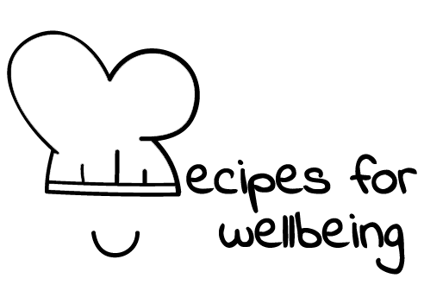
WHOLEBEING FOR EDUCATORS · LESSON PLAN
Staying with an ordinary hard moment
The skill of resilience · discomfortability · one class period · ages 13 to 18
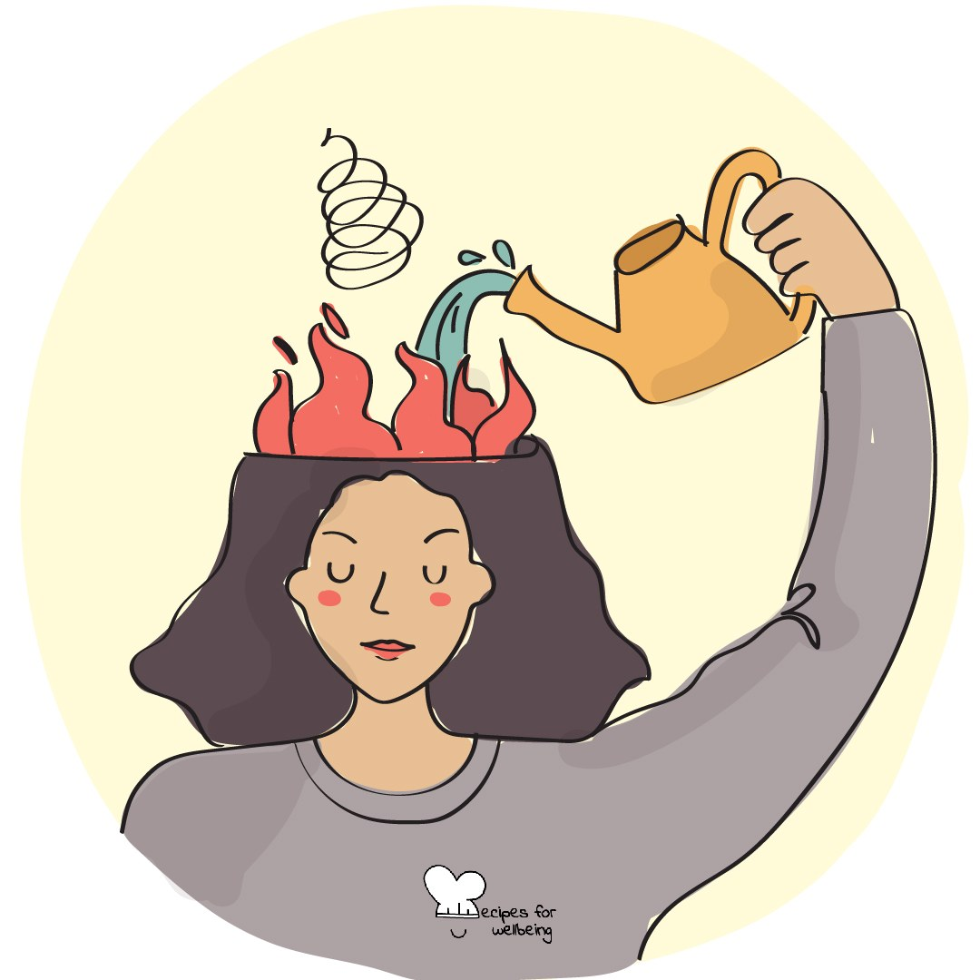
Learning intention
By the end of this lesson, students can describe an ordinary difficult feeling as something that can change over time and identify a safe way to stay present without making the moment worse.

The big idea
Nerves, embarrassment, restlessness and disappointment can create a strong wish to escape immediately. Distress tolerance is the ability to move through an ordinary hard moment without demanding that the feeling disappear first. It is not endurance of danger, abuse or overwhelming distress, and it includes asking for help or stepping away.
Opener (5 min): Befriending the wobble
Use Befriending the wobble only for everyday, low-intensity discomfort. Students may focus on a fictional situation, an external object or the room instead of their own body.
Explore (10 min)
Some feelings change in intensity over minutes or hours, although they do not follow one predictable wave or timetable. Distress tolerance means reducing the chance of making an ordinary hard moment more harmful while we wait, act or seek support.
The skill is not "put up with it." Safety comes first, and leaving, contacting someone, using a health plan or getting professional help may be the right response. Distraction can also be a wise short-term choice; the question is whether it helps the person move through the moment safely or keeps a larger problem hidden and unsupported.
Discuss
- What do people commonly do when they want an uncomfortable feeling to stop at once?
- How can someone distinguish a manageable hard moment from one that needs immediate help?
- When can distraction, company or leaving be a caring response?
Activity (18 min): Chart a changing feeling
Materials: paper, pens and fictional low-stakes scenarios · Grouping: groups of three or four
- Explain that feelings can rise, level, return or ease in different ways; draw several possible shapes rather than one guaranteed wave.
- Give each group a fictional ordinary situation, such as waiting outside an office, feeling embarrassed after a small mistake or waiting for a routine reply.
- Sketch how the feeling might change over the next hour, allowing uncertainty and more than one possibility.
- At the most difficult point, add three options: something the character can do alone, support from another person and a way to step away or get help.
- Mark any response that could make the situation less safe, then revise it without judging the impulse behind it.
- Each group shares one supportive option and one sign that the character needs more help than this lesson can offer.
Reflect (6 min)
Without recording the event, think of a small and ordinary difficult feeling you have moved through before. What helped, and how did you know whether you could stay with it or needed support?
How: private journal
Close (3 min)
A hard moment does not need to become a lesson or a positive story. We can meet what is here, use support and let safety guide whether we stay, step away or ask someone to help.
In other settings
Form or tutor time (advisory / homeroom): Use a fictional wobble, draw several possible feeling shapes and name one safe support at the hardest point.
Assembly or large-group gathering: Explain the distinction between ordinary discomfort and distress that requires help, then model support for one low-stakes fictional example.
Youth club or small group: Map one fictional situation together and spend more time on the signals that mean a person should step away or involve a trusted adult.
Adapting for age
13 to 15: Use very concrete, low-stakes examples and model several possible shapes. Keep all personal reflection optional and private.
16 to 18: Use ordinary scenarios involving results, waiting and social uncertainty, and discuss cultural pressure to recover quickly. Keep crisis and traumatic material outside the activity.
Curriculum links
IB · Approaches to Learning: Self-management: affective skills (resilience)
OECD Learning Compass 2030: Core foundations: social and emotional foundations (emotional regulation)
UNESCO MGIEP · SEL (EMC framework): Mindfulness (attention and emotion regulation); Critical Inquiry (examining unhelpful reactions)
WHO · Life skills education: Coping with emotions — recognising how emotions influence behaviour and responding appropriately; Coping with stress
EU · LifeComp: P1 Self-regulation — regulating emotions, resilience (P1.2–P1.3); P3 Wellbeing — risks for wellbeing, using services (P3.2)
UNICEF MENA · Life Skills & Citizenship Education: Resilience — struggling and coping constructively with adversity; Self-management — regulating the urge to escape
Australia · Personal & Social Capability: Self-management — emotional regulation; perseverance and adaptability
Brazil · BNCC general competences: Self-knowledge and self-care (GC 8) — recognising emotions and the capacity to deal with them; Responsibility and citizenship (GC 10)
Canada · British Columbia: Personal Awareness and Responsibility — self-regulating (persevering in difficult circumstances); well-being
Canada · Ontario: Personal skills — coping skills: expressing emotions, seeking help in difficult situations (1.2) · Gr 7–8: A1.1, A1.2
Chile · Orientación: Wellbeing and self-care — strategies for difficult situations and help from significant or specialised people (OA 3, 7°–8°)
England · DfE RSHE (statutory): Mental wellbeing: worrying and feeling down are normal, and managing those feelings (statement 4)
England · PSHE Association: Health and Wellbeing: mental health and emotional wellbeing (KS3 H9, KS4 H6)
Finland · Transversal competences: L3 Taking care of oneself and managing daily life — facing and managing conflicting feelings; anticipating risky situations
Ghana · NaCCA core competencies (JHS): Personal Development and Leadership — perseverance, resilience and self-regulation
Hong Kong · Values Education Curriculum Framework (2026): Moral and ethical education — expressing feelings safely, not harming self or others (S1–S3); Perseverance (堅毅)
India · NEP 2020: Mental health (NEP 4.28); Life skills: resilience (NEP Principles)
Indonesia · 8 dimensi profil lulusan: Health (kesehatan) — mental health; Independence (kemandirian) — adapting (beradaptasi)
Ireland · Junior Cycle Wellbeing: Resilient — coping skills; knowing where I can go for help; Responsible — knowing where my safety is at risk
Japan · Courses of Study (lower secondary): Special activities — facing worries and anxieties and trying to overcome them; Health — coping with stress
Kenya · CBC core competencies & values: Self-efficacy — facing difficult tasks as challenges rather than threats to avoid
Mexico · Nueva Escuela Mexicana: Feelings and their influence on decision-making — managing affect to make safer, assertive decisions
New Zealand · Health and Physical Education: KAL mental health — managing stress and disappointment, accessing support; Hauora: taha hinengaro
Scotland · Health and wellbeing (CfE): Mental and emotional wellbeing — feelings and reactions can change (HWB 3-04a); skills for challenging times (HWB 3-07a)
Singapore · Character & Citizenship Education: SEC: self-management; CCE Curriculum Content Area: Mental Health
South Africa · CAPS Life Orientation: Development of the self in society — challenging situations: counterproductive coping, strategies to respond to emotions (Gr 9)
US · CASEL competencies: self-awareness, self-management
A guide, not a claim of full coverage. Check against your own scheme of work.
Holding the room
This lesson is only for everyday distress such as nerves, embarrassment, restlessness and minor disappointment. Do not use it for self-harm, abuse, bereavement, panic, crisis or any situation in which a student may be unsafe. All group work remains fictional and passing is always available. If a comment or response suggests something more serious, do not process it in the lesson. Stay warm, help the student move to a safer setting and follow the school's safeguarding or clinical escalation route on the same day. If there is immediate risk, use emergency procedures.
Recipes for Wellbeing · CC BY-NC 4.0 · free for classroom use · deep dive: https://recipesforwellbeing.substack.com/p/the-skill-of-resilience

