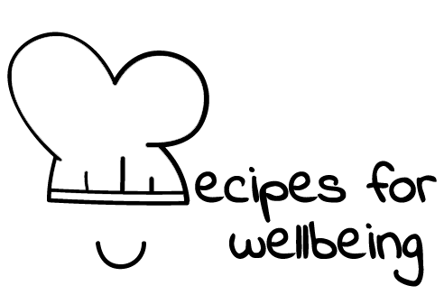
WHOLEBEING FOR EDUCATORS · LESSON PLAN
Deciding when technology gets your attention
The skill of digital boundaries · digital consciousness · one class period · ages 13 to 18
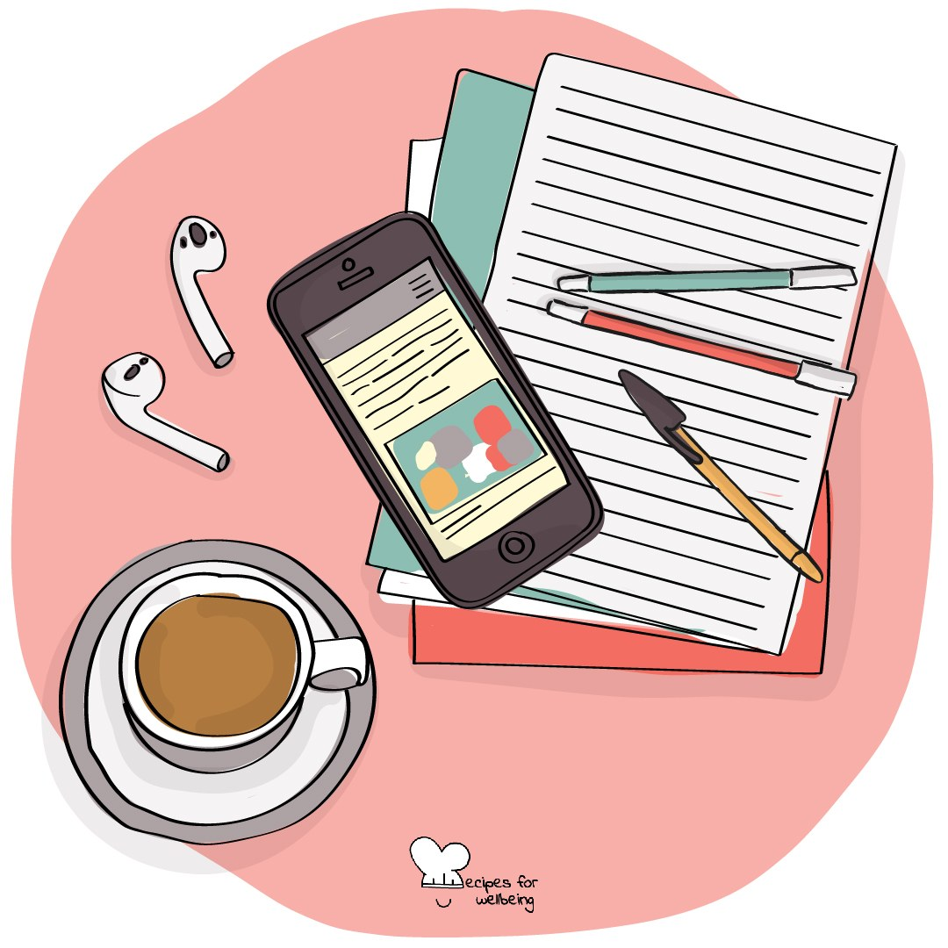
Learning intention
By the end of this lesson, students can explain a digital boundary and design one realistic limit for a fictional situation.

The big idea
Technology can be valuable and still need a boundary. Choosing when and where a device gets our attention may protect sleep, focus, relationships or time that matters for something else. A useful boundary responds to real circumstances and can be adjusted without becoming a punishment.
Opener (4 min): The phone across the room
Use The phone across the room to notice the relationship between location and attention. No device is moved during the practice and no one is asked to describe their phone use.
Explore (10 min)
A digital boundary is a limit on when, where or how technology is used. It may be a device-free time, a place where screens are put aside or a ritual that helps someone move between online and offline activity.
Boundaries are shaped by context. A student may need a device for safety, translation, disability support, work or family responsibilities. There is no universal rule. A good boundary protects something important and fits what the person actually needs.
Discuss
- Why can a chosen boundary feel different from a rule imposed by someone else?
- What may make a digital boundary difficult to keep?
- How can a boundary protect connection rather than cutting someone off from it?
Activity (16 min): Design a boundary
Materials: paper and pens; fictional situations on a board or slide · Grouping: groups of four
- Give each group one fictional situation, such as a group chat that continues through the night, notifications during revision or videos extending beyond a planned stopping point.
- Ask what the person is trying to protect and what needs or responsibilities the boundary must still allow.
- Choose one form: a device-free time, a device-free space or a small transition ritual.
- Design one realistic and kind boundary, then name what could make it hard to keep.
- Adjust the boundary so it includes flexibility, access needs and a way to begin again after it is broken.
- Each group shares its boundary and the value it protects, without discussing personal phone use.
Reflect (6 min)
Which boundary idea could fit a real and busy life? Note a small version, or write why none of today's options would fit your circumstances.
How: private journal
Close (3 min)
A boundary is a way of deciding where attention will go. The most useful one protects something that matters and leaves enough flexibility for the life around it.
In other settings
Form or tutor time (advisory / homeroom): Use the opening observation, then design one boundary together for a fictional late-night group chat.
Assembly or large-group gathering: Introduce the three forms of boundary and think through one fictional example without asking for personal commitments.
Youth club or small group: Design several options for one situation and compare whom each option would support or exclude.
Adapting for age
13 to 15: Use concrete situations and worked examples, then guide each group towards one small boundary rather than a complete digital plan.
16 to 18: Explore trade-offs involving sleep, revision, work, relationships and accessibility. Let students challenge boundaries that assume everyone has the same choices.
Curriculum links
IB · Approaches to Learning: Self-management: affective skills (mindfulness awareness); Self-management: organisation skills (using technology effectively)
OECD Learning Compass 2030: Transformative competencies: taking responsibility; Core foundations: health foundations; Student agency
UNESCO MGIEP · SEL (EMC framework): Mindfulness (attention regulation)
WHO · Life skills education: Decision making — choosing a realistic limit; Coping with stress — changing one's environment or lifestyle
EU · LifeComp: P1 Self-regulation — regulating behaviour (P1.2); P3 Wellbeing — a lifestyle that respects physical and mental wellbeing (P3.3)
UNICEF MENA · Life Skills & Citizenship Education: Self-management — regulating attention and impulses; Decision-making — designing a realistic limit
Australia · Personal & Social Capability: Self-management: goal setting; Social management: decision-making
Brazil · BNCC general competences: Self-knowledge and self-care (GC 8) — caring for physical and emotional health; Digital culture (GC 5) — reflective use of technology
Canada · British Columbia: Personal Awareness and Responsibility — self-regulating; well-being (maintaining a healthy lifestyle)
Canada · Ontario: Personal skills — time-management for greater control over their lives (1.2); Critical and creative thinking — planning (1.5) · Gr 7–8: A1.2
Chile · Orientación: Wellbeing and self-care — appropriate rest, safer use of social networks (OA 4, 7°–8°); positive use of leisure (OA 4, 1°–2° medio)
England · DfE RSHE (statutory): Wellbeing online: the benefits of limiting time online (statement 1)
England · PSHE Association: Health and Wellbeing: balance with online activities, and sleep (KS3 H13, H15, KS4 H12)
Finland · Transversal competences: L3 Taking care of oneself and managing daily life — sleep, rest, a balanced daily rhythm, personal boundaries; L5 ICT competence
Ghana · NaCCA core competencies (JHS): Personal Development and Leadership — self-regulation and health; Digital Literacy — responsible use of digital media
Hong Kong · Values Education Curriculum Framework (2026): Health education (健康生活教育) — varied leisure, not hooked on going online; self-discipline (自律節制, S1–S3)
India · NEP 2020: Mental health (NEP 4.28); Holistic development of learners
Indonesia · 8 dimensi profil lulusan: Health (kesehatan) — healthy living habits (pola hidup sehat); Independence (kemandirian) — responsibility
Ireland · Junior Cycle Wellbeing: Responsible — taking action to protect and promote my wellbeing and that of others
Japan · Courses of Study (lower secondary): Moral education A — moderation and temperance: desirable lifestyle habits (節度，節制); Special activities — healthy living habits
Kenya · CBC core competencies & values: Digital Literacy — safe, responsible use of devices; Learning to Learn — effective management of time
Mexico · Nueva Escuela Mexicana: Axis: Healthy living — daily habits that care for health, such as sleep
New Zealand · Health and Physical Education: Personal health and physical development — self-management skills; Hauora: taha tinana (e.g. sleep) and taha hinengaro
Scotland · Health and wellbeing (CfE): Mental and emotional wellbeing: my feelings and reactions can change depending on what is happening within and around me (HWB 3-04a); Physical wellbeing: assessing and managing risk to protect myself and others (HWB 3-16a)
Singapore · Character & Citizenship Education: SEC: self-management; CCE Curriculum Content Area: Cyber Wellness
South Africa · CAPS Life Orientation: Development of the self in society — lifestyle plan and cyber wellness (Gr 12); Study skills — time management (Gr 10)
US · CASEL competencies: self-awareness, self-management, responsible decision-making
A guide, not a claim of full coverage. Check against your own scheme of work.
Holding the room
Use fictional situations and never ask students to disclose habits, messages or content. Remember that device access can be connected to safety and care. Follow usual safeguarding routes if a student mentions coercion, isolation, harmful content or contact online.
Recipes for Wellbeing · CC BY-NC 4.0 · free for classroom use · deep dive: https://recipesforwellbeing.substack.com/p/the-skill-of-digital-boundaries

