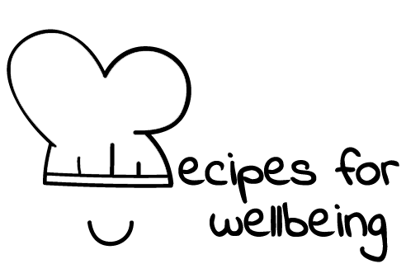
WHOLEBEING FOR EDUCATORS · LESSON PLAN
Choosing how you use your phone
The skill of digital agency · digital consciousness · one class period · ages 13 to 18
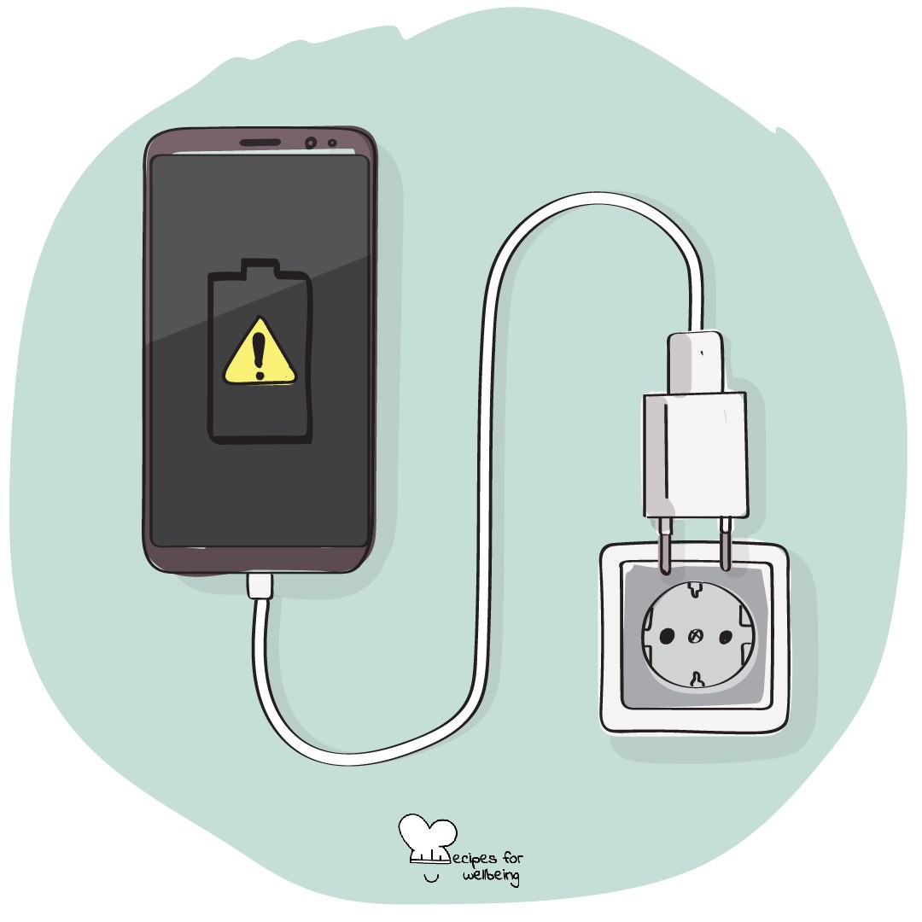
Learning intention
By the end of this lesson, students can identify a feature designed to hold attention and describe one small digital choice connected to something they value.

The big idea
Phones and online spaces can support friendship, creativity, learning and access. They can also compete for attention in ways that are difficult to notice while they are happening. Digital agency begins with understanding that design influences behaviour and remembering that our choices still matter within the limits and pressures we face.
Opener (5 min): The unopened phone
Use The unopened phone as an observation, not a test of self-control. Students without a phone can notice the pull towards another familiar distraction.
Explore (10 min)
Digital agency means having a say in how technology enters your life. That agency is real, but it does not exist in a vacuum. Apps use features such as notifications, autoplay, streaks and infinite scroll because attention has value, and access to devices may also be shaped by family, school, disability and cost.
Here we notice what a digital space invites us to do, ask whether that fits what matters to us and make a choice where choice is available. Technology is neither all good nor all bad, and no student is responsible for an industry designed to keep people engaged.
Discuss
- What do platforms gain when people stay for longer?
- What can make time online feel connecting, useful, tiring or flat?
- Where does personal choice help, and where should designers, schools or governments carry more responsibility?
Activity (16 min): A menu of small choices
Materials: a board, paper and pens · Grouping: groups of three or four
- Introduce several common design features, including infinite scroll, autoplay, streaks, notifications, likes and attention-grabbing headlines.
- Each group chooses two features and asks what behaviour each one encourages and whose interests it may serve.
- Ask what a person may value in the same moment, such as connection, sleep, focus, creativity, safety or enjoyment.
- Groups create a menu of four or five small choices that could support those values, such as changing notifications, moving a charger, unfollowing an account or choosing a stopping point.
- Include choices that do not require owning a newer device, paying for an app or having complete control over the household.
- Gather one menu item from each group. No student needs to say what they use or intend to change.
Reflect (6 min)
What is one small choice that could bring a part of your digital life closer to something you value? "Nothing for now" is also an honest answer.
How: private journal
Close (3 min)
Digital agency can begin before any change is made. We can notice the invitation built into a screen and remember what matters to us before we respond.
In other settings
Form or tutor time (advisory / homeroom): Use the unopened-phone observation, name two design features and build a short menu together.
Assembly or large-group gathering: Introduce several attention features from the front and invite private reflection on one value students want technology to support.
Youth club or small group: Discuss a few common features and make a shared menu that includes options for different levels of access and control.
Adapting for age
13 to 15: Use concrete features from familiar apps and games, keep the menu visual and provide sentence starters for the group discussion.
16 to 18: Explore algorithms, targeted advertising, identity and the attention economy. Invite students to consider the responsibilities of platforms alongside individual choices.
Curriculum links
IB · Approaches to Learning: Self-management: affective skills (mindfulness awareness); Research: media literacy skills (informed choices about viewing)
OECD Learning Compass 2030: Student agency; Core foundations: health foundations
UNESCO MGIEP · SEL (EMC framework): Mindfulness (attention regulation); Critical Inquiry (examining how apps shape attention)
WHO · Life skills education: Critical thinking — assessing how media and design influence behaviour; Decision making — choosing in line with one's values
EU · LifeComp: P3 Wellbeing — how behaviour and environmental factors influence wellbeing (P3.1); P1 Self-regulation — regulating behaviour (P1.2)
UNICEF MENA · Life Skills & Citizenship Education: Critical thinking — assessing how platform design and social media shape behaviour; Decision-making — choices aligned with values
Australia · Personal & Social Capability: Self-awareness: personal awareness; Self-management: goal setting; Social management: decision-making
Brazil · BNCC general competences: Digital culture (GC 5) — using digital technologies critically, reflectively and ethically; Self-knowledge and self-care (GC 8)
Canada · British Columbia: Personal Awareness and Responsibility — self-regulating (owning one's choices); Positive Personal and Cultural Identity — personal values and choices
Canada · Ontario: Critical and creative thinking — decisions about Internet and social media use (1.5); Personal skills — self-monitoring (1.1) · Gr 7–8: A1.6
Chile · Orientación: Wellbeing and self-care — actions for wellbeing, including safety measures when using social networks (OA 4, 7°–8°)
England · DfE RSHE (statutory): Wellbeing online: limiting time online and the impact of content (statement 1); how advertising and information are targeted (statement 5)
England · PSHE Association: Health and Wellbeing: balance with online activities (KS3 H13, KS4 H12); Living in the wider world: media literacy and digital resilience (KS3 L20, L25)
Finland · Transversal competences: L5 ICT competence — responsible and safe use; L3 Taking care of oneself and managing daily life — technology in one's own life
Ghana · NaCCA core competencies (JHS): Digital Literacy — using digital media responsibly; Critical Thinking and Problem-Solving — analysing issues
Hong Kong · Values Education Curriculum Framework (2026): Media and information literacy education (媒體和資訊素養教育) — risks and etiquette of social platforms (S1–S3); Responsibility (責任感)
India · NEP 2020: Mental health (NEP 4.28)
Indonesia · 8 dimensi profil lulusan: Critical reasoning (penalaran kritis) — analysing problems; Independence (kemandirian) — taking responsibility (bertanggung jawab)
Ireland · Junior Cycle Wellbeing: Aware — knowing my values and thinking through my decisions; Responsible — acting to protect my wellbeing
Japan · Courses of Study (lower secondary): Moral education A — freedom and responsibility (自主，自律，自由と責任); information morals (情報モラル)
Kenya · CBC core competencies & values: Digital Literacy — awareness of societal issues raised through digital media; Critical Thinking and Problem Solving
Mexico · Nueva Escuela Mexicana: Axis: Critical thinking — how platform design shapes behaviour; Axis: Healthy living — questioning consumption habits
New Zealand · Health and Physical Education: Healthy communities and environments — societal attitudes and values; KAL mental health — the effects of media messages
Scotland · Health and wellbeing (CfE): Mental and emotional wellbeing — how what happens around me shapes my feelings, reactions and behaviour (HWB 3-04a); Relationships, sexual health and parenthood: popular culture, the media and peer pressure can influence how I feel about myself (HWB 3-46b)
Singapore · Character & Citizenship Education: SEC: self-management and responsible decision-making; CCE Curriculum Content Area: Cyber Wellness
South Africa · CAPS Life Orientation: Development of the self in society — media influence on lifestyle choices; informed decision-making (Gr 9)
US · CASEL competencies: self-awareness, self-management, responsible decision-making
A guide, not a claim of full coverage. Check against your own scheme of work.
Holding the room
Keep discussion about fictional users and general design rather than personal habits or content. Students should never be asked to unlock or show a device. Respond privately through usual safeguarding routes if cyberbullying, exploitation or distressing content is disclosed.
Recipes for Wellbeing · CC BY-NC 4.0 · free for classroom use · deep dive: https://recipesforwellbeing.substack.com/p/the-skill-of-digital-agency

