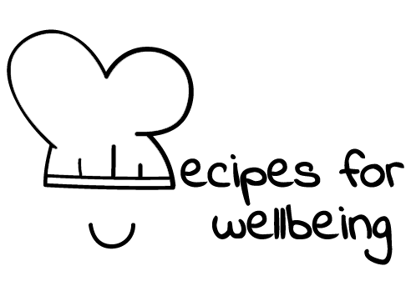
WHOLEBEING FOR EDUCATORS · LESSON PLAN
The pleasure of not knowing yet
The skill of awe · positive emotion · one class period · ages 13 to 18
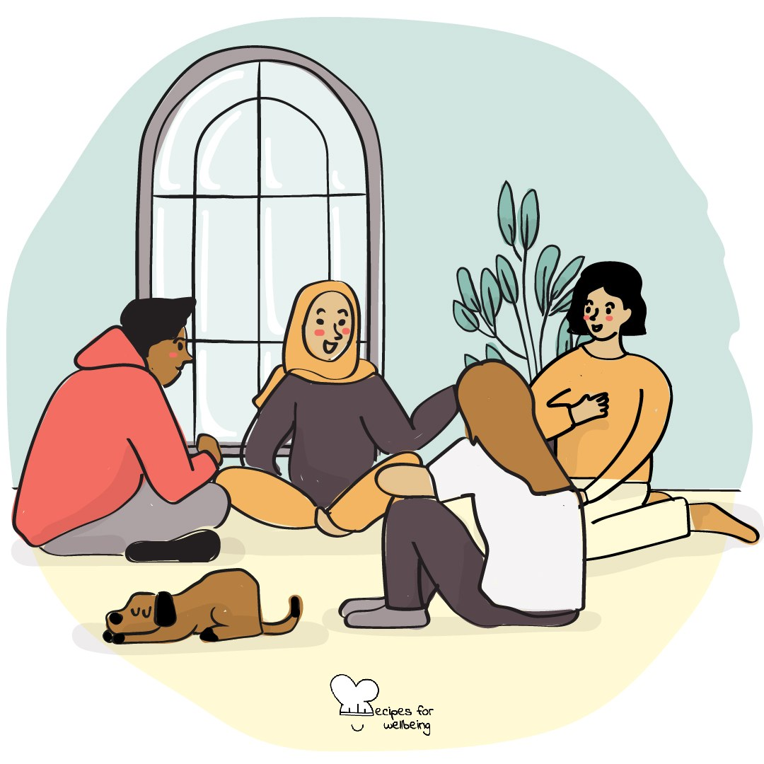
Learning intention
By the end of this lesson, students can generate open questions about an ordinary object and stay with a question without rushing to close it.

The big idea
School often asks for an answer, while curiosity begins with attention to what we do not yet know. Letting a question remain open can make the familiar more interesting and give new ideas time to develop. Not knowing yet is nothing to hide. Curiosity is a way of meeting the world with interest.
Opener (5 min): Questions without answers
Use Questions without answers to collect genuine questions. Students do not need to share, and no one should answer the questions that are offered.
Explore (10 min)
Curiosity is the practice of staying open to what we have not fully understood. It may begin with surprise, uncertainty or the simple thought, "I had never noticed that before."
Wonder does not belong only to rare experiences. A leaf changing colour, a key worn smooth or the route an object took to reach this room can hold many questions. The ordinary does not need to become extraordinary. It needs enough attention to show its detail.
Discuss
- Where do people still make room for wonder outside school?
- What can be lost when every question is treated as a race towards the right answer?
- What helps uncertainty feel interesting rather than threatening?
Activity (18 min): Making the ordinary unfamiliar
Materials: ordinary objects such as leaves, pebbles, shells, coins, keys or seeds; paper and pens · Grouping: groups of three or four
- Give each group one ordinary object and explain that the first task is to notice rather than identify it.
- Allow two quiet minutes for close observation of texture, weight, edges, marks and the way light meets the surface.
- Ask groups to produce as many genuine "I wonder..." questions as they can. No one answers yet, and unusual questions are welcome.
- Choose one question and follow its connections outward. Where might the object have been, what systems brought it here and what remains unseen?
- Each group offers one or two questions to the room, where they are received without answers.
- If time allows, swap objects and notice what becomes possible when attention meets something new.
Reflect (6 min)
Choose one ordinary thing you pass most days without seeing closely. What might become visible if you gave it the same attention as today's object?
How: private journal
Close (3 min)
You do not need to leave with an answer. You can carry one open question and allow it to change what you notice next.
In other settings
Form or tutor time (advisory / homeroom): Use the opening practice, then give each pair one object and collect questions after one minute of close looking.
Assembly or large-group gathering: Invite silent questions, then hold up one ordinary object and model a sequence of questions without answering them.
Youth club or small group: Pass several objects around and wonder aloud together, allowing the conversation to move between small details and larger questions.
Adapting for age
13 to 15: Keep the objects tactile, shorten the silent observation and offer starters such as "I wonder why..." and "What would happen if...?"
16 to 18: Invite students to connect a small object with deep time, systems or a subject they study, and explore the discomfort of not knowing.
Curriculum links
IB · Approaches to Learning: Thinking: creative thinking skills (asking what if questions); Thinking: critical thinking skills (forming questions)
OECD Learning Compass 2030: Core foundations: social and emotional foundations (open-mindedness); Skills: cognitive and meta-cognitive skills (learning-to-learn)
UNESCO MGIEP · SEL (EMC framework): Critical Inquiry (open, unhurried questioning); Mindfulness (attention regulation)
WHO · Life skills education: Creative thinking — looking beyond direct experience; Critical thinking — examining experience with open questions
EU · LifeComp: L1 Growth mindset — learning as lifelong, needing openness and curiosity (L1.2); L2 Critical thinking — creative ideas (L2.3)
UNICEF MENA · Life Skills & Citizenship Education: Creativity — generating open questions; Learning to Know (cognitive dimension) — curiosity about the world
Australia · Personal & Social Capability: Self-awareness: personal awareness
Brazil · BNCC general competences: Scientific, critical and creative thinking (GC 2) — exercising intellectual curiosity, investigation and imagination
Canada · British Columbia: Critical and Reflective Thinking — questioning and investigating; Creative Thinking — generating and incubating
Canada · Ontario: Critical and creative thinking — generating ideas and making connections (1.5) · Gr 7–8: A1.6
Finland · Transversal competences: L1 Thinking and learning to learn — making observations, sharpening observational sensitivity and imagination
Ghana · NaCCA core competencies (JHS): Creativity and Innovation — thinking independently and creatively; Personal Development and Leadership — love for lifelong learning
India · NEP 2020: Learning how to learn (NEP 4.4); Creativity and innovativeness (NEP 4.23)
Indonesia · 8 dimensi profil lulusan: Critical reasoning (penalaran kritis) — curiosity (rasa ingin tahu); Creativity (kreativitas)
Ireland · Junior Cycle Wellbeing: Aware — understanding what helps me to learn; Connected — to the wider world
Japan · Courses of Study (lower secondary): Moral education A — pursuit of truth (真理の探究，創造); Moral education D — being moved, sense of awe (感動，畏敬の念)
Kenya · CBC core competencies & values: Creativity and Imagination — perceiving the world in new ways; Learning to Learn — the will to learn
Mexico · Nueva Escuela Mexicana: Axis: Critical thinking — asking open questions about everyday reality
Singapore · Character & Citizenship Education: SEC: self-awareness
US · CASEL competencies: self-awareness, responsible decision-making
A guide, not a claim of full coverage. Check against your own scheme of work.
Holding the room
Keep the focus on objects and the wider world. If a question moves towards death, fear or another tender subject, receive it calmly without asking the student to explain its personal meaning. Follow usual pastoral routes if concern remains.
Recipes for Wellbeing · CC BY-NC 4.0 · free for classroom use · deep dive: https://recipesforwellbeing.substack.com/p/the-skill-of-awe

