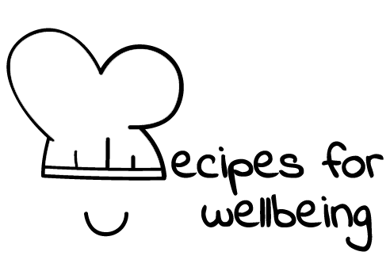
WHOLEBEING FOR EDUCATORS · LESSON PLAN
Kindness that responds
The skill of compassion · radical care · one class period · ages 13 to 18
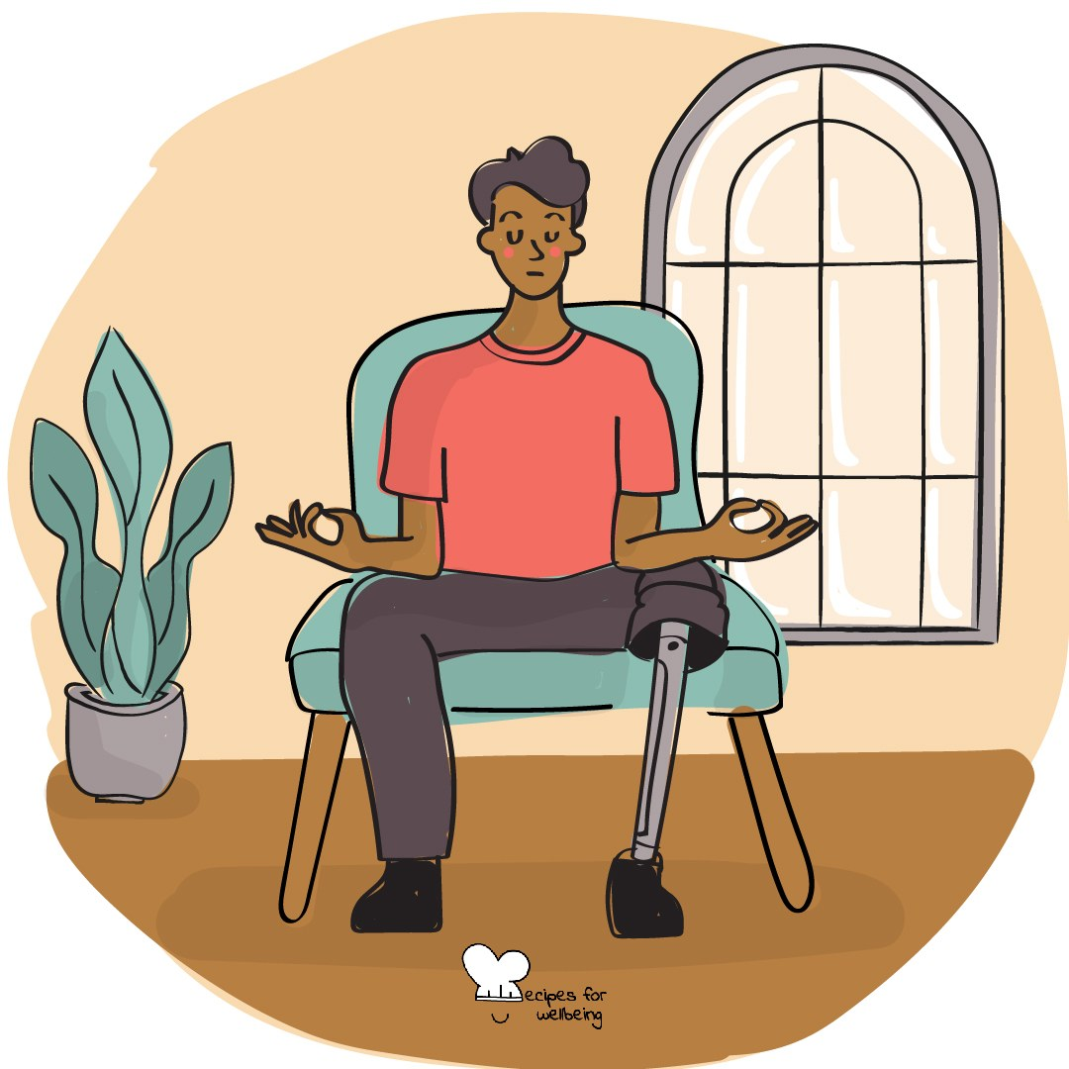
Learning intention
By the end of this lesson, students can describe compassion as noticing difficulty and responding with care, and suggest a small response that respects what a person may need.

The big idea
People often carry difficulties that are not visible. Compassion means noticing suffering, including our own, and asking what care or support might bring some relief. We do not have to fix another person's life or carry more than is safe for us.
Opener (5 min): Three quiet wishes
Use Three quiet wishes as a private practice. Students may keep their hands wherever comfortable, change the words or simply sit quietly.
Explore (10 min)
Compassion begins with recognising that something is difficult and responding without turning away or rushing past it. Empathy helps us sense another person's experience; compassion includes the wish or action to bring relief.
The response needs to fit the situation. Sometimes it is a message, a saved seat or a kinder sentence to ourselves. Sometimes it is asking what would help, involving a trusted adult or respecting that the person wants space. Care without boundaries can become unsafe, so compassion includes knowing what is and is not ours to carry.
Discuss
- What is the difference between pity, empathy and compassion?
- Why can advice feel unhelpful when it arrives before understanding?
- What can self-compassion sound like without pretending that everything is fine?
Activity (16 min): A response that helps
Materials: paper and pens; fictional scenarios on slips or the board · Grouping: groups of three or four
- Offer several fictional situations, such as a student being left out, arriving at a new school, regretting an argument or receiving a disappointing mock result.
- Give each group two situations and ask what the person may need before deciding what anyone should say or do.
- Name two common traps: minimising the difficulty and offering a solution before listening.
- Ask groups to write one caring sentence, one practical option and one boundary or route to adult support for each situation.
- Add a self-directed version of one scenario. Students privately write the response they would offer a friend and consider whether they could offer themselves similar care.
- Gather one sentence from each group without sharing the private reflection, and notice how the response changes when it begins with understanding.
Reflect (6 min)
Picture one small and realistic act of compassion you could offer in the next few days, to yourself or someone else. What might help, and how could you leave room for the person's own choice?
How: private journal
Close (3 min)
Compassion can be quiet and practical. We can notice what hurts and offer what is safely ours to give.
In other settings
Form or tutor time (advisory / homeroom): Use the three wishes, then work through one fictional situation by asking what the person may need before drafting a response.
Assembly or large-group gathering: Lead the private wishes, then model how a compassionate response can include care, practical support and a boundary.
Youth club or small group: Explore one fictional situation together and make several responses available, including listening, practical help and trusted adult support.
Adapting for age
13 to 15: Use concrete fictional situations and model a response that acknowledges the difficulty before offering help. Keep group sharing to one sentence.
16 to 18: Explore self-kindness, shared humanity and mindful noticing, while questioning when a caring response requires boundaries, referral or collective action.
Curriculum links
IB · Approaches to Learning: Social: collaboration skills (practising empathy)
OECD Learning Compass 2030: Skills: social and emotional skills (empathy)
UNESCO MGIEP · SEL (EMC framework): Compassion (prosocial action); Empathy
WHO · Life skills education: Empathy — imagining another's situation and encouraging care for people in need; Coping with emotions
EU · LifeComp: S1 Empathy — responsiveness to another's emotions and experiences (S1.3); P3 Wellbeing — seeking and offering social support (P3.3)
UNICEF MENA · Life Skills & Citizenship Education: Empathy — noticing difficulty and acting to support; Decision-making — choosing a safe, respectful response
Australia · Personal & Social Capability: Social awareness: empathy; Self-awareness: emotional awareness
Brazil · BNCC general competences: Empathy and cooperation (GC 9) — exercising empathy; Self-knowledge and self-care (GC 8) — recognising one's own and others' emotions
Canada · British Columbia: Social Awareness and Responsibility — resolving problems (showing empathy); Personal Awareness and Responsibility — self-advocating
Canada · Ontario: Interpersonal skills — reaching out with compassion to a struggling friend (1.3); Personal skills — seeking help (1.2) · Gr 7–8: A1.4
Chile · Orientación: Wellbeing and self-care — turning to support networks (OA 3, 1°–2° medio); Interpersonal relationships — constructive relationships (OA 5)
England · DfE RSHE (statutory): Respectful relationships: kindness, respect and communicating respectfully (statements 2, 5)
England · PSHE Association: Relationships: forming and maintaining respectful relationships (KS3 R14); Health and Wellbeing: recognising when others need help (KS3 H12, KS4 H10)
Finland · Transversal competences: L3 Taking care of oneself and managing daily life — responsibility for oneself and others; L2 — putting oneself in another's position
Ghana · NaCCA core competencies (JHS): Personal Development and Leadership — empathy, seeking the well-being of others
Hong Kong · Values Education Curriculum Framework (2026): Benevolence (仁愛); Empathy (同理心) — seeing from others' situations, tolerance and forgiveness (S4–S6)
India · NEP 2020: Socio-emotional learning (NEP 5.14); Empathy and compassion (NEP 4.28)
Indonesia · 8 dimensi profil lulusan: Collaboration (kolaborasi) — caring (peduli); Faith and devotion (keimanan) — noble character: compassion (kasih sayang)
Ireland · Junior Cycle Wellbeing: Responsible — acting to promote my wellbeing and that of others; Resilient — knowing where I can go for help
Japan · Courses of Study (lower secondary): Moral education B — consideration and human love (思いやり，人間愛); Special activities — facing worries and anxieties
Kenya · CBC core competencies & values: Values — respect, empathy and compassion for all people; Core value — love
Mexico · Nueva Escuela Mexicana: Feelings and their influence on decision-making — empathy towards others' emotional reactions
New Zealand · Health and Physical Education: KAL mental health — supporting themselves and other people in times of stress and loss; Hauora: taha whānau (compassion, caring)
Scotland · Health and wellbeing (CfE): Mental and emotional wellbeing — giving appropriate support (HWB 3-08a); access to practical and emotional support (HWB 3-03a)
Singapore · Character & Citizenship Education: SEC: social awareness (cognitive and emotional empathy) and relationship management
South Africa · CAPS Life Orientation: Development of the self in society — respecting others' feelings (Gr 12); responding to emotions in challenging situations (Gr 9)
US · CASEL competencies: social awareness, self-awareness, relationship skills
A guide, not a claim of full coverage. Check against your own scheme of work.
Holding the room
Keep all scenarios fictional and the self-directed response private. Make clear that peers should not promise secrecy or take responsibility for serious concerns. If a scenario lands close to home, offer a quiet pause and follow usual safeguarding and pastoral routes without pressing for public detail.
Recipes for Wellbeing · CC BY-NC 4.0 · free for classroom use · deep dive: https://recipesforwellbeing.substack.com/p/the-skill-of-compassion

