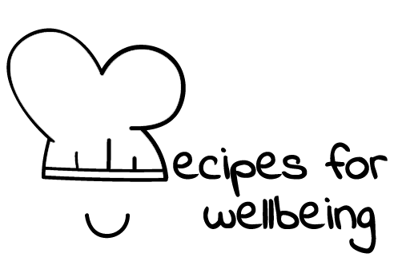
WHOLEBEING FOR EDUCATORS · LESSON PLAN
The connections in this room
The skill of community building · community · one class period · ages 13 to 18
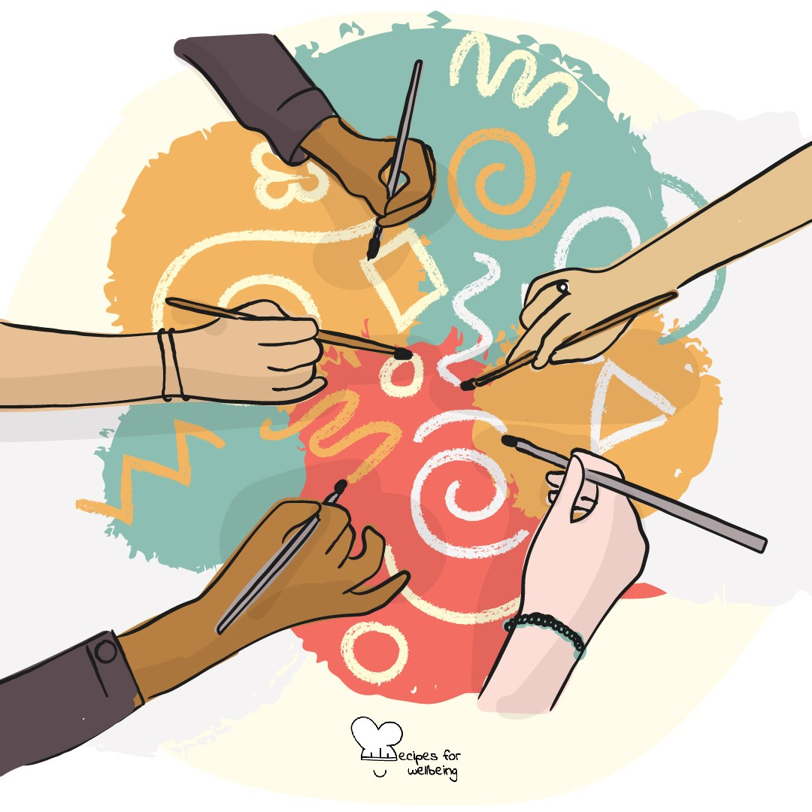
Learning intention
By the end of this lesson, students can name small actions that support belonging and identify everyday points of connection across a group.

The big idea
Belonging is shaped by ordinary moments: who receives a reply, who is welcomed into a conversation and whether there is room for difference. These choices will not remove wider barriers, and no one is responsible for their own inclusion. They still shape how a group feels and who gets to take part.
Opener (5 min): Make it rain
Use Make it rain to create a shared sound. Students can use smaller movements, join without touching the desk or listen throughout.
Explore (10 min)
Community is not the same as sameness. People can belong together while bringing different needs, histories and opinions. Belonging becomes more possible when a group makes its expectations clear, notices barriers and treats care as something shared.
Small actions matter, but they sit inside larger conditions. Saving a seat can welcome someone; it cannot repair discrimination or replace the responsibility of adults and institutions to make a setting safe and accessible.
Discuss
- What small actions help a group feel welcoming without asking everyone to be the same?
- What can make joining a group difficult, even when individuals intend to be friendly?
- How can a group respond when someone is repeatedly left out?
Activity (18 min): Finding points of connection
Materials: a simple 3 by 3 grid and pens · Grouping: whole class
- Fill each square with a low-disclosure prompt, such as enjoying a comfort programme, learning another language, preferring rain to sunshine or having a song to recommend.
- Invite students to find a different classmate for each square. They may write a first name only with permission, leave squares blank or pass on any prompt.
- Give the class seven minutes and encourage one follow-up question before moving on. Filling the grid is not a race or a requirement.
- Make alternatives available for anyone who cannot or does not want to move around, such as partners coming to them, seated groups or a show of hands.
- Bring the group back and ask what common ground appeared in unexpected places. Do not invite comments about individual students.
- Close by naming the actions that made connection easier and any design changes that would make the activity more inclusive next time.
Reflect (5 min)
Think of a group you are part of without naming it. What is one small action you could offer, and what is one change the group itself could make, to support belonging?
How: private journal
Close (2 min)
Today's connections were ordinary, and that is where much of community is made. Belonging grows when people offer care and when groups remove the barriers that keep care from reaching everyone.
In other settings
Form or tutor time (advisory / homeroom): Use a six-square grid and four minutes, then name one action that made joining easier.
Assembly or large-group gathering: Read low-disclosure prompts and use optional hands or quiet noticing to reveal shared interests without singling anyone out.
Youth club or small group: Replace the grid with a gentle conversation about everyday points of connection and what helps each person participate.
Adapting for age
13 to 15: Use playful, concrete prompts, model one conversation and reduce the grid to six squares if needed. Give students a seated option from the beginning.
16 to 18: Invite students to distinguish welcoming behaviour from structural inclusion, and consider how a group can hold disagreement without becoming hostile or closed.
Curriculum links
IB · Approaches to Learning: Social: collaboration skills (practising empathy)
OECD Learning Compass 2030: Skills: social and emotional skills (empathy, collaboration); Student agency: co-agency
UNESCO MGIEP · SEL (EMC framework): Empathy
WHO · Life skills education: Interpersonal relationship skills — making and keeping friendly relationships; Empathy — accepting others who are different
EU · LifeComp: S3 Collaboration — the common good, respecting different backgrounds (S3.1); S1 Empathy — how group belonging shapes attitudes (S1.3)
UNICEF MENA · Life Skills & Citizenship Education: Respect for diversity — valuing individual differences in a group; Participation — shaping group life together
Australia · Personal & Social Capability: Social awareness: community awareness; relational awareness; Social management: communication
Brazil · BNCC general competences: Empathy and cooperation (GC 9) — welcoming and valuing diversity; Responsibility and citizenship (GC 10) — inclusive, solidary action
Canada · British Columbia: Social Awareness and Responsibility — building relationships; valuing diversity (inclusive language and actions)
Canada · Ontario: Interpersonal skills — appreciating differences in people, showing respect (1.4) · Gr 7–8: A1.4, A1.5 (belonging)
Chile · Orientación: Belonging and participation — shared interests and needs within one's groups (OA 7); Interpersonal relationships — inclusion (OA 5)
England · DfE RSHE (statutory): Respectful relationships: treating others with kindness and respect (statement 2)
England · PSHE Association: Relationships: forming and maintaining respectful relationships (KS3 R14, R41)
Finland · Transversal competences: L7 Participation, involvement and building a sustainable future — class and school community; L2 — diversity as a resource
Ghana · NaCCA core competencies (JHS): Core value — diversity: respecting the views of all persons, social cohesion
Hong Kong · Values Education Curriculum Framework (2026): Unity (團結); Respect for Others (尊重他人) — including people of different backgrounds, rejecting prejudice (S1–S3)
India · NEP 2020: Collaboration and teamwork (NEP 4.23); Spirit of service (NEP Principles)
Indonesia · 8 dimensi profil lulusan: Collaboration (kolaborasi) — caring and working with diverse people; Citizenship (kewargaan) — valuing diversity
Ireland · Junior Cycle Wellbeing: Connected — to my school, friends and community; Respected — showing care and respect for others
Japan · Courses of Study (lower secondary): Special activities — respecting individuality, building better relationships; Moral education C — fairness and impartiality (公正，公平)
Kenya · CBC core competencies & values: Citizenship — a sense of belonging and respect for others; Core value — unity
Mexico · Nueva Escuela Mexicana: Field: The human and the community — a sense of community and belonging; Axis: Inclusion
New Zealand · Health and Physical Education: Hauora: taha whānau (feelings of belonging); Relationships with other people — identity, sensitivity, and respect
Scotland · Health and wellbeing (CfE): Social wellbeing — making the school a welcoming place for all (HWB 3-10a); making friends and being part of a group (HWB 3-14a)
Singapore · Character & Citizenship Education: SEC: social awareness and relationship management
South Africa · CAPS Life Orientation: Constitutional rights and responsibilities — unity in diversity: respect difference, celebrate similarity (Gr 8)
US · CASEL competencies: social awareness, relationship skills
A guide, not a claim of full coverage. Check against your own scheme of work.
Holding the room
Keep prompts about interests and everyday preferences, never family circumstances, health, identity disclosure or painful experiences. Watch for isolation and provide alternatives to mingling. Address repeated exclusion through the setting's pastoral and safeguarding routes rather than making a student solve it publicly.
Recipes for Wellbeing · CC BY-NC 4.0 · free for classroom use · deep dive: https://recipesforwellbeing.substack.com/p/the-skill-of-community-building

