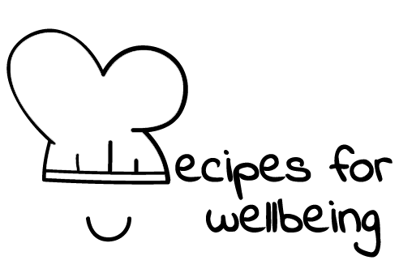
WHOLEBEING FOR EDUCATORS · LESSON PLAN
Making room for every voice
The skill of hosting conversations · community · one class period · ages 13 to 18
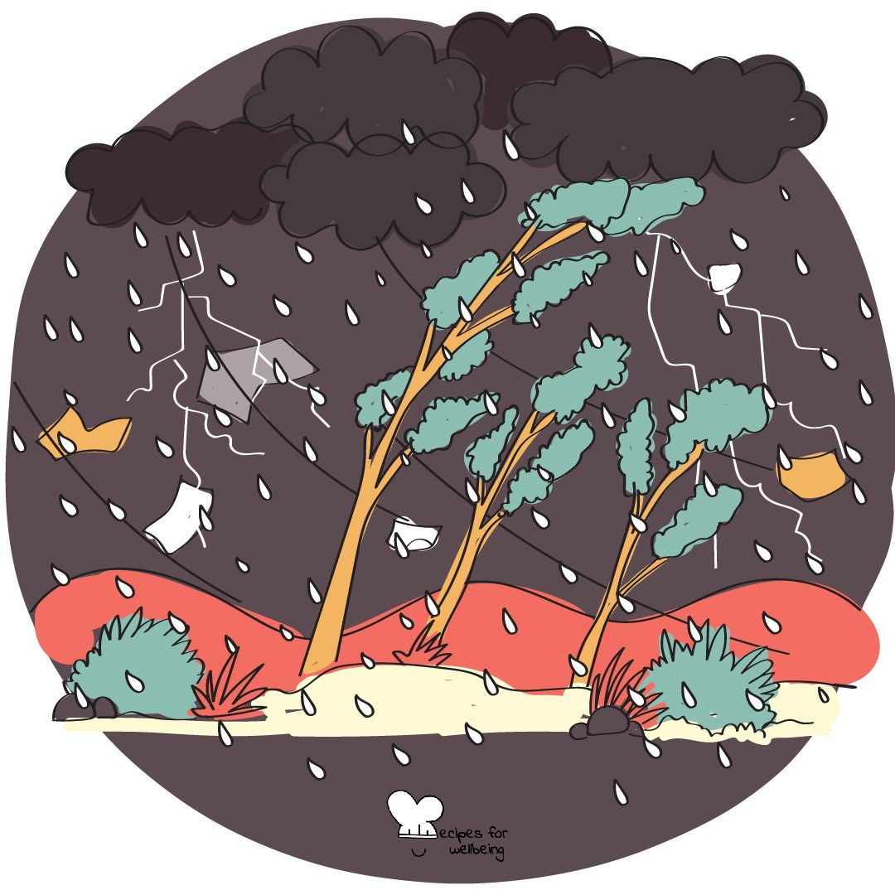
Learning intention
By the end of this lesson, students can use a question, an invitation or a short silence to help more people take part in a group task.

The big idea
Groups shape much of school life, from friendships and group chats to lessons and teams. A group works more fairly when participation does not depend on being the quickest or loudest person in the room. Collaboration asks us to contribute and to notice what would help others contribute too.
Opener (5 min): Making it rain
Use Making it rain to let the class build one sound together without speaking. Lead clearly and allow students to join with smaller movements or by listening.
Explore (10 min)
Collaboration means helping a group think together. That matters most when people bring different ideas, different levels of confidence and different ways of speaking up.
No one person is responsible for making a group inclusive, and an invitation to speak should never become pressure. Useful hosting moves include asking an open question, leaving time to think, checking whose idea has not been heard, and making room for writing or another form of contribution.
Discuss
- What helps you know that your contribution is welcome in a group?
- What can close a conversation even when nobody intends to exclude anyone?
- How can a group make room for quieter contributions without putting someone on the spot?
Activity (18 min): Everyone in
Materials: three paper tokens per student, or three fingers; one neutral challenge per group · Grouping: groups of four or five
- Give each group a neutral task, such as designing a useful 15-minute break or inventing a game with three ordinary objects.
- Give everyone three voice tokens. Each time a student speaks, they use one; when the tokens are gone, they move into listening and hosting.
- Name a first host whose task is to ask questions, hold short silences and make several ways of contributing available. Rotate the host halfway through.
- Run the challenge for eight minutes. If a group stalls, offer a question rather than an answer.
- Ask each group to agree on one response and identify a hosting move that helped the conversation.
- Gather one sentence from each group about its idea and one about how it made room for participation.
Reflect (6 min)
Think of a group that works well, whether real or imagined. What does it do to make participation easier, and which hosting move could you try in a future group?
How: private journal
Close (2 min)
At the start, the room made one rainstorm by noticing and responding to other people. Collaboration grows through the same small choices: offering an idea, and leaving enough room for another voice to arrive.
In other settings
Form or tutor time (advisory / homeroom): Use the rainstorm, then run one short challenge with voice tokens and a named host.
Assembly or large-group gathering: Make the rainstorm together, then introduce several hosting moves from the front without asking for personal examples.
Youth club or small group: Complete one shared challenge and pause halfway through to notice whose ideas have entered the plan and what would widen participation.
Adapting for age
13 to 15: Keep groups to four, use a playful task and model two hosting questions students can borrow. A visible timer will help the activity stay clear.
16 to 18: Use a task with genuine trade-offs and invite students to notice power, airtime and whose ideas are credited. Extend the discussion to online groups.
Curriculum links
IB · Approaches to Learning: Social: collaboration skills (encouraging others to contribute)
OECD Learning Compass 2030: Skills: social and emotional skills (collaboration); Student agency: co-agency
UNESCO MGIEP · SEL (EMC framework): Empathy
WHO · Life skills education: Interpersonal relationship skills — helping a group work well together; Effective communication — expressing and inviting views
EU · LifeComp: S3 Collaboration — eliciting the expression of different views (S3.3); S2 Communication — managing conversations (S2.2)
UNICEF MENA · Life Skills & Citizenship Education: Cooperation — working respectfully with diverse teams; Participation — making room for every voice
Australia · Personal & Social Capability: Social management — collaboration; communication
Brazil · BNCC general competences: Empathy and cooperation (GC 9) — dialogue and cooperation; Communication (GC 4) — sharing ideas towards mutual understanding
Canada · British Columbia: Collaborating — supporting group interactions; Social Awareness and Responsibility — creating space for others' voices
Canada · Ontario: Interpersonal skills — teamwork, working collaboratively towards a common goal (1.4); communication (1.3) · Gr 7–8: A1.4
Chile · Orientación: Belonging and participation — teamwork that values each member's contribution (OA 7, 7°–8°); dialogue, diverse opinions (OA 8)
England · DfE RSHE (statutory): Respectful relationships: communicating respectfully (statement 5)
England · PSHE Association: Relationships: forming and maintaining respectful relationships, team working and active listening (KS3 R15, R16)
Finland · Transversal competences: L2 Cultural competence, interaction and self-expression — cooperation and interaction situations; L7 — negotiating, being heard
Ghana · NaCCA core competencies (JHS): Communication and Collaboration — sharing ideas through dialogue; Core value — teamwork/collaboration
Hong Kong · Values Education Curriculum Framework (2026): Unity (團結); Respect for Others (尊重他人) — friendly, accepting collaboration with peers (S1–S3)
India · NEP 2020: Collaboration and teamwork; Oral and written communication (NEP 4.23)
Indonesia · 8 dimensi profil lulusan: Collaboration (kolaborasi) — cooperating in diverse groups (kelompok yang beragam); Communication (komunikasi)
Ireland · Junior Cycle Wellbeing: Respected — being listened to and valued; Connected — how my interactions affect the wellbeing of others
Japan · Courses of Study (lower secondary): Moral education C — better school and group life: one's role and responsibility in a group (よりよい学校生活，集団生活の充実)
Kenya · CBC core competencies & values: Communication and Collaboration — collaborative learning and teamwork; Core value — unity
Mexico · Nueva Escuela Mexicana: Ways of being, thinking, acting and relating — mutual understanding and shared decisions; Axis: Inclusion
New Zealand · Health and Physical Education: Relationships with other people — interpersonal skills; KAL mental health — working co-operatively to achieve common goals
Scotland · Health and wellbeing (CfE): Social wellbeing — valuing individuals equally, a welcoming place for all (HWB 3-10a); being part of a group (HWB 3-14a)
Singapore · Character & Citizenship Education: SEC: social awareness and relationship management
South Africa · CAPS Life Orientation: Democracy and human rights — democratic participation and representation (Gr 11); Development of the self in society — effective communication (Gr 12)
US · CASEL competencies: relationship skills, social awareness
A guide, not a claim of full coverage. Check against your own scheme of work.
Holding the room
Keep the challenge neutral and the reflection private. Speaking must remain invitational, and students should be able to contribute by writing, hosting or listening. If exclusion or bullying is disclosed, do not investigate it in the group; follow usual safeguarding and pastoral procedures.
Recipes for Wellbeing · CC BY-NC 4.0 · free for classroom use · deep dive: https://recipesforwellbeing.substack.com/p/the-skill-of-hosting-conversations

