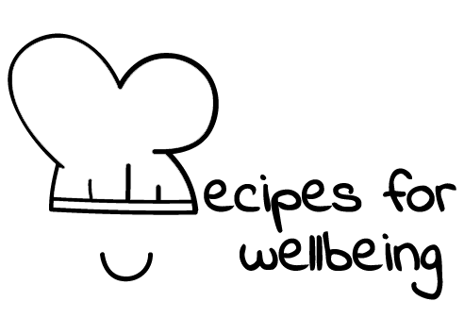
WHOLEBEING FOR EDUCATORS · LESSON PLAN
A pause you carry with you
The skill of breathing · awareness · one class period · ages 13 to 18
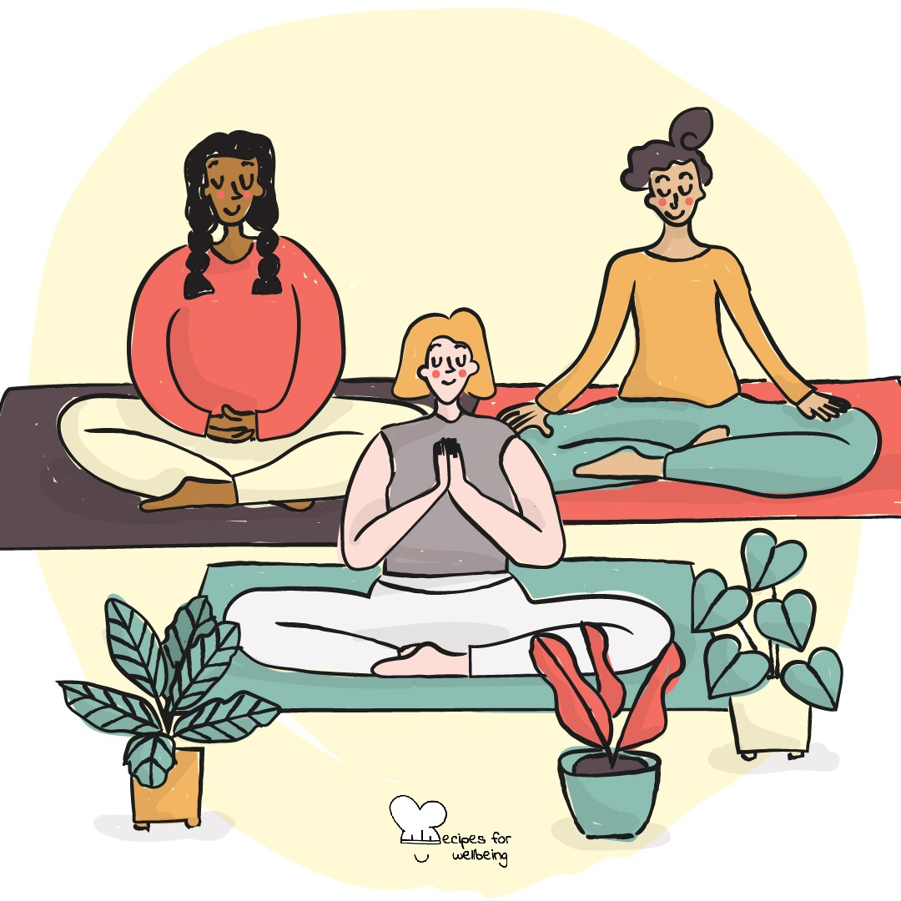
Learning intention
By the end of this lesson, students can try a simple breathing pattern and explain that changing the pace of the breath may help some people settle.

The big idea
The breath is always present, although most of the time we do not notice it. Paying attention to its pace can create a small pause during pressure, before a test or after a difficult moment. Breath practices do not work in the same way for everyone, so this lesson offers options rather than a single correct technique.
Opener (5 min): Four, seven, eight
Offer the Four, seven, eight card as one option, alongside breathing normally or watching the count without joining in. Students can shorten or remove the hold at any point.
Explore (10 min)
Breathing mostly happens without our attention, but we can also notice and gently change its rhythm. For some people, a comfortable out-breath that is slightly longer than the in-breath can support settling. It is not a test of control, and a bigger or slower breath is not always better.
Breathing cannot remove the source of stress, and it should not be used to ask someone to tolerate an unsafe situation. It can offer a brief pause in which we notice what is happening and decide what support or action is needed next.
Discuss
- What can make a breathing practice feel supportive, uncomfortable or distracting?
- Why is it useful to have more than one way of pausing?
- Where might a brief breath practice help, and where would practical action or another person's support matter more?
Activity (16 min): Draw your breath
Materials: paper and pens, although finger tracing also works · Grouping: small groups
- Invite each student to draw a simple continuous shape they can trace with one finger, such as a square, triangle, wave or circle.
- Demonstrate on a square: trace one side while breathing in, the next while pausing if comfortable, the third while breathing out, and the last while resting.
- Give students three quiet rounds with their own shape. They can change the pace, remove the hold, breathe normally while tracing or simply look at the shape.
- In groups of three or four, invite each person to show their shape and, if they wish, lead one round using only "in, pause, out, rest".
- Ask groups to discuss which pace felt easiest to follow and why different people may prefer different patterns.
- Invite one willing group to lead a final round, with watching or passing treated as full participation.
Reflect (6 min)
Which version of today's practice felt most usable, including ordinary breathing or not taking part? Note one situation in which it might offer a pause, and one situation in which you would need a different kind of support.
How: private journal
Close (3 min)
The breath is one possible place to pause, and it will not remove the thing causing pressure. If it gives you a little more room, you can use that room to choose what you need next.
In other settings
Form or tutor time (advisory / homeroom): Offer the counted breath with clear alternatives, then give students three quiet rounds of shape tracing.
Assembly or large-group gathering: Demonstrate a short shape breath from the front, making ordinary breathing and observation equally visible options. No one needs to share a response.
Youth club or small group: Try several comfortable patterns and talk about individual preferences without deciding which one works best for everyone.
Adapting for age
13 to 15: Keep the practice visual and hands-on, use short counts and make all breath holds optional. Emphasise that comfort matters more than completing the pattern.
16 to 18: Connect the practice to revision, exams, driving tests or difficult conversations, while acknowledging that it does not change the demands around them. Offer counting without drawing for students who prefer it.
Curriculum links
IB · Approaches to Learning: Self-management: affective skills (mindfulness awareness, emotional management)
OECD Learning Compass 2030: Core foundations: health foundations (mental well-being); Core foundations: social and emotional foundations (emotional regulation)
UNESCO MGIEP · SEL (EMC framework): Mindfulness (breath awareness and physiological regulation)
WHO · Life skills education: Coping with stress — learning how to relax so that tension does not build; Coping with emotions
EU · LifeComp: P1 Self-regulation — regulating emotions and behaviour, including stress responses (P1.2); P3 Wellbeing — care of mental health
UNICEF MENA · Life Skills & Citizenship Education: Self-management — regulating stress and emotions with a simple breath practice
Australia · Personal & Social Capability: Self-awareness — emotional awareness; Self-management — emotional regulation
Brazil · BNCC general competences: Self-knowledge and self-care (GC 8) — caring for physical and emotional health; recognising emotions and dealing with them
Canada · British Columbia: Personal Awareness and Responsibility — self-regulating; well-being (managing stress)
Canada · Ontario: Personal skills — coping skills such as relaxation techniques (1.2); recognizing stress (1.1) · Gr 7–8: A1.2 (e.g. deep breathing)
Chile · Orientación: Wellbeing and self-care — everyday actions for wellbeing: appropriate rest (OA 4, 7°–8°); managing stress (OA 4, 1°–2° medio)
England · DfE RSHE (statutory): Mental wellbeing: worrying and feeling down are normal, and managing those feelings (statement 4); coping strategies (statement 7)
England · PSHE Association: Health and Wellbeing: mental health and emotional wellbeing (KS3 H7, H10, KS4 H7)
Finland · Transversal competences: L3 Taking care of oneself and managing daily life — emotional skills and ways of acting that promote wellbeing
Ghana · NaCCA core competencies (JHS): Personal Development and Leadership — health and self-regulation
Hong Kong · Values Education Curriculum Framework (2026): Health education (健康生活教育) — promoting physical and psychological well-being
India · NEP 2020: Mental health (NEP 4.28); Wellness (NEP 4.23)
Indonesia · 8 dimensi profil lulusan: Health (kesehatan) — physical and mental health (kesehatan fisik dan mental): settling through the breath
Ireland · Junior Cycle Wellbeing: Resilient — coping skills for life's challenges; knowing where I can go for help
Japan · Courses of Study (lower secondary): Health — mind and body affect each other; coping with stress (ストレスへの対処)
Kenya · CBC core competencies & values: Self-efficacy — effectively managing stressful situations
Mexico · Nueva Escuela Mexicana: Feelings and their influence on decision-making — self-regulation; Axis: Healthy living (keeping stress manageable)
New Zealand · Health and Physical Education: Personal health and physical development — self-management skills; Hauora: taha tinana and taha hinengaro
Scotland · Health and wellbeing (CfE): Mental and emotional wellbeing — learning ways of managing thoughts and emotions (HWB 3-02a); personal coping skills (HWB 3-06a)
Singapore · Character & Citizenship Education: SEC: self-management; CCE Curriculum Content Area: Mental Health
South Africa · CAPS Life Orientation: Development of the self in society — stress management: coping techniques (Gr 12)
US · CASEL competencies: self-awareness, self-management
A guide, not a claim of full coverage. Check against your own scheme of work.
Holding the room
Focusing on or holding the breath can feel uncomfortable for students with asthma, anxiety, trauma or other health needs. Offer ordinary breathing, quiet tracing or observation throughout, and stop immediately if anyone feels dizzy or distressed. Follow health plans and usual safeguarding procedures.
Recipes for Wellbeing · CC BY-NC 4.0 · free for classroom use · deep dive: https://recipesforwellbeing.substack.com/p/the-skill-of-breathing

