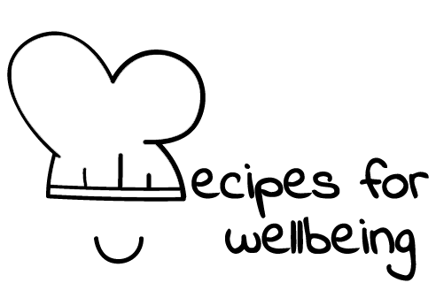
WHOLEBEING FOR EDUCATORS · LESSON PLAN
What would a forest do?
The skill of bioinspiration · bioempathy · one class period · ages 13 to 18
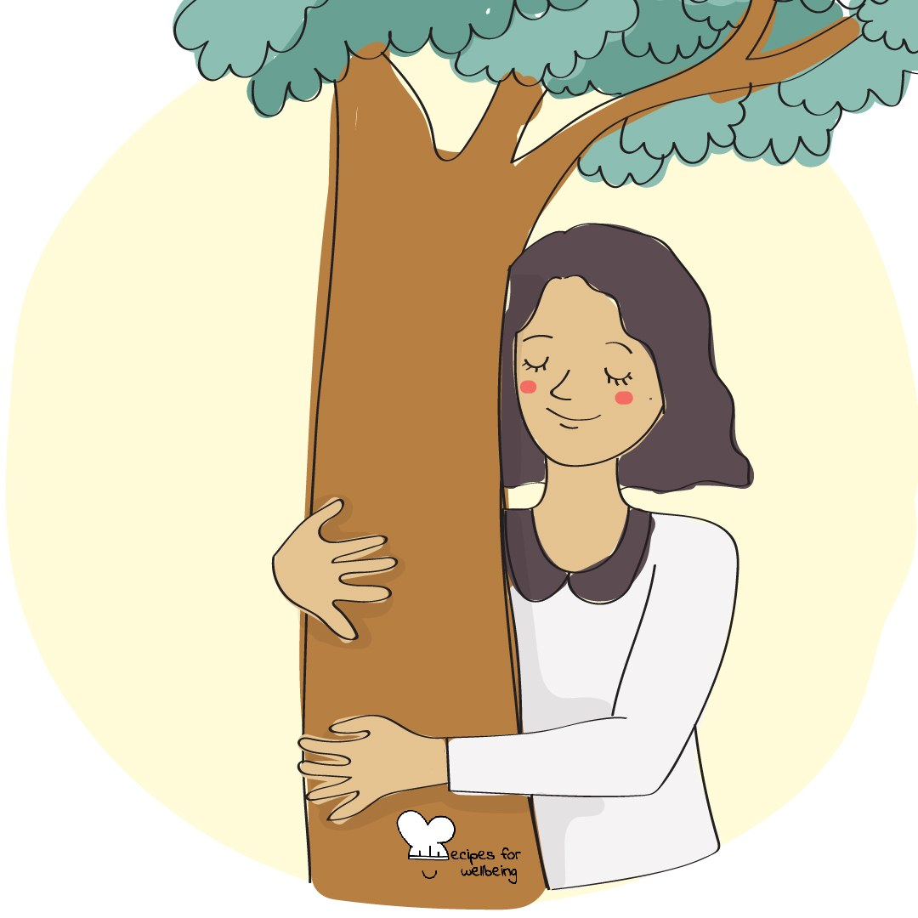
Learning intention
By the end of this lesson, students can describe a pattern from the natural world and suggest how it might inform a human response to change, pressure or cooperation.

The big idea
Living systems have developed many ways to adapt, cooperate and recover. Paying closer attention to these patterns can widen our thinking when the usual human answer is not enough. Nature will not hand us instructions. It can offer questions and principles worth testing.
Opener (5 min): What the trees are doing
Use What the trees are doing as a quiet observation. Students can look outside or bring a familiar tree to mind, and any reflection about letting go stays private.
Explore (10 min)
Recipes for Wellbeing describes bioinspiration as consciously looking to nature for guidance, insight and innovation. This does not mean assuming that every natural process is kind or useful to copy. We observe a pattern, ask what principle may sit beneath it, and decide carefully whether that principle belongs in a human setting.
A river may suggest flexibility, a forest may show interdependence, and a seed may remind us that growth includes periods that look quiet from the outside. These are starting points for thought rather than rules for how a person should live.
Discuss
- Where have people already borrowed an idea from nature in design, technology or community life?
- What might a river, flock or forest help us notice about responding to change?
- What are the limits of treating nature as a teacher?
Activity (18 min): Nature's advice panel
Materials: paper and pens, with optional nature prompt cards · Grouping: small groups
- Give each group a natural system to explore, such as a tree in autumn, a river, a flock, an ant colony, a coral reef or a seed in the soil.
- Ask students to describe what it does before interpreting it. How does it respond to change, share resources or work with its surroundings?
- Invite the group to name a possible principle in plain language, such as finding another route or sharing effort across a network.
- Ask where that principle might be useful in an ordinary school week, and where the comparison stops being helpful.
- Each group prepares one sentence beginning "We noticed..." and another beginning "This might invite people to..."
- Gather the ideas without turning them into instructions. Several interpretations can sit beside one another.
Reflect (6 min)
Which pattern from today would you like to keep thinking about, and what question does it leave you with?
How: private journal
Close (3 min)
The living world continues around us whether or not we are paying attention. When you need another way of seeing a problem, you can begin by looking closely and asking what nature makes possible.
In other settings
Form or tutor time (advisory / homeroom): Use the opening card, then explore one shared natural system and name a pattern the class notices.
Assembly or large-group gathering: Lead the opening observation, then offer two examples of bioinspiration and include the limits of each comparison.
Youth club or small group: Observe one natural system together, separate observation from interpretation, and explore where its pattern may or may not be useful.
Adapting for age
13 to 15: Use concrete picture prompts and model one observation before asking for a principle. Keep the distinction between what students can see and what they are interpreting.
16 to 18: Explore optimisation, interdependence and the limits of endless growth. Invite students to examine where a human system follows or ignores these patterns.
Curriculum links
IB · Approaches to Learning: Thinking: creative thinking skills (unusual connections, metaphors and analogies)
OECD Learning Compass 2030: Transformative competencies: creating new value; Skills: cognitive and meta-cognitive skills (creative thinking)
WHO · Life skills education: Creative thinking — looking beyond direct experience to respond adaptively; Critical thinking — testing where a comparison stops
EU · LifeComp: P2 Flexibility — adopting new ideas and approaches as contexts change (P2.2); L2 Critical thinking — creative ideas (L2.3)
UNICEF MENA · Life Skills & Citizenship Education: Creativity — generating new ideas from patterns in nature; Critical thinking — testing where an analogy stops working
Australia · Personal & Social Capability: Social awareness: community awareness (natural environments); Social management: collaboration
Brazil · BNCC general competences: Scientific, critical and creative thinking (GC 2) — imagination and creativity to create solutions; Responsibility and citizenship (GC 10)
Canada · British Columbia: Creative Thinking — generating and incubating ideas; Critical and Reflective Thinking — analyzing and critiquing
Canada · Ontario: Critical and creative thinking — making connections (1.5); Personal skills — adaptive skills for challenges and change (1.2) · Gr 7–8: A1.6
Finland · Transversal competences: L1 Thinking and learning to learn — imagination and systemic thinking; L7 Participation, involvement and building a sustainable future
Ghana · NaCCA core competencies (JHS): Creativity and Innovation — new ways of solving problems; Critical Thinking and Problem-Solving — analysing situations
Hong Kong · Values Education Curriculum Framework (2026): Education for sustainable development (可持續發展教育) — learning from how living systems adapt and cooperate
India · NEP 2020: Creativity and innovativeness; Environmental awareness (NEP 4.23)
Indonesia · 8 dimensi profil lulusan: Creativity (kreativitas) — formulating solutions to problems around us; Critical reasoning (penalaran kritis)
Ireland · Junior Cycle Wellbeing: Connected — to the wider world, in local and global contexts; Resilient — coping skills for life's challenges
Japan · Courses of Study (lower secondary): Moral education D — love and care for nature (自然愛護); Moral education A — pursuit of truth, creativity (真理の探究，創造)
Kenya · CBC core competencies & values: Creativity and Imagination — finding hidden patterns and connecting unrelated phenomena; Critical Thinking and Problem Solving
Mexico · Nueva Escuela Mexicana: Technology — strategic and creative thinking in problem solving; Axis: Healthy living (environment and community life)
New Zealand · Health and Physical Education: Healthy communities and environments — people and the environment (interdependence); Hauora: taha hinengaro
Singapore · Character & Citizenship Education: Building Connections: care for nature and animal welfare; environmental issues and sustainability
South Africa · CAPS Life Orientation: Study skills — critical, creative and problem-solving skills (Gr 10)
US · CASEL competencies: social awareness, responsible decision-making
A guide, not a claim of full coverage. Check against your own scheme of work.
Holding the room
Keep the discussion about nature and people in general, and leave the opener's reflection private. Avoid presenting illness, disability, death or survival as simple metaphors for personal resilience. Follow usual safeguarding procedures if a concern arises.
Recipes for Wellbeing · CC BY-NC 4.0 · free for classroom use · deep dive: https://recipesforwellbeing.substack.com/p/the-skill-of-bioinspiration

