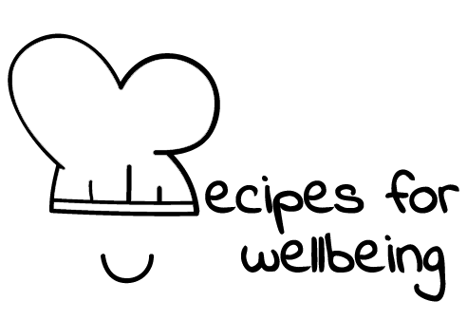
WHOLEBEING FOR EDUCATORS · LESSON PLAN
Say the good part out loud
The skill of celebration · positive emotion · one class period · ages 13 to 18
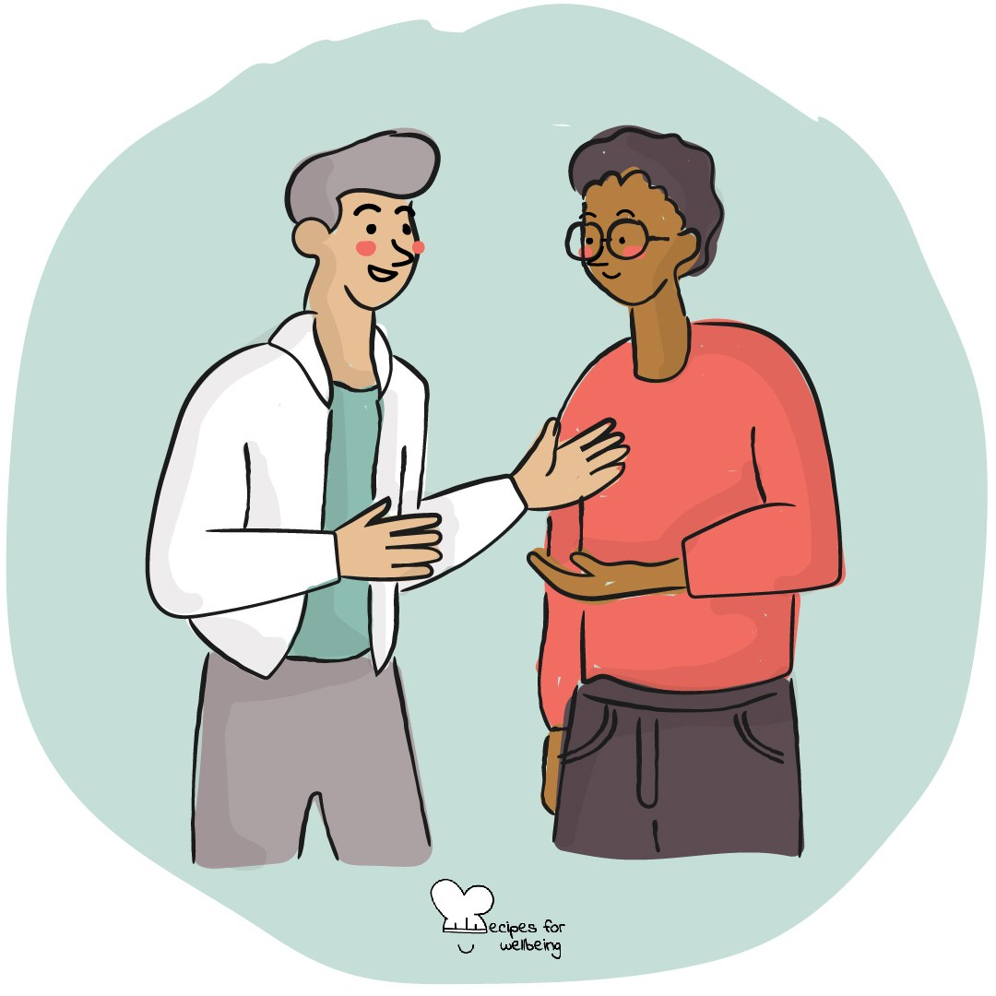
Learning intention
By the end of this lesson, students can offer a specific and sincere affirmation, and receive one with a simple thank you.

The big idea
A general compliment can be pleasant, but a specific affirmation helps someone understand what we noticed and valued. Naming a thoughtful action, a useful contribution or a quality we have genuinely seen can help appreciation feel sincere rather than automatic.
Opener (5 min): Good gossip
Use the Good gossip card to practise speaking well of someone who is not in the room. Keep all examples kind, true and appropriate to share.
Explore (10 min)
Affirmation means noticing something we value and finding honest words for it. It is different from flattery, which can be vague or offered because we want something in return.
Specific language helps. "You are brilliant" gives someone little information, while "Your explanation helped me understand the question" names what happened and why it mattered. An affirmation should be true, freely offered and free of comparison with anyone else.
Receiving appreciation can also feel uncomfortable. A simple "thank you" is enough; no one has to agree with every word or respond with a compliment of their own.
Discuss
- What makes an affirmation feel sincere?
- Why can comparison weaken a compliment, even when the speaker means well?
- What makes receiving appreciation difficult for some people?
Activity (18 min): Making appreciation specific
Materials: optional paper and pens; fictional scenarios on the board or read aloud · Grouping: small groups
- Show the class a general compliment and a specific affirmation, such as "Good job" and "Your clear summary helped our group decide what to do next". Ask what makes the second more useful.
- Agree on three guides: an affirmation is specific, true and offered without wanting anything back.
- Give groups several fictional examples, such as someone welcoming a new student, admitting a mistake or helping a team stay organised.
- Ask each group to write an affirmation for the person in each example, then review the wording for assumptions, comparisons or exaggeration.
- Invite groups to share selected examples and explain why the words feel sincere.
- Offer an optional final round in which students affirm something they observed in the lesson. They can pass or appreciate the group as a whole, and the receiver only needs to say "thank you".
Reflect (6 min)
Think of something helpful or caring that someone does which often goes unnamed. Without identifying them, draft one specific and honest sentence you might offer if the moment feels right.
How: private journal
Close (3 min)
Appreciation does not need to wait for a celebration. When you notice something you genuinely value, you can name it clearly and allow the other person to receive it in their own way.
In other settings
Form or tutor time (advisory / homeroom): Use Good gossip, then compare one general compliment with one specific affirmation and identify what makes the second clearer.
Assembly or large-group gathering: Compare two fictional examples from the front and invite students to notice which one says more. Keep all reflection private.
Youth club or small group: Use the fictional scenarios, then offer an optional round of affirming contributions made within the group that day.
Adapting for age
13 to 15: Model a complete affirmation before students begin and use concrete fictional examples from school, sport, gaming and family life. Keep any real affirmations to behaviour observed during the lesson.
16 to 18: Explore why sincere appreciation can feel awkward, and consider how specific affirmation differs from feedback, flattery and a reference. Include self-affirmation as an optional extension.
Curriculum links
IB · Approaches to Learning: Social: collaboration skills (helping others to succeed); Communication: communication skills (giving and receiving meaningful feedback)
OECD Learning Compass 2030: Skills: social and emotional skills (empathy, collaboration)
UNESCO MGIEP · SEL (EMC framework): Empathy
WHO · Life skills education: Effective communication — expressing appreciation specifically and sincerely; Interpersonal relationship skills
EU · LifeComp: S2 Communication — clarity and reciprocity in conversation (S2.3); S3 Collaboration — trust and respect for others (S3.2)
UNICEF MENA · Life Skills & Citizenship Education: Communication — sharing meaning through specific, sincere appreciation
Australia · Personal & Social Capability: Social awareness: relational awareness; Social management: communication
Brazil · BNCC general competences: Empathy and cooperation (GC 9) — valuing others' knowledge, identities and potential; Communication (GC 4) — sharing feelings
Canada · British Columbia: Social Awareness and Responsibility — building relationships; valuing diversity (everyone has something to contribute)
Canada · Ontario: Interpersonal skills — expressing responses and giving feedback (1.3); relationship and social skills (1.4) · Gr 7–8: A1.3, A1.4
Chile · Orientación: Interpersonal relationships — constructive relationships (OA 5); Personal growth — building positive self-representations together (OA 1, 7°–8°)
England · DfE RSHE (statutory): Respectful relationships: self-esteem and a positive relationship with oneself (statements 3, 1)
England · PSHE Association: Health and Wellbeing: personal strengths, self-confidence and self-esteem (KS3 H1, H4); Relationships: positive relationships (KS3 R14)
Finland · Transversal competences: L2 Cultural competence, interaction and self-expression — meeting others with appreciation; L7 — experiences of being heard and valued
Ghana · NaCCA core competencies (JHS): Personal Development and Leadership — building self-esteem and developing others; Communication and Collaboration
Hong Kong · Values Education Curriculum Framework (2026): Respect for Others (尊重他人) — discovering and appreciating others' strengths (S4–S6)
India · NEP 2020: Oral and written communication (NEP 4.23); Ethics and values such as empathy, respect for others and courtesy (NEP Principles)
Indonesia · 8 dimensi profil lulusan: Communication (komunikasi) — speaking well and ethically (sesuai etika)
Ireland · Junior Cycle Wellbeing: Respected — feeling listened to and valued; positive relationships with friends, peers and teachers
Japan · Courses of Study (lower secondary): Special activities — bringing out each other's strengths (互いのよさ); Moral education B — consideration and gratitude (思いやり，感謝)
Kenya · CBC core competencies & values: Communication and Collaboration — clear, appropriate communication; Core value — integrity
Mexico · Nueva Escuela Mexicana: Feelings and their influence on decision-making — building inclusive, equitable affective relationships; Axis: Inclusion
New Zealand · Health and Physical Education: Relationships with other people — interpersonal skills; KAL mental health — enhancing a sense of self-worth
Scotland · Health and wellbeing (CfE): Mental and emotional wellbeing — caring, sharing and positive relationships (HWB 3-05a); Relationships — skills to sustain them (HWB 3-44b)
Singapore · Character & Citizenship Education: SEC: social awareness and relationship management
South Africa · CAPS Life Orientation: Development of the self in society — enhancing others' self-image through positive actions (Gr 7); building confidence in others (Gr 10)
US · CASEL competencies: relationship skills, social awareness
A guide, not a claim of full coverage. Check against your own scheme of work.
Holding the room
Let fictional examples carry the main practice and keep passing available. Do not invite comments on appearance, identity, popularity or private circumstances. If a response raises a concern, do not explore it publicly; follow your setting's safeguarding procedures.
Recipes for Wellbeing · CC BY-NC 4.0 · free for classroom use · deep dive: https://recipesforwellbeing.substack.com/p/the-skill-of-celebration

