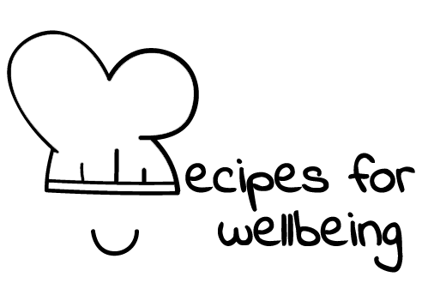
WHOLEBEING FOR EDUCATORS · LESSON PLAN
Letting people be who they are
The skill of holding space · radical care · one class period · ages 13 to 18
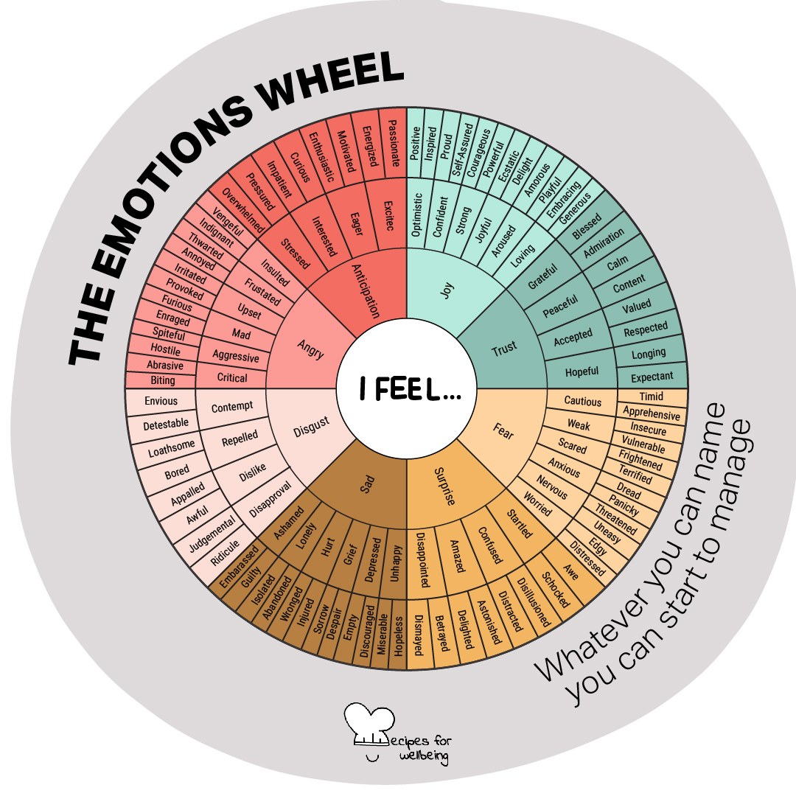
Learning intention
By the end of this lesson, students can listen without interrupting or rushing to fix, and describe what helps another person feel accepted.

The big idea
When someone tells us how they are, it can be tempting to answer with advice or a story of our own. Acceptance begins by staying with the person in front of us and allowing their experience to be what it is. We can still disagree or name harm. We listen first, then decide what should happen next.
Opener (5 min): Inner weather report
Use the Inner weather report card to help the class arrive. Students can offer one word or pass, and no one needs to explain or change their answer.
Explore (10 min)
In the opening practice, every forecast was allowed to be present. We can offer the same kind of room when another person speaks. Recipes for Wellbeing calls this holding space: giving someone our attention without judging, taking over or immediately trying to make the feeling disappear.
Listening does not make us responsible for solving everything, and acceptance does not require us to agree or stay silent when someone is unsafe. It asks us to understand what is being shared before we respond. Sometimes advice is useful, but it is kinder to find out whether it is wanted.
Discuss
- What can you see or hear when someone is giving another person their full attention?
- Why might we rush to offer advice before we know whether it is wanted?
- How can we accept someone's feelings while still keeping a boundary or disagreeing with their behaviour?
Activity (15 min): Just listen
Materials: a clock or timer · Grouping: pairs
- Arrange pairs, with a trio if needed, and explain that the listener's task is to pay attention without giving advice, comparing experiences or taking over.
- Offer a low-disclosure topic, such as something ordinary you are looking forward to. Students can keep it light, choose another safe topic or pass.
- Partner A speaks for 90 seconds while Partner B listens. Keep the time and give a gentle signal at the end.
- Swap roles, inviting each listener to notice any urge to interrupt, fix or compare without acting on it.
- Ask pairs to discuss the experience rather than repeat the content. What helped the listening feel attentive, and what made it difficult?
- Gather general observations, then ask what a listener could say if they were unsure whether the speaker wanted comfort, advice or practical help.
Reflect (7 min)
Bring to mind a time when someone listened without trying to change how you felt. Without recording any private details, note what they did and where you might offer the same quality of attention this week.
How: private journal
Close (3 min)
The weather in someone else's day is theirs. We can make room for them to describe it, and ask what kind of support would be welcome before we offer an answer.
In other settings
Form or tutor time (advisory / homeroom): Use the weather check-in, then run one 90-second listening round in pairs. Close by asking what helped the listener stay present.
Assembly or large-group gathering: Keep the weather check-in silent, explain holding space, and invite students to think privately of someone who listens well.
Youth club or small group: Use the full paired practice with low-stakes topics, then talk together about what made listening easier or harder.
Adapting for age
13 to 15: Keep the topic light and concrete, model an attentive listener, and shorten each round to 60 seconds. Students can write instead of speaking, or observe in a trio before taking a turn.
16 to 18: Extend each round to two minutes if the class is comfortable. Explore how listening changes online, during disagreement or when the speaker needs more support than a friend can safely provide.
Curriculum links
IB · Approaches to Learning: Social: collaboration skills (practising empathy)
OECD Learning Compass 2030: Skills: social and emotional skills (empathy)
UNESCO MGIEP · SEL (EMC framework): Empathy; Compassion (holding space without judgement)
WHO · Life skills education: Empathy — understanding and accepting others as they are; Interpersonal relationship skills — relating in positive ways
EU · LifeComp: S1 Empathy — understanding and responding to another's emotions (S1.2–S1.3); S2 Communication — listening to others (S2.3)
UNICEF MENA · Life Skills & Citizenship Education: Empathy — understanding another's feelings before responding; Respect for diversity — recognising each person as unique
Australia · Personal & Social Capability: Social awareness: empathy; relational awareness
Brazil · BNCC general competences: Empathy and cooperation (GC 9) — empathy, dialogue and welcoming others without prejudice; Self-knowledge and self-care (GC 8)
Canada · British Columbia: Social Awareness and Responsibility — building relationships (respecting others' needs); Communicating — connecting and engaging with others
Canada · Ontario: Interpersonal skills — active listening (1.3); relationship and social skills, showing respect for others (1.4) · Gr 7–8: A1.4
Chile · Orientación: Interpersonal relationships — dialogue and empathic listening (OA 6, 7°–8°); relationships that respect dignity (OA 5)
England · DfE RSHE (statutory): Respectful relationships: treating others with kindness and respect, and tolerance (statements 2, 4)
England · PSHE Association: Relationships: forming and maintaining respectful relationships, active listening (KS3 R16); diversity and inclusion (KS3 R3, R41)
Finland · Transversal competences: L2 Cultural competence, interaction and self-expression — putting oneself in another's position; L1 — listening to oneself and others
Ghana · NaCCA core competencies (JHS): Personal Development and Leadership — empathy; Communication and Collaboration — respecting others' perspectives
Hong Kong · Values Education Curriculum Framework (2026): Respect for Others (尊重他人) — accepting peers who differ (S1–S3); Empathy (同理心)
India · NEP 2020: Socio-emotional learning (NEP 5.14); Oral and written communication (NEP 4.23)
Indonesia · 8 dimensi profil lulusan: Communication (komunikasi) — listening (menyimak) ethically; Collaboration (kolaborasi) — caring (peduli)
Ireland · Junior Cycle Wellbeing: Respected — others feel listened to and valued; showing care and respect for others
Japan · Courses of Study (lower secondary): Moral education B — mutual understanding and tolerance (相互理解，寛容); Special activities — respecting others' individuality
Kenya · CBC core competencies & values: Self-efficacy — empathy in interpersonal relationships; Core value — respect
Mexico · Nueva Escuela Mexicana: Ways of being, thinking, acting and relating — understanding the different ways people experience situations; Axis: Inclusion
New Zealand · Health and Physical Education: Relationships with other people — interpersonal skills; Hauora: taha whānau (compassion, caring and social support)
Scotland · Health and wellbeing (CfE): Mental and emotional wellbeing — giving appropriate support (HWB 3-08a); Relationships — responding to verbal and non-verbal communication (HWB 3-45b); Social wellbeing: a school community that values individuals equally and is welcoming (HWB 3-10a)
Singapore · Character & Citizenship Education: SEC: social awareness and relationship management
South Africa · CAPS Life Orientation: Development of the self in society — respect for others and differences (Gr 10); understanding others in relationships (Gr 12)
US · CASEL competencies: social awareness, relationship skills, self-awareness
A guide, not a claim of full coverage. Check against your own scheme of work.
Holding the room
Use neutral, self-chosen topics and keep passing available throughout. Listeners should not probe or promise secrecy. If a student shares something concerning, do not ask for details in front of the class; follow your setting's safeguarding and pastoral procedures.
Recipes for Wellbeing · CC BY-NC 4.0 · free for classroom use · deep dive: https://recipesforwellbeing.substack.com/p/the-skill-of-holding-space

